Homework #20: Journal Reading
This exercise requires you to read and interpret actual passages regarding statistics from real psychological research journals. In several cases you will need to extrapolate on what you’ve learned and make your best guess. The purpose is to help prepare you for reading research articles in preparation for conducting your own research project in PSYC 302, Research Methods.
Article #1: Banerjee, P., Chatterjee, P., & Sinha, J. (2012). Is It Light or Dark? Recalling Moral Behavior Changes Perception of Brightness. Psychological Science. HELPFUL HINTS: These authors hypothesize that people unconsciously associate bad behavior with darkness and good behavior with light. They prime people to think about one or the other and then see if this affects their perceptions and preferences regarding light.
- IV: __recalling (un)ethical deed_  - DV: __brightness perception, 1-7 scale____  - Obtained t value: __2.03____  - Type of t-test: ____Independent______  - Mean for the ethical condition __5.3____  - Was there a treatment effect? __Yes___  - Based on the effect size statistic, how many standard deviation units of difference does the IV cause? __0.65____  - The effect size is ___Medium____. |  |  |  | Study 1: “Forty participants at a large public university participated in this study in return for partial course credit. We asked participants to recall and describe in detail either an ethical or an unethical deed from their past and to describe any feelings or emotions associated with it (Zhong & Liljenquist, 2006). After completing a filler task, participants were asked to judge the brightness of the room, using a 7-point scale (1 = low, 7 = high). A t test revealed a significant difference in perception of the room’s brightness between the two conditions (ethical condition: M = 5.3; unethical condition: M = 4.71), t(38) = 2.03, p < .05, Cohen’s d = 0.65. As predicted, participants in the unethical condition judged the room to be darker than did participants in the ethical condition. In our next study, we sought to extend these findings by testing whether participants who recalled unethical behavior, relative to those who recalled ethical behavior, exhibited a greater preference for light-producing objects (i.e., lamp, candle, and flashlight) that would brighten the room.”
- DV for brightness perception: __estimated Wattage___  - How big of difference did they find in perception of brightness? (State the statistic and its value): _d=0.64__  - What was the preference for the lamp in the ethical condition vs. the unethical condition: _M=2.34__vs._ _M=4.16__  - The largest effect size was for which object? __Flashlight___  - For which objects were there no significant differences? __Jug, Crackers, Apple___  - Why would the above objects not show a significant difference? _They do not give off light.__ |  |  |  | Study 2: “Seventy-four students participated in this study in return for partial course credit. As in Study 1, we asked participants to recall and describe either an unethical or an ethical deed from their past, as well as the feelings or emotions they associated with it. Next, participants were asked to indicate their preferences for the following products: a jug, a lamp, crackers, a candle, an apple, and a flashlight. Responses were made using 7-point scales (1 = low, 7 = high). We also asked participants to estimate (in watts) the brightness of the light in the lab. As expected, participants in the unethical condition found the lab to be darker than did participants in the ethical condition (ethical condition: M = 87.6 W; unethical condition: M = 74.3 W), t(72) = 2.7, p < .01, d = 0.64. Moreover, as predicted, participants in the unethical condition demonstrated greater preference for the light-related objects (but not the other objects): lamp (ethical condition: M = 2.34; unethical condition: M = 4.16), t(72) = 5.23, p < .0001, d = 1.23; candle (ethical condition: M = 2.37; unethical condition: M = 3.62), t(72) = 3.36, p < .01, d = 0.79; and flashlight (ethical condition: M = 2.35; unethical condition: M = 4.33), t(72) = 5.68, p < .0001, d = 1.33.”
Article #2: Eppig, C., Fincher, C. L., & Thornhill, R. (2011). Parasite prevalence and the distribution of intelligence among the states of the USA. Intelligence, 39(2–3), 155–160. HELPFUL HINTS: The authors hypothesize that in early childhood development the body makes a trade-off between maximizing brain functioning and maximizing immune system functioning. If the body detects a high parasite-stress environment, it will devote more resources to the immune system, thereby sacrificing a some level of intelligence. They therefore predict that people will be less intelligent in regions of the country where there are more risks from parasites (typically those areas that are closer to the equator – that is, lower in latitude). They conduct a hierarchical regression which tries to control for other potential variables (e.g., educational quality) that could provide another explanation for the relationship between IQ and parasite-stress).
- Parasite-stress (PS) correlated with what geographical variable? ___Latitude____  - As you head south, PS __Increases____.  - What amount of variance in PS could you account for with latitude: __20.25%____.  - What’s the correlation between PS and life expectancy? ___r=-0.67____  - At what level was this relationship significant? ____p<.001________  - Which variable was standardized? __parasite stress_ |  |  | Excerpt from literature review. Hint: The authors are providing evidence that their measure of parasite-stress (i.e., the level of risk for a parasite infection in a given area) measures what it is supposed to. “This index of parasite-stress, Parasite-Stress USA, is validated by the fact that it shows a negative correlation with latitude (−0.45, n=50, and p=0.001; or after removing the latitudinal outliers Alaska and Hawaii, −0.71, n=48, and p=0.0001) just as do global measures of parasite-stress (Cashdan, 2001; Guernier, Hochberg, & Guégan, 2004; Low, 1990). Furthermore, Parasite-Stress USA was correlated strongly and negatively across US states with the average lifespan expectancy at birth for both sexes in the year 2000 according to data we collected from www.census.gov (r=−0.67, n=50, and p=0.0001). Similar strong relationships between infectious disease stress and lifespan expectancy are found in cross-national analyses (Thornhill et al., 2009). This variable was z-scored (mean= −0.0044, median=−0.023, and SD=0.91). See Fincher and Thornhill (in press) for further details and data.”
- What’s the cor. between IQ and PS?  -0.67_  - What percent of variance in IQ can you account for with PS? ___44.89%______  - The reason n=50 is because that’s the number of ___US states_____.  - Based on the regression line, if PS is 2 standard deviations above average, the average IQ should be just a little above _96__.  - What’s the next best predictor of IQ? _percent of teachers highly qualified_  - Besides PS, the only other negative correlation with IQ is with __student-teacher ratio_ |  |  | Excerpt from Results: “Average state IQ and parasite stress correlated at r=−0.67 (n=50, and p=0.0001; Fig. 1). Average IQ also correlated signiﬁcantly with wealth (r=0.32, n=50, and p=0.025), percent of teachers highly qualiﬁed (r=0.42, n=50, and p=0.0023), and student–teacher ratio (r=−0.31, n=50, and p=0.031) (see Table 1 for additional correlations). |  | 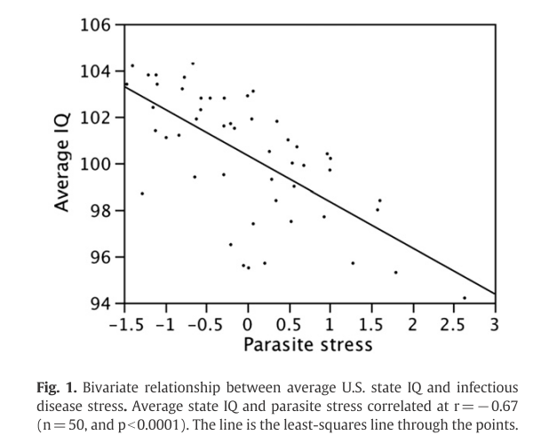
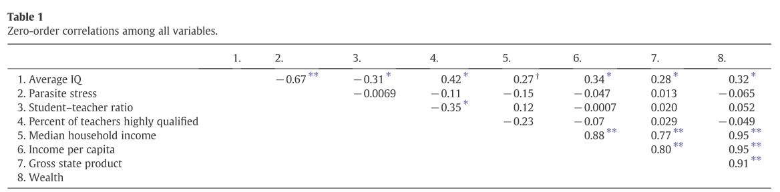
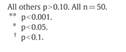 | - What’s the cor. IQ and Med. Household income? ___0.27________ Is it significant? __No_______  - What’s the best predictor of Household income? __Wealth or Income per capita_ What’s the r value? __0.95__  - The relationship between IQ and household income isn’t sig., but ____it’s close, p<.10 ___________.  - If a relationship has two asterisks it’s significant at the __p<.001____ level.
- What’s the amount of variance accounted for in IQ after entering just PS in the first step? _____ R²= 0.445_______  - What does the amount of variance accounted for reach after everything is entered in the third step? __ R²= 0.698______  - Is PS still significant after they’ve controlled for wealth, education, etc.? ___Yes________ |  | Excerpt from Results: Hierarchical regression was used to predict average state IQ using parasite stress, wealth, percent of teachers highly qualiﬁed, and student/teacher ratio (Table 2). Parasite stress was added in the first iteration of the model, resulting in a change in R² of 0.445. Wealth was added in the second iteration of the model, resulting in a change in R² of 0.075. Both education variables were added simultaneously in the third iteration of the model because they both measure the same theoretical construct, resulting in a change in R² of 0.133. While these variables were added into the model in order of presumed causal priority, adding these variables in a different order did not appreciably change the additive R² of each iteration. In the final model, parasite stress (Std Beta= −0.62, variance inﬂation factor (VIF)=1.02, and p=0.0001), wealth (Std Beta=0.30, VIF=1.00, and p=0.0006), percent of teachers highly qualiﬁed (Std Beta=0.29, VIF=1.16, and p=0.0019), and student/teacher ratio (Std Beta=−0.22, VIF=1.15, and p=0.015) (Table 3) were all signiﬁcant predictors of average state IQ. The whole model R² was 0.698 (p=0.0001).” Also see Table 2 below.

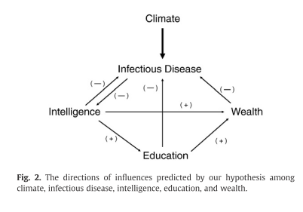 | 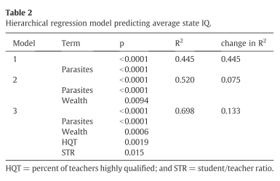
Answer the following based on the above model (not your own intuition).
- What’s the fundamental driver of infectious disease risk? ____Climate?__________
- What’s the direction of relationship between education and infectious disease risk? ____Negative__________
- As infectious disease risk increases, wealth ____Decreases________________
- Can education increase intelligence? ___No, the model shows causality running from Intelligence to Education_________
- As intelligence increases, what happens to infectious disease risk? _Decreases?__. Speculate below on why they might suggest this relationship: As intelligence increases, people invest more resources in public health and prevention (e.g., vaccinations).

