Labor Demand Notes

Labor is a derived demand. It stems from the demand for the goods and services labor produces.

Production function

Q = f(K,L)
Q is the total product, or output
Output depends on capital and labor
Holding one input constant
MPL = change in Q/ change in L – holding labor constant

Assuming a price of $2 per unit in a perfectly competitive product market

Labor Output MP AP MRP VAP
0 0 - - - -
1 11 11 11 22 22
2 27 16 13.5 32 27
3 47 20 15.7 40 31.4
4 66 19 16.5 38 33
5 83 17 16.6 34 33.2
6 98 15 16.3 30 32.6

MRP is the price times the MP, it is the dollar value of what a worker produces.
AP is the per worker contribution to the firm

Assume a farmer owns an apple orchard. He picks 3 bushels of apples an hour; he can sell each bushel for $4. In this example, his MP per hour is 3 and P = $4, therefore his MRP_{L} is $12. Since he owns the farm his wage rage is $12 per hour.

What if he picked more apples per hour?

How is the typical employee paid?
Are athletes, celebrities, doctors, lawyers, salesman, and CEOs paid differently than customer service representatives, retail clerks, construction workers, school teachers?

Why?

How is marginal productivity measured in the service sector versus the manufacturing sector?

The labor demand curve is the relationship between L and MRP.

Total Product of Labor and the derivation of the labor demand curve
Labor
Total Product of Labor

Average Product of Labor
Labor
Marginal Product of Labor
A B C
wage
rate

MRP_{L} = D_{L}

A B C

Explaining the graphs and the Zone of Production
From A to B the total product is increasing at an increasing rate, as a result the marginal product is rising. At point A, the point of inflection, marginal product reaches its peak, and begins to decline. Total product is still increasing but not as fast as before.

Beyond point C, MPL is negative.

Production range, known as the Zone of Production, is between points B and C. Since MPL is the wage, and APL is the average contribution per worker, the company would like the average contribution to be above the wage rate. It is from this zone that the labor demand curve is derived.

Law of Diminishing Marginal returns states that, holding capital constant, increasing the number of labor units does not have as positive an effect as the number of labor units increase. The reason is not because worker A differs from worker B, all workers are assumed to be identical in a perfectly competitive labor market. The reason is that after the specialization process, the existing workers are exhausting the fixed capital resources.

Competitive Labor Market

In a competitive labor market w = MRP_{L}. Think about a perfectly competitive product market. The demand curve is downward sloping but all firms charge the same price. In this market, the labor demand curve is downward sloping, and all firms pay the same wage rate which is equal to the MRP.

wage

S_{L} = MWC_{L}

Ld = MRP_{L}

Assume the labor supply curve is flat, in other words there are numerous workers willing to work at a particular wage. The labor demand assumption is that each of these workers is equally skilled. The wage rate will determine the number of employees hired. An increase in wages would result in a decrease in the number of employees hired.

The labor demand curve can be more or less flat (elastic).
The factors that affect the labor demand curve’s elasticity (shape) are
- the ease of substitution between labor and capital
- the elasticity of the product
- the competitive nature of the industry
- labors share of total cost
- public sector issues versus private sector issues
- International competition - in a labor intensive industry

Wage taker

wage

S_{L}

S_{L} = MWC_{L}

Ld = MRP_{L}
D_{L}

Labor Labor
industry firm

Imperfectly Competitive Labor Market
Workers have unique skills. You can assume the worker, as a supplier of labor, has some power in setting his/her wage. This is comparable to an imperfect product market where the MR curve and the demand curve differ because the product prices change with output. The company loses revenue because when the price is lowered to one customer it is lowered to them all. The labor demand curve will be steeper as well.

wage

W

S_{L} = MWC_{L}

MRP_{L} Ld

Labor
Holding everything else constant, the worker with a unique skill set can obtain a higher wage rate than someone with skills that are easily replicated.

The Labor Demand Curve in the long run

wage

Ld LR

Ld SR

Output (scale) effect
As wages decrease, supply shifts right in the product market – mc curve shifts right. This decrease in wages leads to a decrease in costs. The decrease in costs inspires an increase in the quantity demanded for the product labor is producing. Therefore, the quantity of labor demanded increases.

Substitution effect
The same decrease in wages can have a different affect on labor. In the short run capital is fixed, so a reduction in wages does not lead to a reduction in capital. In the long run, a reduction in wages inspires firms to substitute labor for capital.

Therefore, the long run labor demand cure is flatter (more elastic) because
- substitution of capital for labor is more easily accomplished in the long run
- as wages fall the output effect means more will be produced, therefore labor needs to increase
- technology can replace labor
- international options

What happens to the demand for capital in the long run when the wage rate fall?
Output effect – as more is produced more capital is needed since output (Q) is a function of capital and labor (K,L).
Substitution effect – as labor becomes cheaper, labor is substituted for capital, less capital is needed.
The answer depends on which effect outweighs the other.

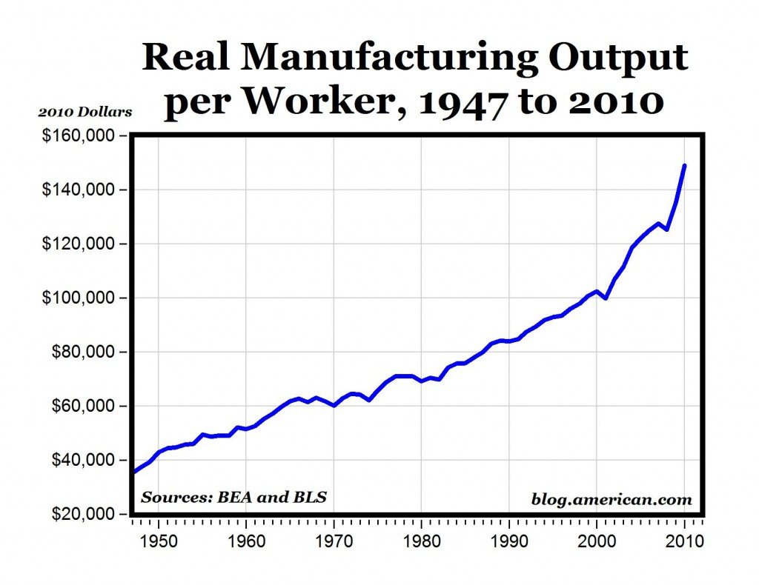

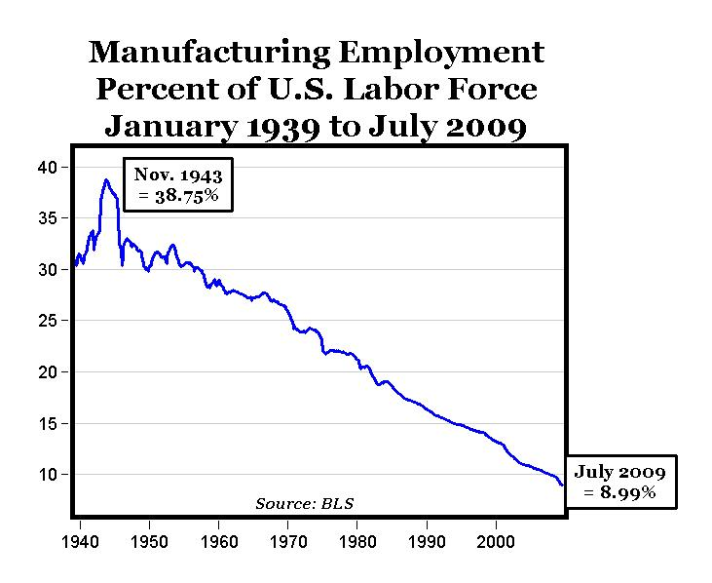

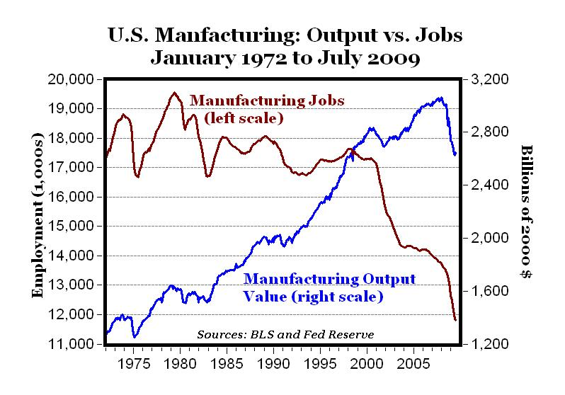

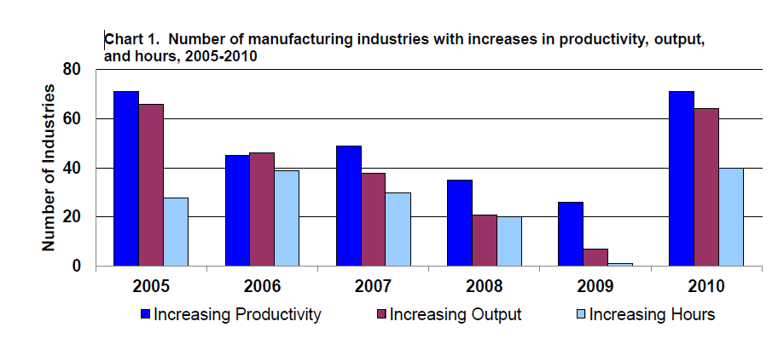

http://www.chinaglobaltrade.com/article/us-manufacturing-and-trade-with-china

Chapter 6 Notes

Factors that effect labor demand
- Product demand measured by business cycles, taste and preferences, and interest rates
- Productivity increases in the marginal product of labor will result in an increase in the labor demand curve
- Number of Employers or potential buyers of labor
Prices of related goods such as substitutes or compliments

Factors that effect labor supply
- Other wage rates - in other occupations in other areas where labor is mobil
- Nonwage income
- Preferences for work and leisure
- Nonwage aspect of jobs - hedonic wages theory (pleasant conditions, enjoyable work)
- Number of qualified suppliers –education, training

Labor Demand Sample Questions

1. Draw a total product of labor curve holding capital constant. Underneath draw an average product of labor curve and a marginal product of labor curve. Explain the peak points for MPL and APL, as well as the point where MPL is zero.

2. Explain the firms hiring decision. What quantity of labor should the firm employ?

3. Derive a labor demand curve from your AP_{L} and MP_{L} graph.

4. Explain the firm’s decision to hire when AP_{L} is greater than MP_{L}.

5. Where is APK maximized?

6. What is the difference between labor demand curves when the product market is perfectly competitive as opposed to imperfectly competitive?

7. How is the labor demand curve impacted by an increase in productivity? Begin by looking at the impact on the total product curve.

8. Explain how an increase in interest rates will impact the labor demand curve, particularly in the long run.

9. Using the scale and substitution effect explain how the long run labor demand curve differs from the short run labor demand curve.

10. What is the impact of an increase in wages on the quantity of labor demanded? Explain the output and substitution effects.

11. What is the impact of a decrease in wages on capital in the long run?

12. What factors will impact the elasticity of the labor demand curve?

13. How will elasticity be impacted if labor and capital are perfectly substitutable?

14. How will an increase in the price of capital impact the labor demand curve if labor and capital are compliments? Why?

15. The hiring decisions of firms operating in a competitive labor market are considered to have no impact on market wages. Show graphically how the firm takes it wage from the market.

16. What factors impact the labor supply curve?

17. Explain the logic behind the MRP = MCW hiring rule.

