What are the issues for the US economy?
Is the stock market overvalued? What are the alternatives to stock?
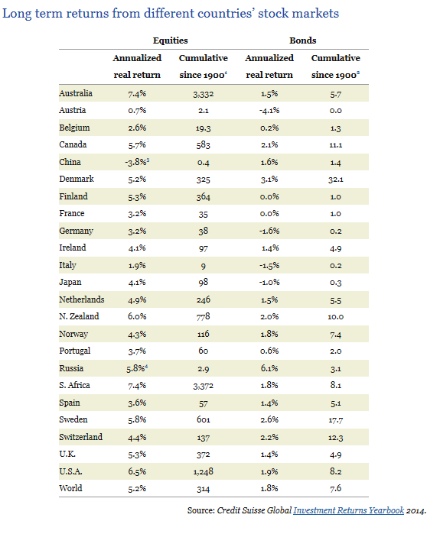
Is Washington ever going to be functional again?
Will the economy ever grow by more than 3% again?
How does the North Korea situation affect stock prices?
Health Care Repeal, either way change is coming!
Tax Reform, is it built in to the market?
Can the US win by being tough with their trade partners?
Other issues
The decline of the middle class
Unemployment in the inner cities among blacks
Low Labor force participation rates
Immigration – will prices start to rise when immigration falls?

What do you care about?
My generation is looking for ….
Student debt – after addressing the problem, suggest a solution; but you need to explain how to pay for your solution
Satisfying jobs
Free stuff. Who pays? Do the benefits outweigh the costs?

Negative Interest Rates
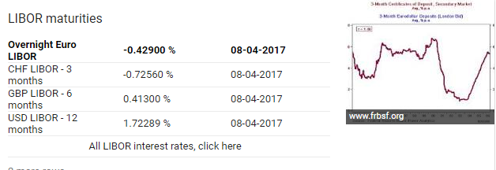
http://online.wsj.com/mdc/public/page/2_3020-moneyrate.html?mod=topnav_2_3024

What does the money supply have to do with these issues?
https://www.bloomberg.com/quicktake/negative-interest-rates
http://www.bbc.com/news/business-32284393
Real GDP 2.6%
Personal Income 0%
LFP Male 69%
Unemployment Rate 4.3%
Inflation Rate 1.6%

