The relationship between bond prices and interest rates
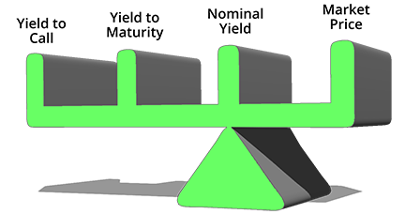
When a bond is selling at par value

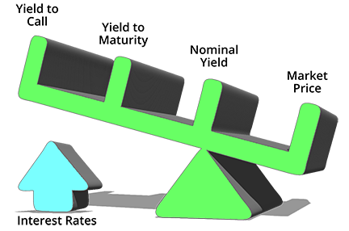
When interest rates increase, the bond sells at a discount
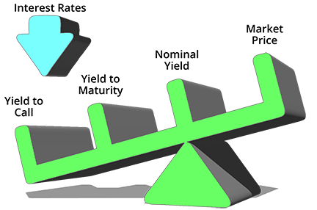
When interest rates decrease the bond sells at a premium.

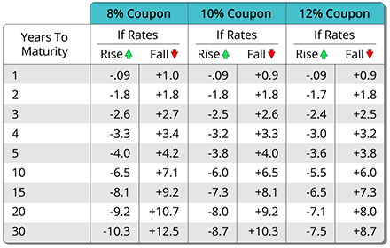

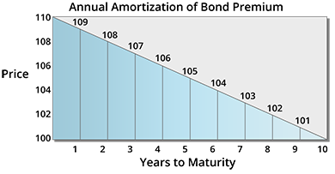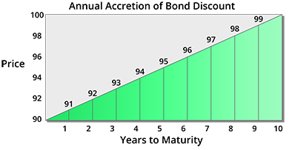

Price At Discount
If market interest rates rise after issuance from 5% to 6% for similar bonds, then this bond's price would fall in the marketplace. This occurs because the cash flows generated by this 5% coupon rate bond will now be discounted at the current 6% market rate.

Year 1 |  | Year 2 |  | Year 3
$50  1.06 | + | $50  (1.06)² | + | $1,050  (1.06)³

The present value of the first year's payment is:

$50 / 1.06 = $47.17

The present value of the second year's payment is:

$50 / (1.06)² = $50 / 1.1236 = $44.50

The present value of the third year's payment is:

$1,050 / (1.06)³ = $1,050 / 1.191016 = $881.60

If we add up the present value of the three cash flows, they are:

$47.17 + $44.50 + $881.60 = $973.27

This bond is selling at a discount of $26.73 to par. In order to increase the yield on the bond, above the stated 5% coupon rate, the dealer had to lower the price below par, so that the bond gives a competitive yield to the current market.
Price At Premium
If market interest rates fall after issuance from 5% to 4% for similar bonds, then this bond's price would rise in the marketplace. This occurs because the cash flows generated by this 5% coupon rate bond will now be discounted at the current 4% market rate.

Year 1 |  | Year 2 |  | Year 3
$50  1.04 | + | $50  (1.04)² | + | $1,050  (1.04)³

The present value of the first year's payment is:

$50 / 1.04 = $48.08

The present value of the second year's payment is:

$50 / (1.04)² = $50 / 1.0816 = $46.23

The present value of the third year's payment is:

$1,050 / (1.04)³ = $1,050 / 1.124864 = $933.45

If we add up the present value of the three cash flows, they are:

$48.08 + $46.23 + $933.45 = $1,027.76
This bond is selling at a $27.76 premium to par. In order to decrease the yield on the bond to prevailing market rates, the dealer raises the price above par, so that the bond gives a competitive yield to the current market.

To summarize, when a bond is issued, the coupon rate on the bond is set at a level that is comparable to the market rate of interest at that time. If the yield that is demanded by the market is the same as the bond's coupon rate, then the bond will sell in the market at par value.
FACTORS INFLUENCING BOND PRICE VOLATILITY
Maturity and Coupon Rate also impact the price volatility of a bond.
Longer Maturity - Greater Volatility
We have shown how, as market interest rates rise, the prices of fixed income securities fall; and vice-versa. However, as interest rates move, bond prices do not move by equal amounts. The longer a bond's maturity, the faster the bond's price will move in response to interest rate changes. This is due to the compounding effect of interest rates on the bond's value.
A bond can be visualized as having 2 components - these are:
- the stream of interest payments over the life of the bond; and
- the final principal repayment.
The actual current market price of the bond is the "present value" of the stream of future interest payments and the final principal repayment, discounted by the current market rate of interest (illustrated in the previous section).
Shorter Maturity - Lower Volatility
Most of a bond's value is in the big final principal repayment. If the repayment will happen soon (a short maturity), then the price cannot move much from par as market interest rates move. If repayment is far in the future, then the "present value" of that large principal payment is greatly discounted to today's value, compounded over many years. Due to this greater compounding effect, the current price of the bond can move greatly as market interest rates move.

Lower Coupon - Greater Volatility
The lower the coupon rate on a given bond, the greater the price volatility of that bond in response to market interest rate movements. Again, bonds can be visualized as having 2 components:
- the stream of interest payments over the life of the bond; and
- the final principal repayment.
Bonds with low interest rates have more of the bond's "present value" in the final principal repayment; and less of the bond's value in the interest stream that is received sooner. If most of a bond's value is in the big final principal repayment that is received at the end of a bond's life, then the "present value" of that large principal payment is greatly discounted to today's value, compounded over many years. Due to this greater compounding effect, the current price of the bond can move greatly as market interest rates move.
Higher Coupon - Lower Volatility
Conversely, bonds with high interest rates have more of the bond's "present value" in the interest payment stream that is received sooner; and less of the bond's value in the final principal repayment that happens at the end of a bond's life. Because most of the value is in the high interest payments that are being received sooner, the "present value" of these cannot be discounted as greatly since they are received much earlier. Due to this lesser compounding effect, the current price of the bond cannot move greatly as market interest rates move.
To summarize:
- Long Maturity bond prices move more rapidly in response to interest rate movements than do short maturity issues.
- Short Maturity bond prices move less rapidly in response to interest rate movements than do long maturity issues.
- Low Coupon (Discount) bond prices move more rapidly in response to interest rate movements than do high coupon (premium) bond prices.
- High Coupon (Premium) bond prices move less rapidly in response to interest rate movements than do low coupon (discount) bond prices.

Different Types of Risks
Default risk is company specific. It is non-systematic risk. It can be diversified away.
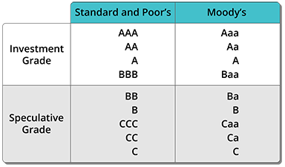
- Purchasing Power Risk (Inflation Risk)
- Purchasing Power Risk: The risk that inflation will lower the value of bond interest payments and principal repayment, thereby forcing prices to fall. Another name for purchasing power risk is inflation risk.
- Marketability Risk
- Marketability Risk: The risk that the security will be difficult to sell. Many factors affect marketability: the issue's size, the number of traders in the market, etc.
- Liquidity Risk
- Liquidity Risk: The risk that the security can only be sold by incurring large transaction costs. Generally, short-term high quality issues are liquid; the longer the term and lower the quality, the lesser the liquidity.
- Legislative Risk (Regulatory Risk)
- Legislative Risk: The risk that new laws reduce the value of a security, such as a change in the tax laws increasing tax rates on interest received from debt investments. Another name for legislative risk is regulatory risk.
- Political Risk
- Political Risk: Unique to investments made in foreign countries, this is the risk that the foreign government will change the laws, devaluing the investment. The ultimate political risk occurs when a government is thrown over, and the new government repudiates the old debt. (Are you holding bonds issued by Iraq under Saddam Hussein?)
- Call Risk
- Call Risk: The risk that the bonds may be redeemed prior to maturity, forcing reinvestment of the proceeds at a lower interest rate. Call risk increases as interest rates fall in the market, since issuers are able to call in existing higher rate issues and refinance at lower current market rates.
- Reinvestment Risk
- Reinvestment Risk: The risk that, as payments are received from an investment, interest rates have fallen. When the funds are reinvested, the investor receives a lower yield.
- Opportunity Cost
- Opportunity Cost: The risk that the return on a chosen investment turns out to be lower than the return offered by other similar investments. Thus, the "opportunity cost" of the chosen investment is the "lost" incremental return offered by the other investments.

