Chapter One Notes

Introduction and Overview

Why study financial markets?
What would the U.S. be like without financial markets?

Financial Markets and the role of money - where net lenders interact with net borrowers.

Some terms:
Savers – those with excess funds
Borrowers – those in need of funds
Securities = stocks and bonds – claim to future income or assets
Stocks = ownership, share in profits and losses
Bonds = bond holders are creditors (lenders to) of the bond issuers.
Interest rates = the cost of money
Foreign exchange market = when entities (buyers and sellers) from different countries join together to make an exchange they need to use the sellers currencies. The foreign exchange market is where the buyers exchange their currency for the seller’s currency.
Value of the dollar

Financial Institutions
This is another course. We do very little with financial institutions credit unions, commercial banks, brokerages, etc. we look at the factors that effect all financial institutions.

Why study money and monetary policy?
Macroeconomic terms
Unemployment rates
https://fred.stlouisfed.org/series/UNRATE
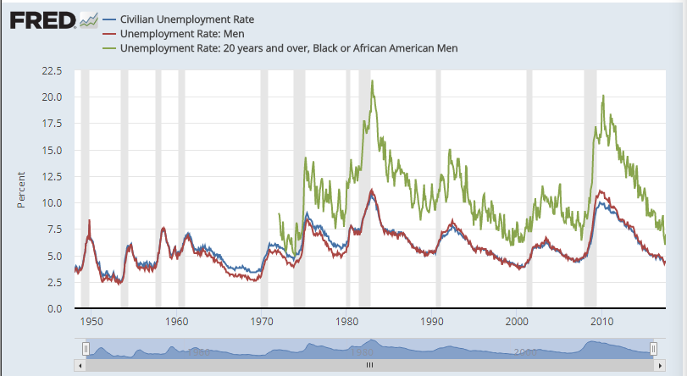

Labor force participation rate
https://fred.stlouisfed.org/series/LNS11300001

https://fred.stlouisfed.org/graph/?id=LNS11300002,LNS11300001

Inflation rates – what causes inflation?

http://inflationdata.com/Inflation/images/charts/Annual_Inflation/annual_inflation_chart.htm

http://www.bls.gov/cpi/

http://www.bls.gov/news.release/cpi.nr0.htm

GDP growth and Business Cycles
http://www.tradingeconomics.com/united-states/gdp-growth

Budget deficits and surpluses

http://www.davemanuel.com/charts2/surpluses_and_deficits_1940-2011.html

Business Cycles - volatility is not good for consumers, business, or government.
Why not? Consumers spend too much or too little
Businesses over-expanding or are unprepared for demand
Government revenues fluctuate state agencies and workers are affected (it seems to always be negatively)
National debt- accumulation of overspending by the federal government

Trade deficit – imports – exports
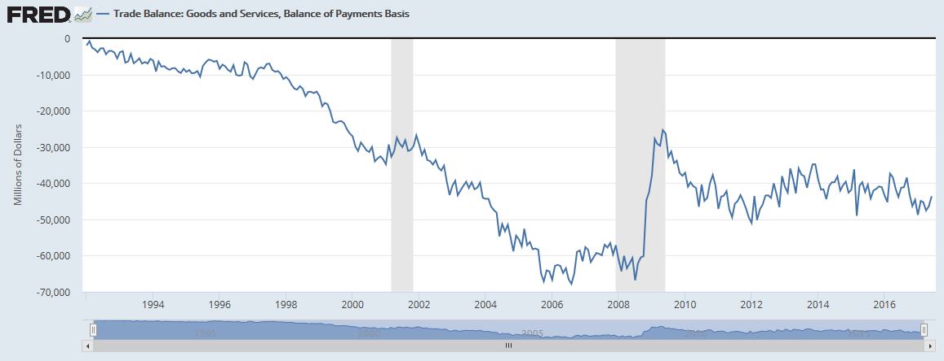

Monetary Policy if it works can reduce volatility of the business cycle.
http://www.federalreserve.gov/releases/h41/current/

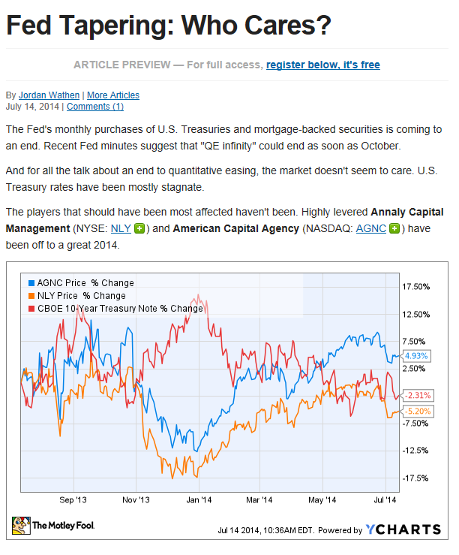
Monetary Theory explains how money can be used to impact the economy.

The conductor of monetary policy in the US is the Federal Reserve Bank.

Market Analysis
Money Market
The demand and supply of money
What is determined in the money market?
Interest rates – value of the dollar (or currency)
Quantity of money demanded and supplied
http://online.wsj.com/mdc/public/page/mdc_bonds.html

http://www.cnbc.com/id/102332516

Goods/product market
The aggregate demand for all goods and services, in a given economy in a given time period. The aggregate supply of all goods and services.
What is determined in the goods market?
Prices – inflation at an aggregate level
Output – GDP at an aggregate level
http://www.bea.gov/newsreleases/glance.htm

http://www.bea.gov/scb/index.htm#chartsandtables

Labor Market
The demand and supply of labor
What is determined in the labor market?
Wages hourly – $25.69

It was $23.01 in 2011.
Wages increased by 11.6 percent over the last five years. Prices increased by 9.1 percent over that time.
Over 11 million new jobs have been created, but real wages have only grown by .4 percent per year.
Unemployment fell from 9 to 5 percent during that time.
Part time employment for economic reasons- from 4.6 million in 2006 to 6.2 million in 2016. http://data.bls.gov/pdq/SurveyOutputServlet
http://www.bls.gov/news.release/empsit.t08.htm

The article mentions that the best workers stayed and were over paid. Now they are paid
appropriately.
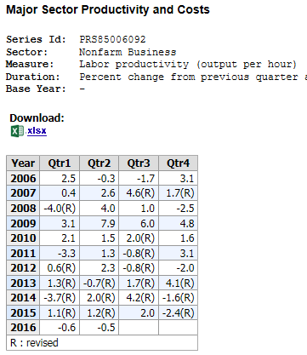

Employment -- unemployment 4.3 percent
Labor force = 160.5 million
Employed = 153.5 million
Unemployed = 7.7 million

How has the labor market impacted the goods market?
How has the goods market impacted the labor market?
http://data.bls.gov/timeseries/LNS14000000

Housing Market (overlaps with the goods market) approximately 33 percent of consumer spending is on housing. (17.6 percent of the gdp)

http://us.spindices.com/indices/real-estate/sp-case-shiller-20-city-composite-home-price-index

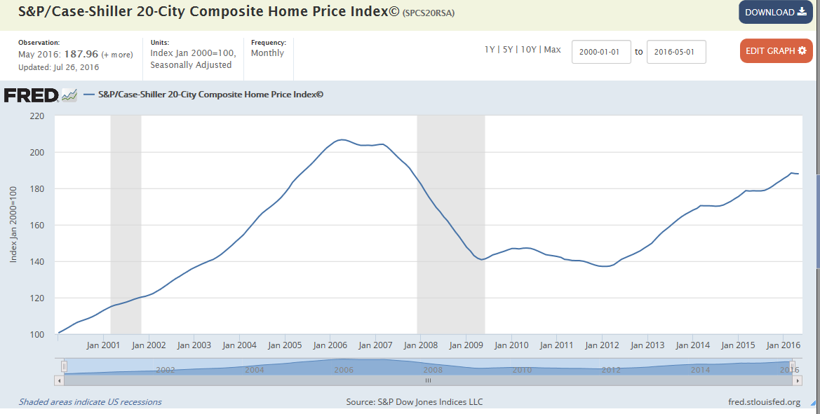

The demand and supply of houses.
What is determined in the market for houses?
Housing prices https://www.census.gov/const/uspriceann.pdf
http://www.economist.com/blogs/graphicdetail/2016/08/daily-chart-20

Quantity of homes sold
What is the relationship between the housing market and the money market?
What is the relationship between the housing market and the goods market?
How has the change in the housing market impacted the inflation?
What are banks currently doing in terms of lending?

What does it mean to be up-side-down on a house?
Why did banks overextend themselves?
How has the government bailed out banks?
What role has the Federal Reserve Bank played in the bank bailout?
How have the Fed actions impacted the value of the dollar?

Health care market (overlaps with the labor market, and product market)
The demand and supply of health care.
What is determined on the health market?
Price of health services and the quantity of health services.
How does health care impact the product market?
How does health care impact the money market?

Chapter 2 Notes

An Overview of the financial system

Debt Markets are more complex because of the variety of ways debt can be packaged.
- One of the most distinguishing characteristics of debt is its length of maturity of the loan.

Short-term debt is from 1 day to one year.
A lot of short debt has a maturity of 270 days or less. Any debt instrument that is issued for longer is subject to SEC registration (which can be expensive and time consuming)
Long-term debt is 2 – 30 years
Intermediate term is the near long term (1 - 10 years)
Car loans are intermediate term – new car rates 2.84 percent

Mortgages are long term – 3.7 percent
https://www.zillow.com/mortgage-rates/

Credit cards are short term (hopefully) 13 percent fixed, 15 percent variable http://www.bankrate.com/finance/credit-cards/rate-roundup.aspx

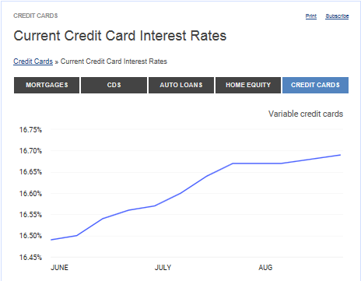

Money market instruments are short term in nature.
Capital market instruments are long term.

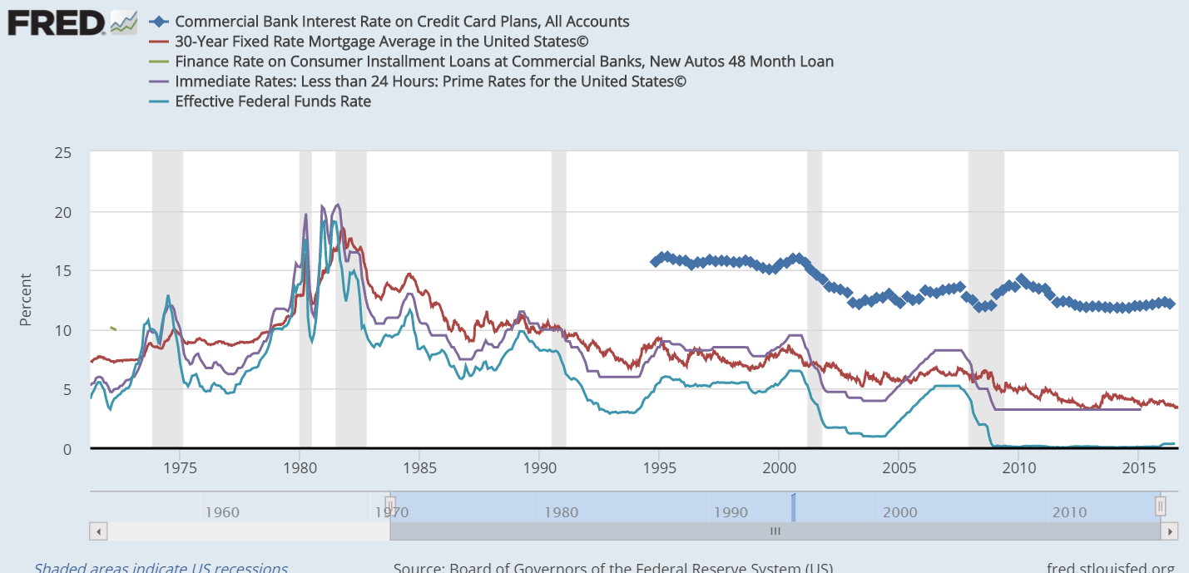

Rates of Return from an investment perspective

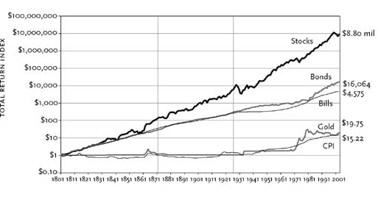

http://pages.stern.nyu.edu/~adamodar/New_Home_Page/datafile/histretSP.html
after 20 years after 30 years
$10,000
S&P 500 around 11.5 percent $88,206 $261,967
T-bill around 3.5 percent $19,898 $28,068
Ten year Treasury bond 5.2 percent $27,262 $45,758

Equities Market is mainly common stock. Common stock has no maturity date, it last as long as the company remains in business.

- Another distinguishing characteristic of a security is who issues it, or who it is bought from.

Primary market is a new issue. The buyer purchases a security and the money goes to the issuing firm (or underwriting firm) - Underwriters can act as brokers or dealers.
http://www.investopedia.com/study-guide/series-62/issuing-corporate-securities/types-underwriting-commitments/

Secondary market is a previously issued security. The security is traded from one investor to another. The issuing company typically is not involved in the transaction.
NYSE, NYSE Amex, NASDAQ are the main secondary markets

Investment bankers work in the primary market

Brokers - middle people liaisons between buyers and sellers. Never take ownership of the security.

Dealers take ownership and then sell (bid –buy price- and ask –sell price- prices)

Some money market instruments

Issuer or borrower security
Federal Government US Treasury Bills
Respectable Corporations Commercial Paper
Banks Certificate of Deposit, Federal Funds
Importing Firm Bankers Acceptance
Banks, Corporations Repurchase Agreements

What is a 'Repurchase Agreement - Repo'
A repurchase agreement (repo) is a form of short-term borrowing for dealers in government securities. The dealer sells the government securities to investors, usually on an overnight basis, and buys them back the following day.
For the party selling the security, and agreeing to repurchase it in the future, it is a repo; for the party on the other end of the transaction, buying the security and agreeing to sell in the future, it is a reverse repurchase agreement.

What is a 'Banker's Acceptance - BA'
A banker's acceptance (BA) is a short-term debt instrument issued by a firm that is guaranteed by a commercial bank. Banker's acceptances are issued by firms as part of a commercial transaction. These instruments are similar to T-Bills and are frequently used in money market funds. Banker's acceptances are traded at a discount fromface value on the secondary market, which can be an advantage because the banker's acceptance does not need to be held until maturity. Banker's acceptances are regularly used financial instruments in international trade.

Capital Market Instruments

Issuer security
Corporations stocks
Consumers mortgages
Corporations corporate bonds
US Government Treasury Notes and Treasury Bonds
State and Local Governments municipal bonds

Mutual Funds.

Potential Topics:
Tappering
QE
Unemployment
Job Creation
Elections
National Debt
Monetizing the Debt
Who are the uninsured?
Inflation- Gold
Mortgage backed Securities
Banks lending trends

Winthrop University
College of Business Administration

Money and Banking Dr. Pantuosco
Econ 335

MONEY NOTES
Is money the root of all evil?
Is the lack of money the root of all evil?

Money is anything that is generally accepted as a means of final payment.

Money characteristics
Medium of exchange – use it to buy things
store of value - consumption decisions over a time horizon
unit of account – like pounds, inches… it measures value

Things that have been used as money.

Life without money.
A barter system
A cashless society

What problems would exist if society did not have cash?
freedom
dependency on electricity
dependency on credit
every move can be traced
white collar crime

What would be the benefits of a cashless society?
Illegal activity would be easier to monitor
Drugs
Gambling
Other organized crime would suffer
theft

Monetary aggregates
M1, M2, M3, L

Money moved from M1 to M2 does nothing to the economy, but it decreases M1.

