Principles of Macroeconomics
Outline and Assignment
Unemployment and Employment

Calculating the unemployment rate
CNIP = civilian non-institutionalized population
CNIP = Population - military - institutionalized - under 16 years old
CNIP = employed + unemployed + out of the labor force
LF (labor force) = employed + unemployed
Unemployment Rate = unemployed / labor force

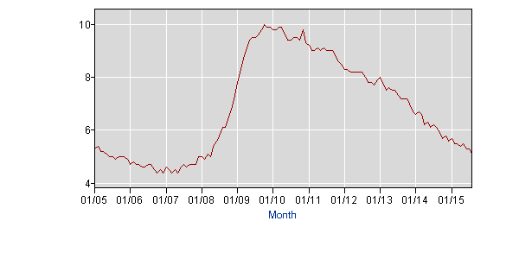

To be unemployed one must be (1) not working
(2) able to work
(3) in the CNIP
(4) actively seeking employment.

1. What are some of the social problems of unemployment?
How does being unemployed affect individuals?

How does being unemployed affect society?

Employment levels are recovering.
Series Id: CES0000000001
Seasonally Adjusted
Super Sector: Total nonfarm
Industry: Total nonfarm
NAICS Code: -
Data Type: ALL EMPLOYEES, THOUSANDS

Download:

Year | Jan | Feb | Mar | Apr | May | Jun | Jul | Aug | Sep | Oct | Nov | Dec
2005 | 132752 | 132991 | 133126 | 133489 | 133665 | 133908 | 134283 | 134479 | 134545 | 134629 | 134966 | 135124
2006 | 135401 | 135716 | 135997 | 136179 | 136203 | 136280 | 136486 | 136671 | 136827 | 136830 | 137039 | 137211
2007 | 137448 | 137536 | 137724 | 137802 | 137947 | 138018 | 137984 | 137967 | 138053 | 138136 | 138253 | 138350
2008 | 138365 | 138278 | 138199 | 137986 | 137803 | 137631 | 137421 | 137162 | 136710 | 136234 | 135469 | 134773
2009 | 133977 | 133274 | 132450 | 131766 | 131411 | 130944 | 130619 | 130402 | 130175 | 129974 | 129968 | 129685
2010 | 129717 | 129649 | 129810 | 130057 | 130575 | 130445 | 130381 | 130342 | 130293 | 130541 | 130662 | 130751
2011 | 130826 | 130993 | 131199 | 131520 | 131623 | 131808 | 131925 | 132053 | 132276 | 132459 | 132605 | 132831
2012 | 133211 | 133458 | 133674 | 133761 | 133874 | 133909 | 134086 | 134274 | 134418 | 134631 | 134795 | 135088
2013 | 135293 | 135607 | 135722 | 135909 | 136128 | 136255 | 136419 | 136675 | 136825 | 137050 | 137367 | 137476
2014 | 137642 | 137830 | 138055 | 138385 | 138621 | 138907 | 139156 | 139369 | 139619 | 139840 | 140263 | 140592
2015 | 140793 | 141059 | 141178 | 141365 | 141625 | 141870 | 142115(P) | 142288(P)
P : preliminary

- tools

The demise of the construction industry since July 2006.

Series Id: CES2000000001
Seasonally Adjusted
Super Sector: Construction
Industry: Construction
NAICS Code: 23
Data Type: ALL EMPLOYEES, THOUSANDS
Year | Jan | Feb | Mar | Apr | May | Jun | Jul | Aug | Sep | Oct | Nov | Dec
2001 | 6824 | 6841 | 6862 | 6844 | 6849 | 6840 | 6845 | 6827 | 6813 | 6804 | 6784 | 6785
2002 | 6775 | 6766 | 6755 | 6710 | 6684 | 6701 | 6688 | 6701 | 6702 | 6689 | 6713 | 6700
2003 | 6704 | 6667 | 6654 | 6689 | 6706 | 6723 | 6735 | 6760 | 6783 | 6784 | 6796 | 6827
2004 | 6848 | 6838 | 6887 | 6901 | 6948 | 6962 | 6977 | 7003 | 7029 | 7077 | 7091 | 7117
2005 | 7095 | 7153 | 7181 | 7266 | 7294 | 7333 | 7353 | 7394 | 7415 | 7460 | 7524 | 7533
2006 | 7601 | 7664 | 7689 | 7726 | 7713 | 7699 | 7712 | 7720 | 7718 | 7682 | 7666 | 7685
2007 | 7725 | 7626 | 7706 | 7686 | 7673 | 7687 | 7660 | 7610 | 7577 | 7565 | 7523 | 7490
2008 | 7476 | 7453 | 7406 | 7327 | 7274 | 7213 | 7160 | 7114 | 7044 | 6967 | 6813 | 6701
2009 | 6567 | 6446 | 6291 | 6154 | 6100 | 6010 | 5932 | 5855 | 5787 | 5716 | 5696 | 5654
2010 | 5580 | 5500 | 5537 | 5553 | 5520 | 5516 | 5508 | 5524 | 5501 | 5508 | 5506 | 5467
2011 | 5432 | 5458 | 5476 | 5492 | 5516 | 5527 | 5547 | 5552 | 5588 | 5585 | 5588 | 5612
2012 | 5629 | 5629 | 5628 | 5627 | 5608 | 5623 | 5632 | 5641 | 5649 | 5668 | 5684 | 5724
2013 | 5746 | 5798 | 5815 | 5813 | 5833 | 5856 | 5854 | 5866 | 5893 | 5918 | 5953 | 5937
2014 | 6006 | 6032 | 6062 | 6103 | 6114 | 6121 | 6152 | 6169 | 6191 | 6201 | 6231 | 6275
2015 | 6316 | 6347 | 6335 | 6365 | 6377 | 6378 | 6385(P) | 6388(P)
P : preliminary

Series Id: CES2000000001
Seasonally Adjusted
Super Sector: Construction
Industry: Construction
NAICS Code: 23
Data Type: ALL EMPLOYEES, THOUSANDS
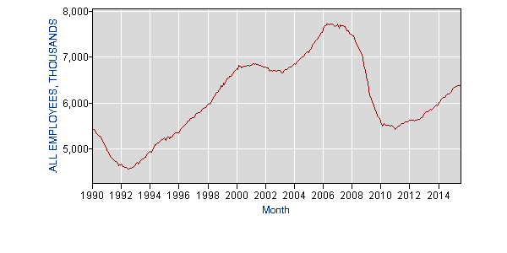

Manufacturing employment has been falling for decades
Series Id: CES3000000001
Seasonally Adjusted
Super Sector: Manufacturing
Industry: Manufacturing
NAICS Code: -
Data Type: ALL EMPLOYEES, THOUSANDS
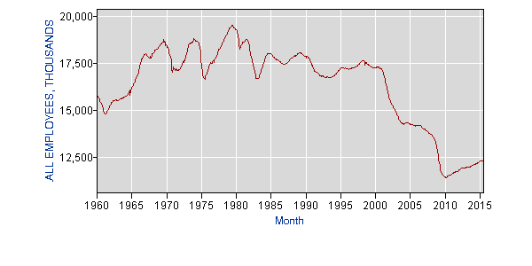

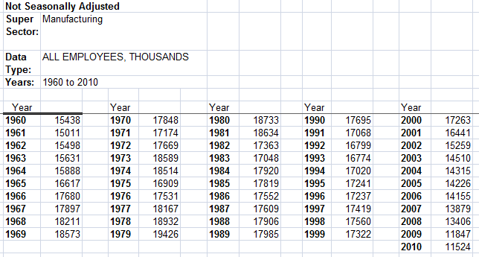

2. How have some of the recent trends affected the labor market?
Where have all of the men gone?
http://www.bls.gov/cps/cpsaat12.htm 2012 data men vs women employed

The decline of unions
Changes in the minimum wage

http://www.nbcnewyork.com/news/local/New-York-State-New-Minimum-Wage-15-Dollars-Hour-First-State-326456581.html

http://fortune.com/2015/07/30/1223726-15-hour-minimum-wage-workers-fast-food/

http://seattle.eater.com/2015/8/13/9143329/is-the-seattle-minimum-wage-law-as-bad-for-restaurants-as-the

Extension of unemployment insurance
The housing market recovery
The recent recession
US corporate taxes

http://taxfoundation.org/blog/us-has-highest-corporate-income-tax-rate-oecd

The Overworked American

http://20somethingfinance.com/american-hours-worked-productivity-vacation/

Productivity changes

http://www.tradingeconomics.com/united-states/productivity

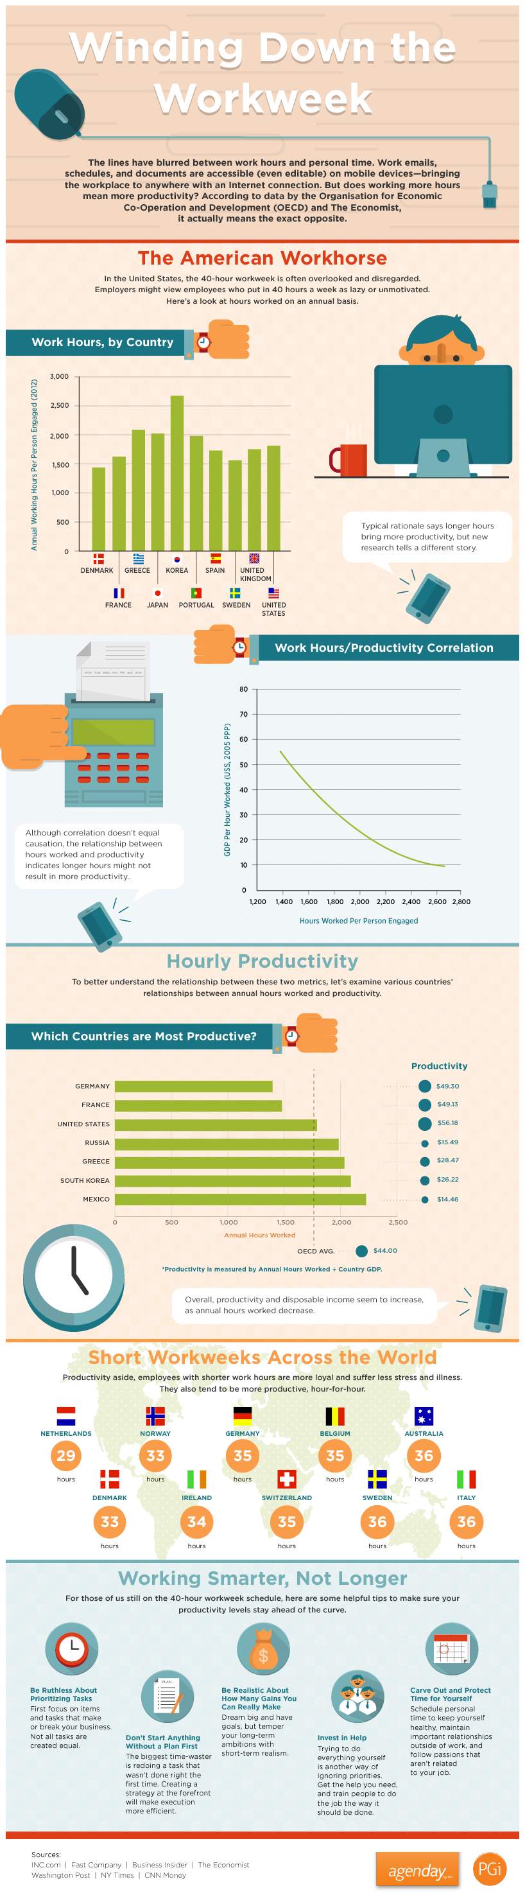

Technology changes

3. Who demands labor?

4. Who supplies labor?

5. What are the types of unemployment? Briefly explain the below types.
Frictional
Seasonal
Cyclical
Structural

6. What are the measurement problems with unemployment? Briefly explain why the items listed below cause measurement problems for the unemployment rate.
Part-time workers
Moonlighters
Underemployed
Liars
Discouraged Workers

7. What is the labor force participation rate? Labor force / cnip

http://www.bls.gov/emp/ep_table_303.htm labor force particpation men vs women 1990
find five interesting facts/trends in this table
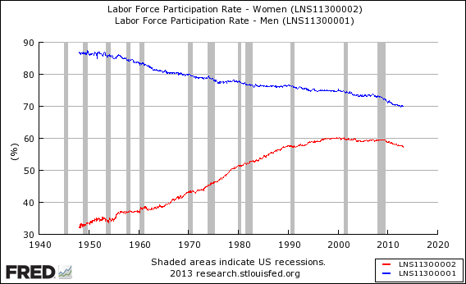

8. What are the recent trends in labor force participation?

Labor Force Statistics from the Current Population Survey

Series Id: LNS11300000
Seasonally Adjusted
Series title: (Seas) Labor Force Participation Rate
Labor force status: Civilian labor force participation rate
Type of data: Percent or rate
Age: 16 years and over
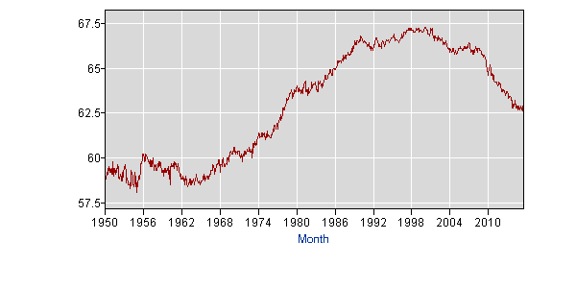

9. What factors cause unemployment rates to change?

10. How is the unemployment rates calculated?
If population = 1400
Institutionalized = 75
Employed = 800
Out of the labor force = 200
Military = 100
Under 16 = 50

a. What is the unemployment rate?
b. What is the labor force participation rate?

Assignment: These two pages serve as a general outline for the unemployment section of this course. There are a number of questions asked in this section (10 to be exact) that you are expected to answer. On a separate sheet type the questions and your answers to those questions. Written answers will not be accepted. After this assignment is turned in grade and returned, it will serve as an organized study guide for your upcoming exam.

