Winthrop University
College of Business Administration

Notes on the National Debt Dr. Pantuosco

The National Debt is the sum of all over spending by the government. This includes budget spending and off-budget spending.

http://www.usdebtclock.org/
http://demonocracy.info/infographics/usa/us_debt/us_debt.html visual!

Who does the government owe the money to? 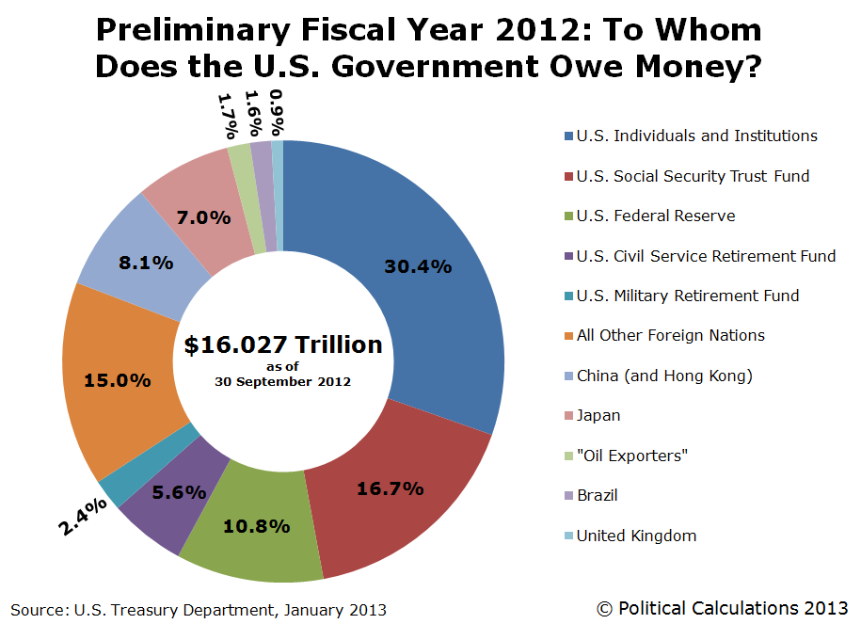

Major Owners
Foreigners
http://www.treasury.gov/resource-center/data-chart-center/tic/Documents/mfh.txt

Owned by Federal Reserve Bank
http://www.federalreserve.gov/releases/h41/current/h41.htm
Anyone who borrows money has an obligation to repay their creditors (the lender).

In its latest monthly report, the Federal Reserve said that as of Dec 11, 2013 it owned $2.178 trillion in U.S. Treasury securities. That was more than double the $812 billion in U.S. Treasury securities the Fed said it owned as of Sept. 29, 2010.

Percent held by government 31 percent
http://www.treasurydirect.gov/govt/charts/principal/principal_govpub.htm

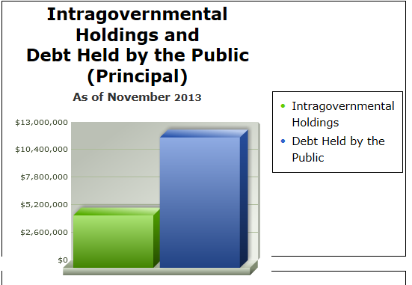

People wait in line to lend the US Government money.

How is the money moved from these groups to the US Government?

These groups give money to the government, and the government gives the groups US Treasury Bonds. These bonds are IOUs from the government.

Where does the money go?

The government spends the money. When they need money to pay their creditors (the people who lend them money) they borrow money from one group and give the money to another. It’s like you owing using one credit card to pay off another credit card.

The US Treasury Trust Fund
The workers in this country pay over $600 in social security taxes. Most of this money, say $550 goes to the current recipients of social security. The excess $50 goes to the US Treasury Department. They give this money to Congress to spend. Then, the US Treasury Dept issues a $50 bond (IOU) to the US Treasury Trust Fund. So the Trust fund holds this bond.
There is over $2.7 trillion in this Trust Fund. Picture that stack of IOUs.

So what’s the problem? 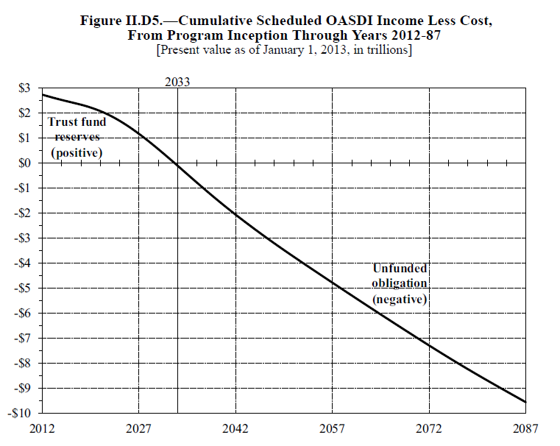

When the Baby Boomers retire, the contributions will decrease and the payouts will increase. So there will be no more money going into the Trust Fund.

In fact, the government will need to pay some of their IOUs to cover the amount owed to the Social Security recipients.

Where will the money come from?

- The government will have to borrow money from some group to pay the recipients. Who will they borrow it from? Savers. Who saves? The working people.

- The government can increase taxes to get money. Who will pay the taxes? The working people.

- The government can reduce benefits, restrict benefits for higher income people (the people who paid the most into the system), or increase the eligibility age.

At what age can I retire and be eligible for benefits?
You have several options about when you may retire and be eligible for benefits:
- Full Retirement:
The age at which you can retire and get full Social Security retirement benefits ranges from 65 to 67, depending on the year in which you were born. People born before 1938 can retire at age 65. For people born in 1938 or later, the full retirement age gradually increases, until it reaches age 67 for people born after 1959.
You can continue working while you get full retirement benefits. As long as you have reached full retirement age, the income you earn after retirement will not reduce your benefits.

http://www.massresources.org/social-security-eligibility.html#whatage
http://www.socialsecurity.gov/retire2/agereduction.htm

Debt Ceiling
http://nationalpriorities.org/budget-basics/federal-budget-101/borrowing-and-federal-debt/

The Debt Ceiling
The debt ceiling is the limit set by Congress on the total amount that the U.S. Treasury can borrow. If the level of federal debt hits the debt ceiling, the government cannot borrow additional funds without Congress raising the debt ceiling.
Congress has the legal authority to raise the debt ceiling as needed. Doing so does not authorize new spending, but rather allows the Treasury to pay the bills for spending that has already been authorized by Congress.

Debt Ceiling Debate in 2013
As of October 2013, the federal debt stands at $16.699 trillion – exactly the level of the current debt ceiling. The Treasury is expected to run out of cash by the end of October. Without congressional action, the Treasury will be unable to pay all of its bills, likely triggering a default on its debt payments and lapsed payments to Social Security beneficiaries and other programs. A debt default by the U.S. government is expected to have a negative impact on the global economy with the potential to raise interest rates that American consumers pay for home and car loans.

Why Is There a Debt Ceiling?
The debt ceiling evolved from restrictions that Congress placed on federal debt nearly from the founding of the country. Legislation that laid the groundwork for the current debt ceiling was passed in 1917, and the first overall debt ceiling was passed in 1939. Since then, the debt ceiling has been raised more than 100 times, including more than a dozen times since 2000.
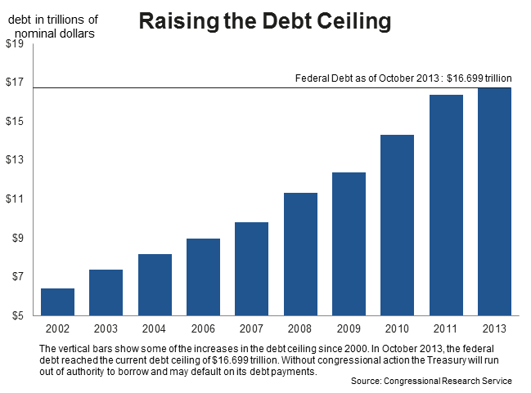

In many years, the decision by Congress to raise the debt ceiling has not been controversial. Since 2011, however, due to political partisanship as well as debates about the size of the federal budget and deficit spending, the debt ceiling has become a highly contentious issue. Some members of Congress have pledged to allow the federal government to default on its debt payments rather than raise the debt ceiling.

What is this surplus?

What is the solution?

