Winthrop University
College of Business Administration

Principles of Macroeconomics Dr. Pantuosco
GDP Assignment

2012 2013
Consumer Expenditures 850 910
Government Expenditures 240 270
Government Tax Receipts 250 260
Imports 150 110
Goods 120 80
Services 30 30
Exports 120 160
Goods 50 60
Services 70 100
Savings 100 100
Investment 200 190

1. What was the value of the GDP in 2012?

2. What was the GDP growth rate in 2013?

3. In 2013, what stage of the business cycle was the economy in?

4. In 2012, was there a government spending surplus or deficit? What was the amount?

5. Was there a trade surplus or deficit in 2013? What was the amount?

6. Was there a merchandise trade deficit, or surplus in 2013? What was the amount?

Use the information below to answer questions 7 through 11.
GDP data
Real GDP Nominal GDP Deflator
2008 12900 .80
2009 13100 .90
2010 13000 13000
2011 13200 1.06

7. Fill in the table.
8. Which year is the base year?
9. Does there appear to have been a recession? If so, what year?
10. Why does the economy have to grow by 3 percent to stay even?
11. Interpret the deflator value for 2009.
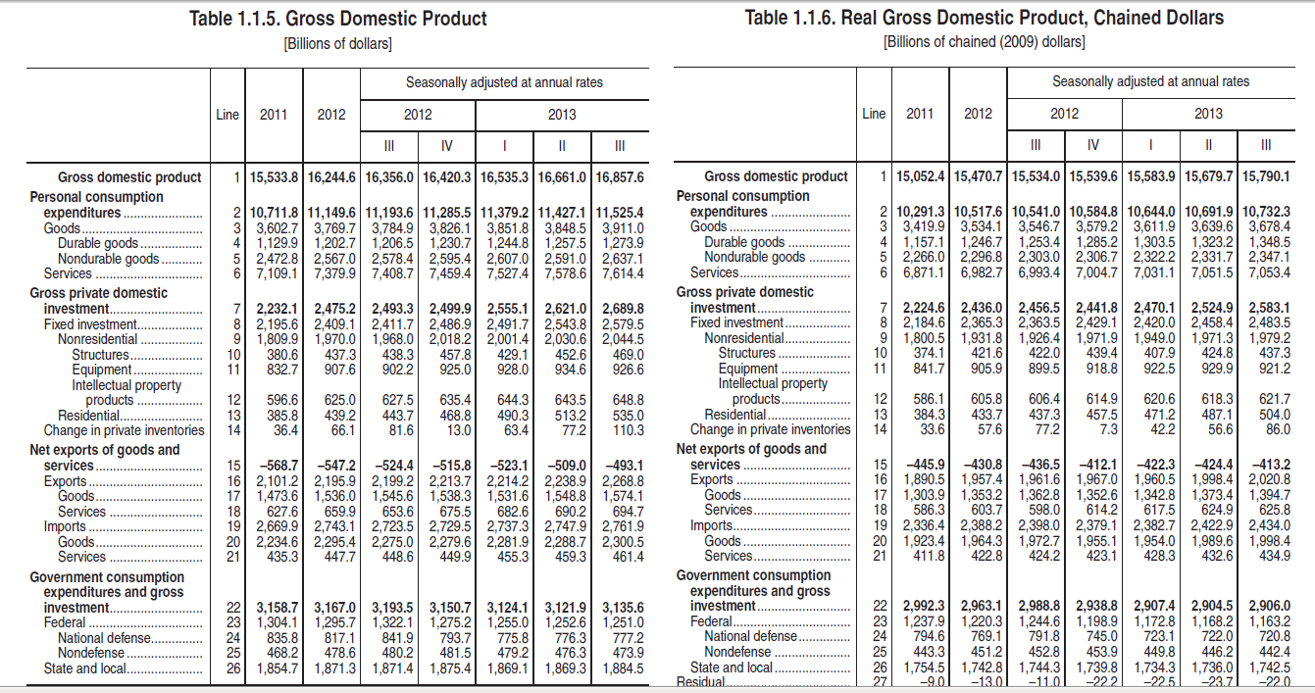

7. What was the real GDP in 2012?

8. What was the nominal GDP in the third quarter of 2013?

9. What was the amount of nominal government spending in 2013?

10. What was the amount of the trade deficit in 2012?

11. What percent of overall spending is done by consumers in the third quarter of 2013?

12. What is the GDP deflator in 2012?



