Outline of GDP Notes

Gross Domestic Product is the market value of all final goods and services produced within a given country in a given time period.

Real versus Nominal GDP

Why use real GDP to measure economic activity?

Imagine a world with only 2 goods
bread and wine

2014
loaves price
Bread 1000 1.00 = 1000

bottles
Wine 50 2.00 = 100

Nominal GDP in 2014 = 1100
Since 2014 is the base year
Real GDP in 2014 = 1100

2015
Bread 500 x 2 = 1000
Wine 50 x 4 = 200
Nominal GDP in 2015 1200

It appears that since nominal GDP rose from 1100 to 1200 that the economy performed better in 2015 but the increase was due to a price increase not an increase in the production of goods. When prices are held constant there is a different story.

Use 2014 prices to compare output in 2014 to output in 2015.
2015 2014 prices
Bread 500 x 1 = 500
Wine 50 x 2 = 100
Real GDP in 2013 600

From 2014 to 2015 two things changed Price and Quantity; the price indices hold Price constant so we can evaluate changes in Quantity.

To focus in on price changes from year to year, keep goods and services the same and use the prices from the respective years.

price of all goods and services use 2014 goods and services
Price Index = in a given year 2015 prices
prices of the same goods in use 2014 good and services
the base year 2014 prices

GDP deflator = nominal GDP_{t}/ real GDP_{t}
This number represents an overall level of prices for all goods and services produced in the US. For example, the
The Business Cycle – the change in real GDP over time (the goal is for GDP to grow by 3 percent)
Expansions
Growth Recessions
Recessions

business cycle ≈ alternating periods of economic growth and contraction

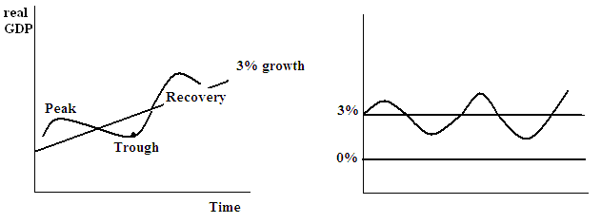

Recession ≈ growth of < 0% for 2 consecutive quarters
Growth recession 0 < growth < 3
Expansion period growth > 3

An example of a recession

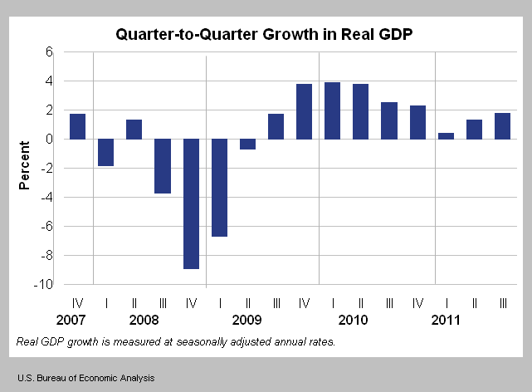

In 2008 and the first two quarters of 2009, it is clear for the graph that the economy is in a recession.

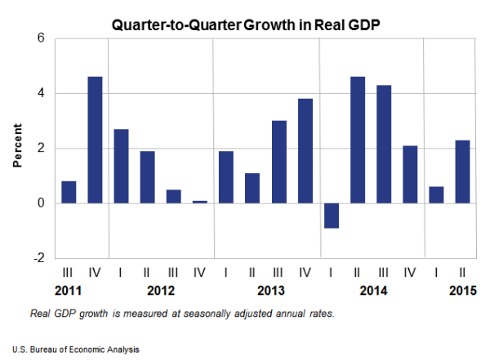

The US economy has been growing at a slow pace 15 out of the last 16 quarters.

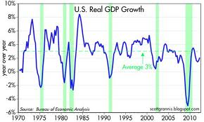

Recessions occur at the dips. They are marked in green.

What is the purpose for measuring the GDP
1. Comparisons over time how do we compare to previous generations

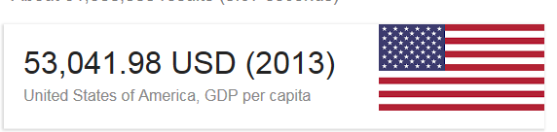
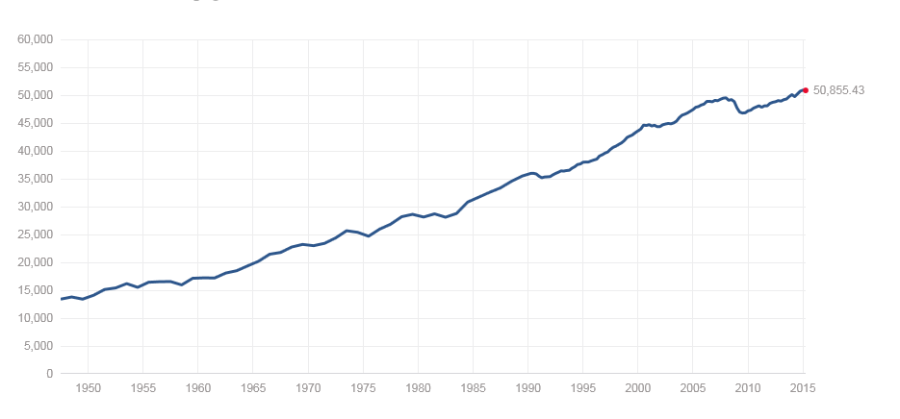

The other day I came across a survey reporting that the average American man owns 12 pairs of shoes, while the average American woman owns a whopping 27 pairs. That would make the national average about 19 pairs per person. Wow! Really?

http://www.census.gov/const/C25Ann/sftotalmedavgsqft.pdf The average house size since 1973 from 1525 to 2169 square feet. The average American house size has more than doubled since the 1950s, despite the fact that the average family size has steadily dropped. In the 1950s, the average house measured about 1,000 square feet (about 90 square meters) and housed three or four people. Since then, the average house size has grown to about 2,500 square feet (about 230 square meters), and the average house is home to two or three people.

http://ushfc.org/about/#fancy-form-delay
After all, the average American adult buys a meal or snack from a restaurant 5.8 times a week, and more than 30 percent of children eat fast food on any given day.

2. Comparisons across countries how do we currently compare to other countries
GDP per capita
Purchasing Power Parity

http://www.measuringworth.org/datasets/usgdp/result.php

http://www.indexmundi.com/g/r.aspx?c=mr&v=67

How is GDP measured? There are two approaches, an income approach and an expenditure approach. The expenditure approach is more commonly referenced.

Measuring GDP
Expenditure Approach
C+I+G+X-M = GDP open economy
C+I+G = GDP closed economy

Survey of Current Business page D-11 Table 1.5.6
http://www.bea.gov/scb/index.htm

Consumption
Investment
Government Spending
Trade (Exports – Imports)
Trade Deficit, Trade Surplus, Balance of Trade
Balancing the Budget (Government Spending – Tax Revenue)
Government Budget Deficit, Government Budget Surplus, Balanced Budget

Income Approach
C+S+T+f = GDP open economy
C+S+T = GDP closed economy

Measurement Problems
Non-market activities
Inventories
Illegal activities
Double Counting
International Measurement dealing with Multinational Firms
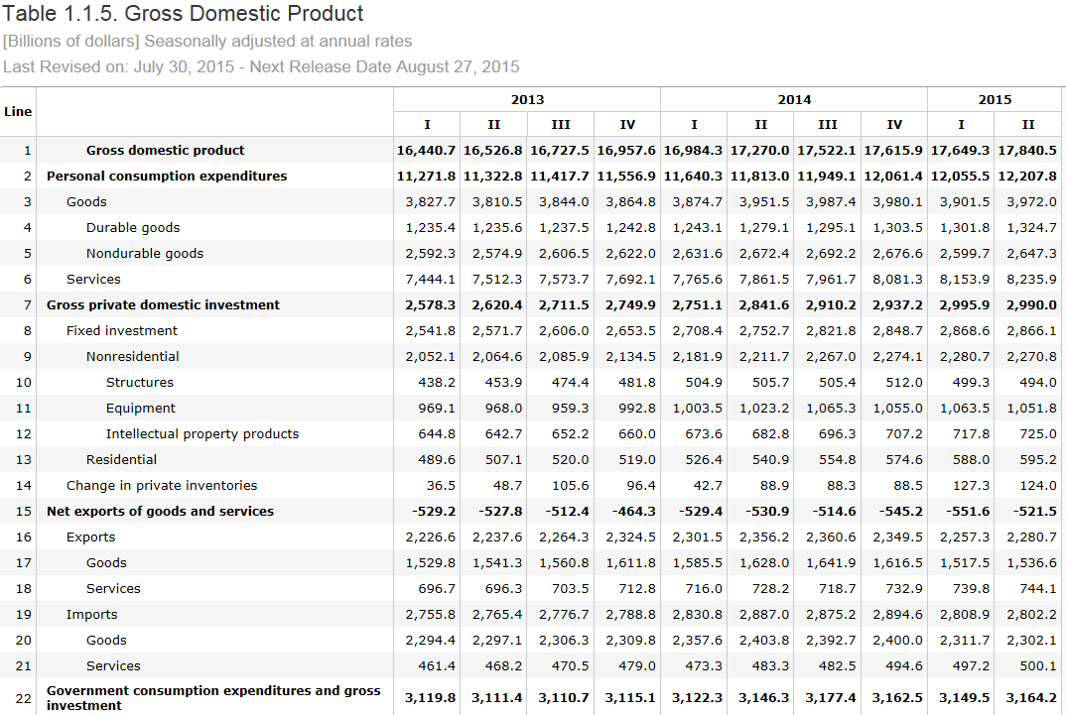

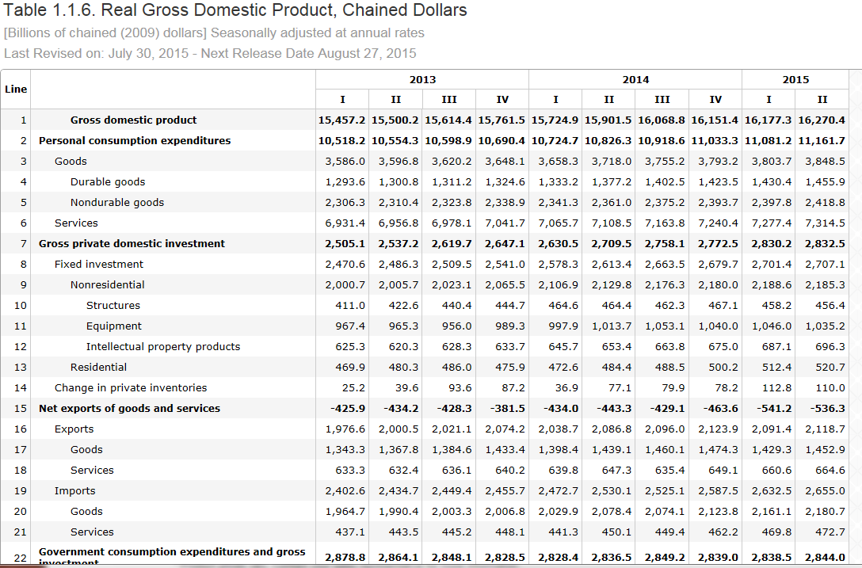
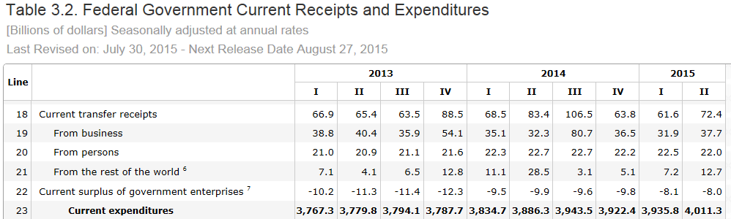
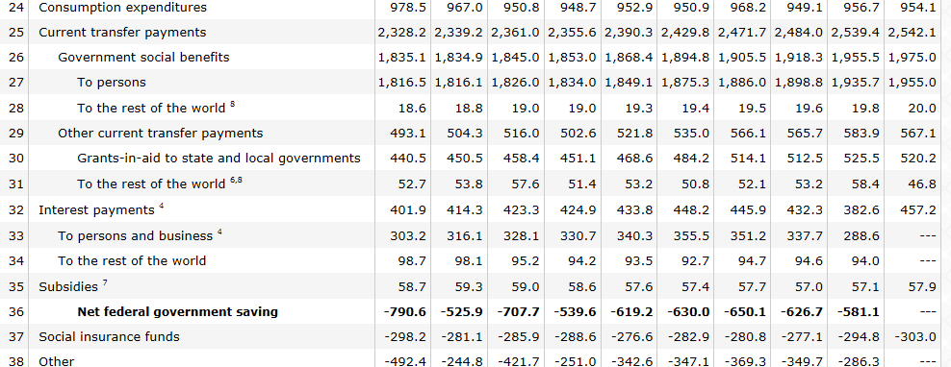

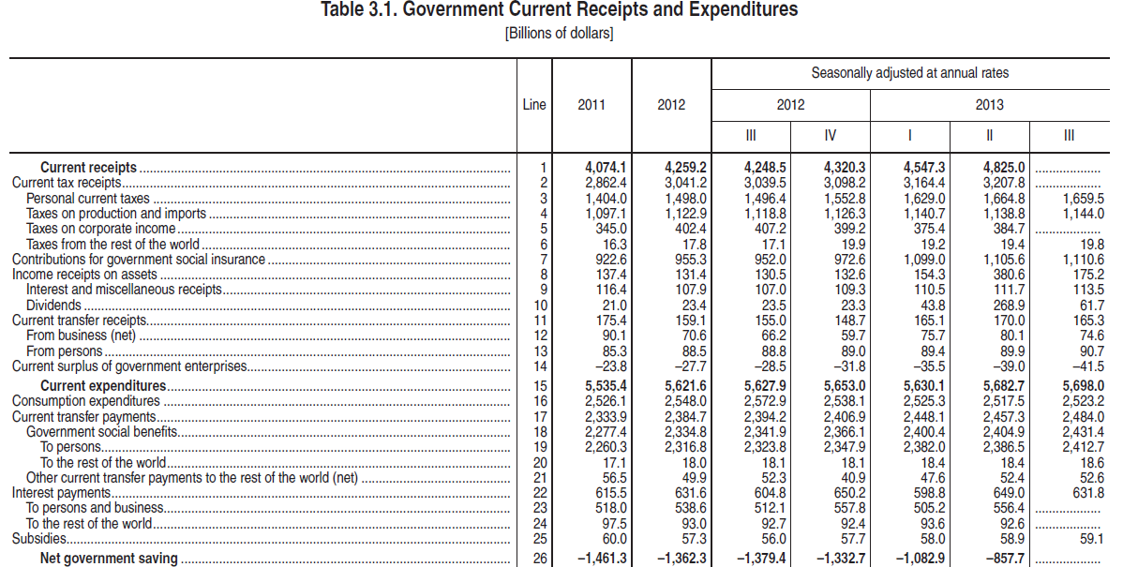

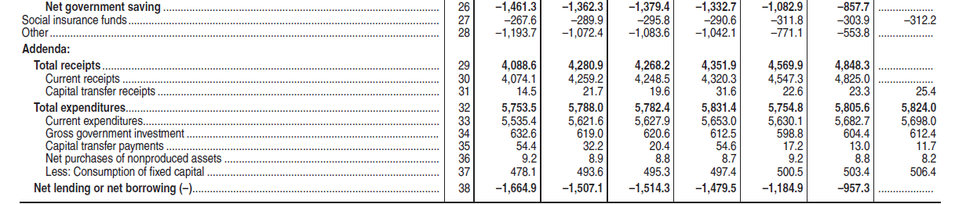

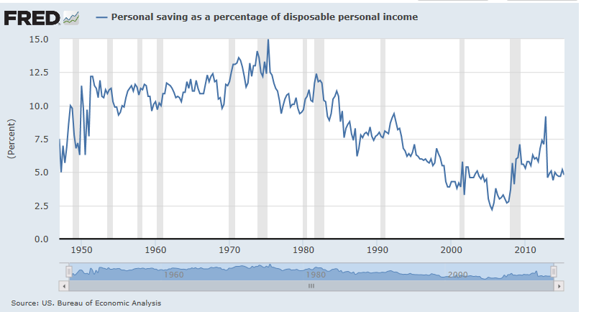

Trade notes Dr. Pantuosco

Trade
Exports versus Imports
Exports are goods and services produced domestically and sold internationally
Imports are goods and services produced abroad and sold domestically

Balance of Trade - when exports = imports
Trade deficit – when imports exceed exports
Trade surplus – when exports exceed imports

Is it better to import or export?

Current Trade Issues
Pros and Cons of trade

Imports per person

What factors affect trade?

The value of the dollar
If the dollar is strong, American dollars can buy more foreign goods, foreign currencies can not buy as much American goods. Therefore, if the value of the dollar increases imports rise and exports fall. What happens to GDP? Holding everything else constant, it falls.
If the value of the dollar is weak, exports, American dollars buy less foreign goods and services – imports drop. Foreign currencies increase in value, providing foreigners with the ability to purchase more American made goods –exports rise. Holding everything else constant, GDP rises.

What factors affect the value of the dollar? Demand and supply of dollars.

The GDP of other countries.
If a country’s income (GDP) rises, their demand for all goods, including foreign goods will rise. Or if a countries income (GDP) falls their demand for all goods will fall.

Relative GPD changes make a difference. If the US GDP is rising by more than one Canada’s GDP then Canadians will not spend as much on US goods, as US will spend on Canadian goods.

Trade Agreements
Governments can manipulate the amount of trade between countries by implementing trade policies. Free trade increases imports and exports.

Overall affect of trade on prices, wages, GDP, and productivity.

GENERAL INFORMATION
If exports increase, holding imports constant, GDP will rise.
If imports increase, holding exports constant, GDP will fall.

X increases and M increases, the change in GDP is uncertain

