http://mjperry.blogspot.com/2011/08/income-mobility-for-all-income-groups.html
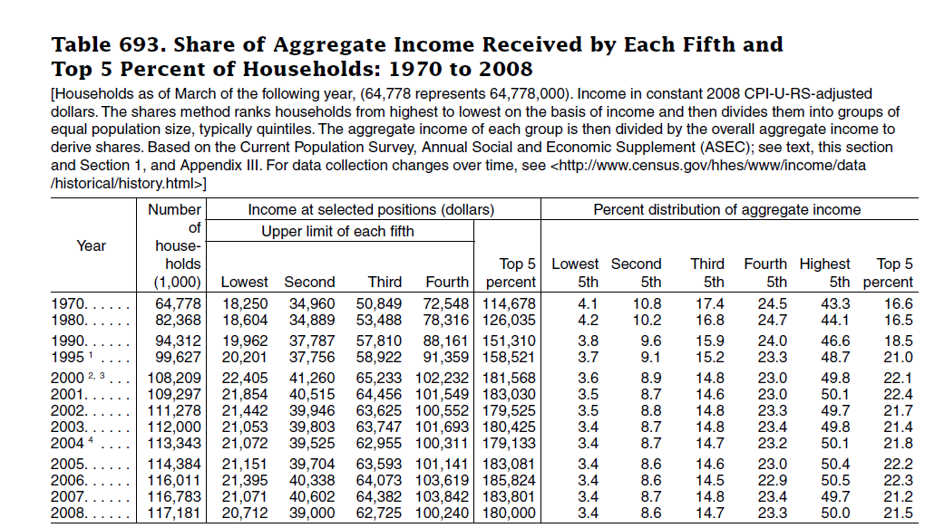

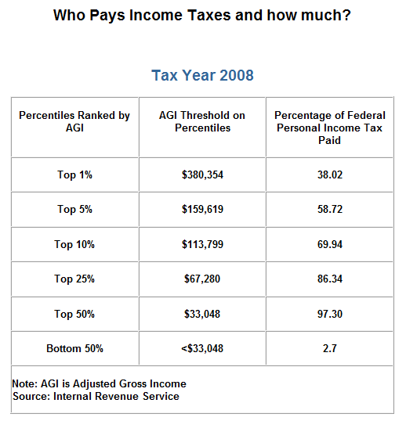
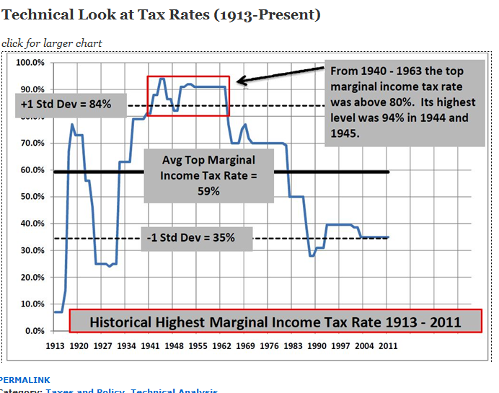

Taxes
Richest 400 Earn More, Pay Lower Tax Rate
Janet Novack, 01.29.09, 5:00 PM ET
Washington, DC -
WASHINGTON, D.C.--The 400 highest-earning taxpayers in the U.S. reported a record $105 billion in total adjusted gross income in 2006, but they paid just $18 billion in tax, new Internal Revenue Service figures show. That works out to an average federal income tax bite of 17%--the lowest rate paid by the richest 400 during the 15-year period covered by the IRS statistics. The average federal tax bite on the top 400 was 30% in 1995 and 23% in 2002.
The new numbers are sure to add fuel to the debate over whether the Bush-era rate cuts for the wealthy, now set to expire Dec. 31, 2010, should be ended or extended.
The current top rate on long-term capital gains is 15%, and the top rate on ordinary income such as interest and salary is 35%. President Barack Obama and congressional Democrats favor moving those rates back to their Clinton-era levels of 20% and 39.6%, although the perilous state of the economy seems likely to delay any rate hike until 2010 or 2011.
The top 400 earners in 2006 reported an average adjusted gross income of $263 million, up 23% from $214 million in 2005. Even adjusted for inflation, the 2006 number set a new high. Calculated in 1990 dollars, it was $68 million, up from $25 million in 1996. In 2006, the minimum income needed to make the top 400 was $111 million, also a record in both nominal and inflation-adjusted dollars.
The IRS report demonstrates how valuable the low capital gains rate has been to the richest of the rich. In 2006, the top 400 realized $66 billion, or 63% of all their income, in net capital gains.
By contrast, Americans overall reported less than 10% of their adjusted gross income as coming from capital gains. The richest 400 reported 1.3% of all adjusted gross income but booked 8.5% of all net capital gains.
The result: the top 5% of earners--those with an adjusted gross income of $153,542 or more--now pay a higher effective tax rate than the top 400.
In 2006, the top 5% paid an average of 21% of their adjusted gross income to Uncle Sam in income taxes. The top 1%, with an income of $388,806 or more, paid an average of 23%.
Social Security and Medicare taxes, which are insignificant to the richest 400, further raised the rate on the merely well paid. Indeed, investor Warren Buffett, the second-richest American, has decried the fact that he pays a lower percentage of his income in federal tax than do the folks who work for him in Berkshire Hathaway's home office.
The IRS points out that its 400 highest earners aren't the same folks from year to year. They also aren't the same individuals who appear on the net-worth based Forbes 400, although there is likely considerable overlap. (Making the Forbes 2006 list took a net worth of $1 billion.) IRS officials have acknowledged, however, that they picked the 400 number because of the Forbes list.

