Free Market Breakdowns

Free market decisions

Governments have to make decisions about the type of economic system they support. In the US, the underlying system is capitalism. Capitalism allows the interaction of consumers and businesses to determine the answer to the economic questions of what will be produced, how should goods and services be produced, who will produce the goods and services, and for whom will the goods and services be produced? The capitalistic/free market system can adapt to the changing needs of consumers, the technological advancements of businesses, and productivity enhancements of the work force.

But, there are situations when capitalism is flawed and the free market breaks down. Recently, this has occurred in the financial markets. “Greed is good” was a famous quote from Gordon Gecko in the movie Wall Street. This saying was generally believed to be true when one considers the underlying nuances of capitalism. But, the last few decades of manipulating the laws to expand one’s own net worth has bought the selfishness of capitalism into question. Is greed really good for our economy and the individual, or does greed lead to a series of market breakdowns, where economic agents search for loopholes to grow their own balance sheet at the expense of the general public and more specifically the tax payer?

The Free Market breaks down in the cases of monopolies, collusion, regulatory loopholes, public goods, externalities, and income disparities. In these circumstances, the government steps in to adjust market inequities. It can be argued that if it were not for the government to step in to address these breakdown areas, then capitalism would not have survived for the past 200 plus years in the US.

The government’s goal is to maximize the welfare of the general public. When the general public loses at the expense of an individual company, the government steps in and regulates the situation. The government looks out for the masses.

Another example of the government stepping in to help consumers is in the area of trade. Trade is the buying and selling of goods and services between countries. Trade is necessary because not all countries have the same resources. Therefore, trade allows countries with different resources to share with each, which allows their respective citizens to enjoy resources from two (or more) countries as opposed to one. Trade increases competition between companies that typically would not compete because they operate in different countries.

Take a look at the tables on the webpage below. You will be amazed with the amount of goods and services are exchanged between countries.

http://www.bea.gov/scb/pdf/2009/01%20January/0109_itaq_tables.pdf
http://www.bea.gov/iTable/iTable.cfm?reqid=62&step=6&isuri=1&6210=1&6200=45#reqid=62&step=7&isuri=1&6210=1&6200=3&6211=28

Here are some sample questions regarding trade.
What are exports?
What are imports?
What is a trade surplus?
What is a trade deficit?
Who is the US’s largest trading partner?
What country does the US have the largest trade deficit with?
Which countries do the US have trade surpluses?

How do we know the free market is working?
If the free market is working correctly then prices and quantities produced will be determined by the interaction of consumers and producers in the private market.

Holding everything else constant, when the free market is working this is what will happen….

On the demand side:
If consumers are not buying the product prices will fall and quantities produced will fall. Think about the market for black and white televisions, computer monitors with extended backs (wide not flat) or film.
If consumers are buying the product prices will rise and quantities produced will rise. Think about the market for houses or college.

On the supply side:
If it cost more for producers to make a product prices will rise and quantities produced will fall. Think about organic foods.
If it cost less for producers to make a product prices will fall and quantities produced will rise. Think about laptops.

If more companies enter into the market prices will fall and quantities produced will rise
If some companies leave the market then prices will rise and quantities produced will fall.

Free market breakdowns occur when the natural adjustments of supply and demand do not occur.
When something is blocking the market from operating efficiently the government should step in.

What are examples of the market operating inefficiently?
Monopolies – one seller of a good. This one seller has the ability to charge higher prices than if there were multiple sellers.

Collusion – when some sellers join together to act as one. These sellers have the ability to raise prices to consumers.

Public goods - are goods that if left up to the individuals they would be under produced. Some examples are national defense, roads, and education. These goods are important to society, but too expensive for one person to purchase.

https://www.nationalpriorities.org/budget-basics/federal-budget-101/spending/

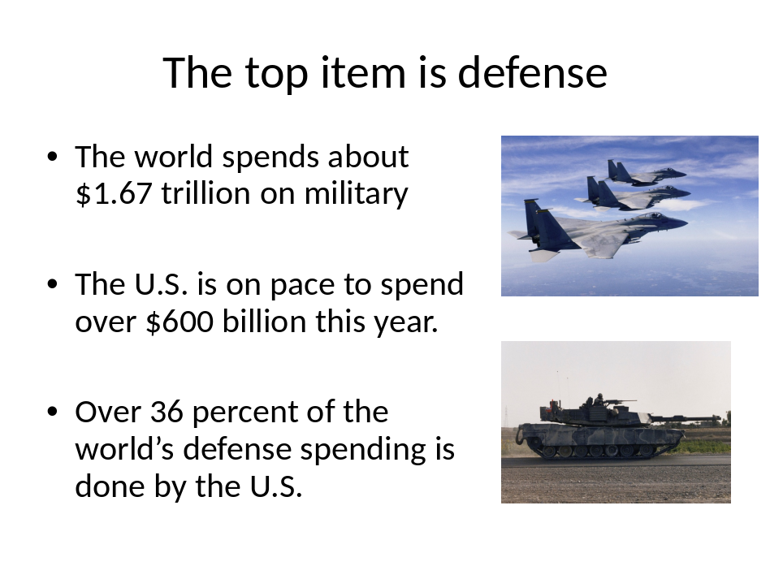

Income distribution – in the US the top wage earnings earn a high percent of the money. See sheet. The government believes without their assistant this problem would be even worse.

Percentiles Ranked by AGI | AGI Threshold on Percentiles | Percentage of Federal Personal Income Tax Paid
Top 1% | $343,049 | 36.73
Top 5% | $154,056 | 58.66
Top 10% | $112,124 | 70.47
Top 25% | $66,041 | 87.30
Top 50% | $32,396 | 97.75
Bottom 50% | <$32,396 | 2.25
Note: AGI is Adjusted Gross Income
Source: Internal Revenue Service

http://ntu.org/tax-basics/who-pays-income-taxes.html

Externalities .. are companies that produce a good and a by-product good. Sometimes the by-product good is bad for society. The government monitors the production of the by-product good by monitoring the production of the sellable good.

Negative externalities are by-products that harm society, such as pollution, noise, or traffic.
Negative externalities are regulated or taxed by the government.

Positive externalities are by-products that benefit society, such as education, increased property values, safety.

Positive externalities are subsidized or encouraged by the government.

Federal Regulation of financial markets
Junk Bonds
Dot Com Stocks
Credit default Swaps
What’s next?

Fiscal Policy – the use of government spending and taxes to fine tune and stabilize the economy. Congress approval rating 18 percent

Monetary Policy – the use of the money supply to fine tune the economy. Ben Bernanke’s approval rating 20 percent (most people do not know who he is).

US Federal, State, and Local

Year | % of overall spending that comes from the government
1902 | 7%
1960 | 29%
1970 | 32%
1980 | 34.4%
2000 | 33.4%
2008 | 36.6%
2011 40.2%
2017 36% $7 trillion estimate

During Economic Downturns the Government grows
 |  | 2000 | 2008
China |  | 20 | 22
Japan |  | 31.9 | 30.9
United Kingdom |  | 39.8 | 50
United States |  | 33.4 | 36.95
Europe |  | 47.6 | 55.7
At the beginning of the twentieth century, in the U.S., state, local, and federal governments spent seven percent of the national income, GDP.
By 2008, the state, local and federal government accounted for 37 percent of the total U.S. spending.

As you can see there are a lot of examples of government intervention in the United States.

Sometimes when the government gets involved society might be better off if the government is not involved – trash collection might be such an example. Private companies could handle the job of trash collection.

Sometimes the government is not involved enough and more involvement might be helpful to society. Police protection might be an example of a place where there could be more government.

