Free Market Breakdowns

Free market decisions

Governments have to make decisions about the type of economic system they support. In the US, the underlying system is capitalism. Capitalism allows the interaction of consumers and businesses to determine the answer to the economic questions of what will be produced, how should goods and services be produced, who will produce the goods and services, and for whom will the goods and services be produced? The capitalistic/free market system can adapt to the changing needs of consumers, the technological advancements of businesses, and productivity enhancements of the work force.

But, there are situations when capitalism is flawed and the free market breakdown. Recently, this has occurred in the financial markets. “Greed is good” was a famous quote from Gordon Gecko in the movie Wall Street. This saying was generally believed to be true when one considers the underlying nuances of capitalism. But, the last few decades of manipulating the laws to expand one’s own net worth has bought the selfishness of capitalism into question. Is greed really good for our economy and the individual, or does greed lead to a series of market breakdowns, where economic agents search for loopholes to grow their own balance sheet at the expense of the general public and more specifically the tax payer?

The Free Market break down is the cases monopolies, collusion, regulatory loopholes, public goods, externalities, and income disparities. In these circumstances, the government steps in to adjust market inequities.

The government’s goal is to maximize the welfare of the general public. When the general public loses at the expense of an individual company, the government steps in and regulates the situation. The government looks out for the masses.

Another example of the government stepping in to help consumers is in the area of trade. Trade is the buying and selling of goods and services between countries. Trade is necessary because not all countries share the same resources. Therefore, trade allows countries with different resources to share with each, which allows their respective citizens to enjoy resources from two (or more) countries as opposed to one. Trade increases competition between companies that typically would not compete because they operate in different countries.

Take a look at the tables on the webpage below. You will be amazed with the amount of goods and services that are exchanged between countries.

http://www.bea.gov/scb/pdf/2009/01%20January/0109_itaq_tables.pdf

Here are some sample questions regarding trade.
What is a trade surplus?
What is a trade deficit?
Who is the US’s largest trading partner?
What country does the US have the largest trade deficit with?
Which countries do the US have trade surpluses?

How do we know the free market is working?
If the free market is working well then prices and quantities produced will be determined by the interaction of consumers and producers.

When the free market is working this is what will happen….

On the demand side:
If consumers are not buying the product prices will and quantities produced will .
If consumers are buying the product prices will and quantities produced will .

On the supply side:
If it cost more for producers to make a product prices will and quantities produced will .
If it cost less for producers to make a product prices will and quantities produced will

If more companies enter into the market prices will and quantities produced will
If some companies leave the market then prices will and quantities produced will

Free market breakdown occurs when the natural adjustments of supply and demand do not occur.
When something is blocking the market from operating efficiently the government should step in.

What are examples of the market operating inefficiently?
Monopolies – one seller of a good. This one seller has the ability to charge higher prices than if there were multiple sellers.

Collusion – when some sellers join together to act as one. These sellers have the ability to raise prices to consumers.

Public goods - are goods that if left up to the individuals they would be under produced. Some examples are national defense, roads, and education. These goods are important to society, but too expensive for one person to purchase.

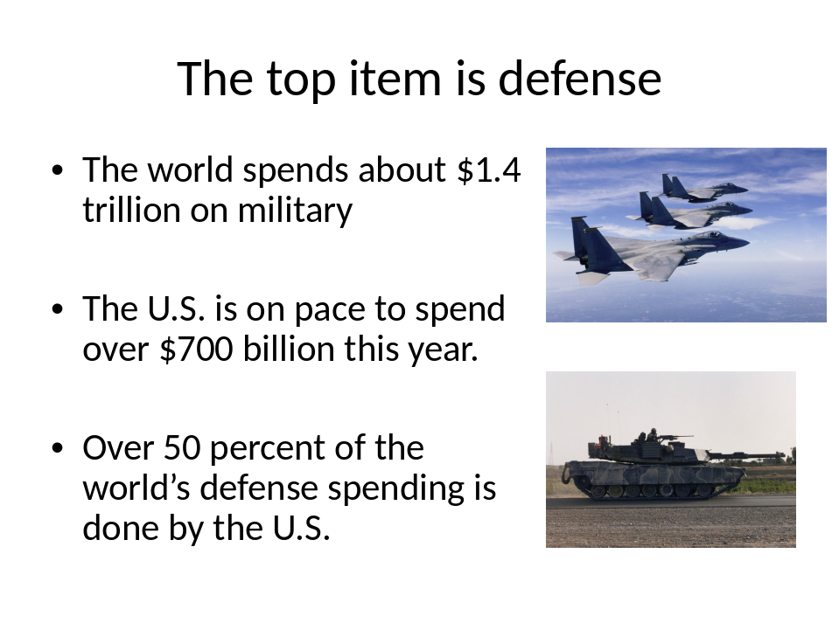

Income distribution – in the US the top wage earnings earn a high percent of the money. See sheet. The government believes without their assistant this problem would be even worse.

Percentiles Ranked by AGI | AGI Threshold on Percentiles | Percentage of Federal Personal Income Tax Paid
Top 1% | $328,049 | 36.89
Top 5% | $137,056 | 57.13
Top 10% | $99,112 | 68.19
Top 25% | $60,041 | 84.86
Top 50% | $30,122 | 96.70
Bottom 50% | <$30,122 | 3.30
Note: AGI is Adjusted Gross Income
Source: Internal Revenue Service

Government’s Version
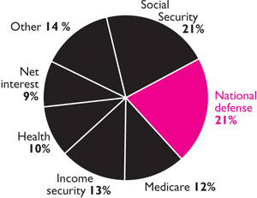
Source:Washington Post , Feb. 6, 2007,
from Office of Management and Budget

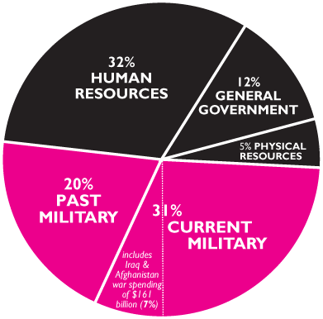

Externalities .. are companies that produce a good and a by-product good. Sometimes the by-product good is bad for society. The government monitors the production of the by-product good by monitoring the production of the sellable good.

Negative externalities are by-products that harm society, pollution, noise, traffic.
Positive externalities are by-products that benefit society, education, increased property values, safety.

Negative externalities are regulated or taxed by the government.
Positive externalities are subsidized or encouraged by the government.
Federal Regulation of financial markets
Junk Bonds
Dot Com Stocks
Credit default Swaps
What’s next?

Fiscal Policy – the use of government spending and taxes to fine tune and stabilize the economy. Congress approval rating 18 percent

Monetary Policy – the use of the money supply to fine tune the economy. Ben Bernanke’s approval rating 20 percent (most people do not know who he is).

Government is growing

US Federal, State, and Local

Year | % of overall spending that comes from the government
1902 | 7%
1960 | 29%
1970 | 32%
1980 | 34.4%
2000 | 33.4%
2008 | 36.6%
2009 45.2%

 |  | 2000 | 2008
China |  | 20 | 22
Japan |  | 31.9 | 30.9
United Kingdom |  | 39.8 | 50
United States |  | 33.4 | 36.95
Europe |  | 47.6 | 55.7
At the beginning of the twentieth century, in the U.S., state, local, and federal governments spent seven percent of the national income, GDP.
By 2008, the state, local and federal government accounted for 37 percent of the total U.S. spending.

