Who Pays Income Taxes? See Who Pays What
For Tax Year 2004
Percentiles Ranked by AGI | AGI Threshold on Percentiles | Percentage of Federal Personal Income Tax Paid
Top 1% | $328,049 | 36.89
Top 5% | $137,056 | 57.13
Top 10% | $99,112 | 68.19
Top 25% | $60,041 | 84.86
Top 50% | $30,122 | 96.70
Bottom 50% | <$30,122 | 3.30
Note: AGI is Adjusted Gross Income
Source: Internal Revenue Service

For Tax Year 2003
Percentiles Ranked by AGI | AGI Threshold on Percentiles | Percentage of Federal Personal Income Tax Paid
Top 1% | $295,495 | 34.27
Top 5% | $130,080 | 54.36
Top 10% | $94,891 | 65.84
Top 25% | $57,343 | 83.88
Top 50% | $29,019 | 96.54
Bottom 50% | <$29,019 | 3.46
Note: AGI is Adjusted Gross Income
Source: Internal Revenue Service
For Tax Year 2002
Percentiles Ranked by AGI | AGI Threshold on Percentiles | Percentage of Federal Personal Income Tax Paid
Top 1% | $285,424 | 33.71
Top 5% | $126,525 | 53.80
Top 10% | $92,663 | 65.73
Top 25% | $56,401 | 83.90
Top 50% | $28,654 | 96.50
Bottom 50% | <$28,654 | 3.50
Note: AGI is Adjusted Gross Income
Source: Internal Revenue Service

For Tax Year 2001
Percentiles Ranked by AGI | AGI Threshold on Percentiles | Percentage of Federal Personal Income Tax Paid
Top 1% | $292,913 | 33.89
Top 5% | $127,904 | 53.25
Top 10% | $92,754 | 64.89
Top 25% | $56,085 | 82.90
Top 50% | $28,528 | 96.03
Bottom 50% | <$28,528 | 3.97
Note: AGI is Adjusted Gross Income
Source: Internal Revenue Service
For Tax Year 2000
Percentiles Ranked by AGI | AGI Threshold on Percentiles | Percentage of Federal Personal Income Tax Paid
Top 1% | $313,469 | 37.42
Top 5% | $128,336 | 56.47
Top 10% | $92,144 | 67.33
Top 25% | $55,225 | 84.01
Top 50% | $27,682 | 96.09
Bottom 50% | <$27,682 | 3.91
Note: AGI is Adjusted Gross Income
Source: Internal Revenue Service
For Tax Year 1999
Percentiles Ranked by AGI | AGI Threshold on Percentiles | Percentage of Federal Personal Income Tax Paid
Top 1% | $293,415 | 36.18
Top 5% | $120,846 | 55.45
Top 10% | $87,682 | 66.45
Top 25% | $52,965 | 83.54
Top 50% | $26,415 | 96.00
Bottom 50% | <$26,415 | 4.00
Note: AGI is Adjusted Gross Income
Source: Internal Revenue Service

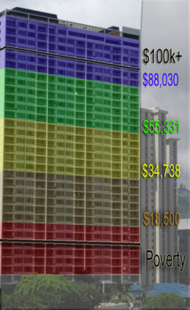

Table 1. Summary of Federal Individual Income Tax Data, 2004 (Updated September 2006)
 | Number of Returns with Positive AGI | AGI ($ millions) | Income Taxes Paid ($ millions) | Group's Share of Total AGI | Group's Share of Income Taxes | Income Split Point | Average Tax Rate
All Taxpayers | 130,371,156 | $6,875,123 | $831,890 | 100.00% | 100.00% | - | 12.10%
Top 1% | 1,303,712 | $1,306,417 | $306,902 | 19.00% | 36.89% | > $328,049 | 23.49%
Top 2-5% | 5,214,846 | $993,178 | $168,322 | 14.45% | 20.23% |  | 16.95%
Top 5% | 6,518,558 | $2,299,595 | $475,224 | 33.45% | 57.13% | > $137,056 | 20.67%
Top 6-10% | 6,518,558 | $749,680 | $92,049 | 10.90% | 11.07% |  | 12.28%
Top 10% | 13,037,116 | $3,049,275 | $567,273 | 44.35% | 68.19% | > $99,112 | 18.60%
Top 11-25% | 19,555,673 | $1,497,126 | $138,642 | 21.78% | 16.67% |  | 9.26%
Top 25% | 32,592,789 | $4,546,401 | $705,915 | 66.13% | 84.86% | > $60,041 | 15.53%
Top 26-50% | 32,592,789 | $1,406,380 | $98,556 | 20.46% | 11.85% |  | 7.01%
Top 50% | 65,185,578 | $5,952,781 | $804,471 | 86.58% | 96.70% | > $30,122 | 13.51%
Bottom 50% | 65,185,578 | 922,342 | 27,419 | 13.42% | 3.30% | > $30,122 | 2.97%
Source: Internal Revenue Service

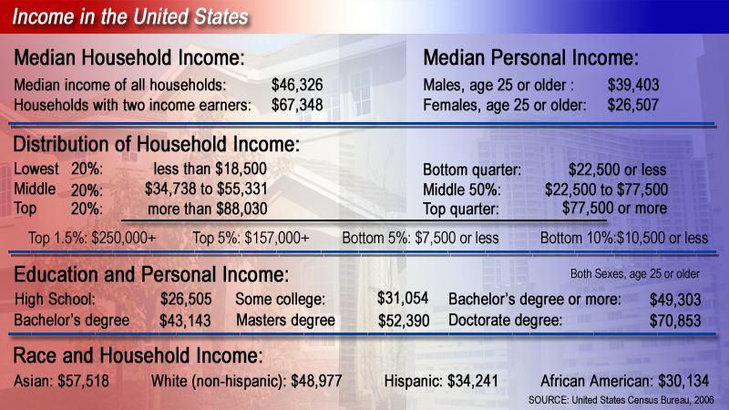

Shares of Household Income
of Quintiles

Lowest quintile 3.5
Second quintile 8.7
Third quintile 14.6
Fourth quintile 23.0
Highest quintile 50.1

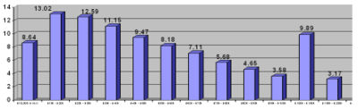
This graph shows the percentage of the population per Income groups in $10,000 increments.

The following table illustrates the number and percentage of households in each of the income groups designated by the US Census Bureau. Households with annual income of less than $25,000, constituted 28.22% of all households, while households with incomes between $25,000 and $50,000 represented 23.25% of the population. Those with incomes ranging from $50,000 to $100,000 who were the largest income group constituted 29.2% of all households, while those with six figure incomes, represented the smallest income group, constituting only 15.82% of all households. Overall the number of households decreased as income went up. While 28.22% of households had annual incomes of less than $25,000, only 10.93% of households with gross annual incomes ranging from $75,000 to $100,000. It should be noted, however, that the top two quintiles have on average twice as many incomes earners per households as the second and middle quintile.^{[5]}
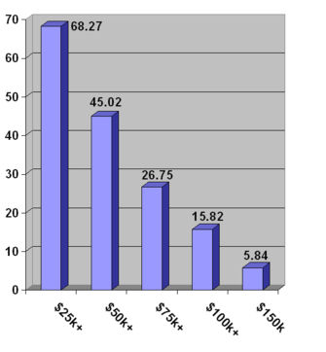
The above graph shows the percentage earning the amount shown on the graph or more.^{[5]}
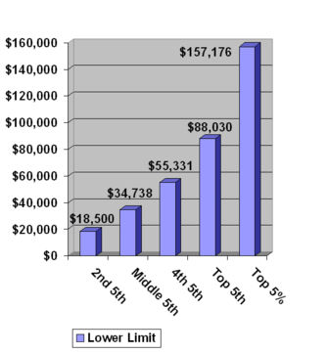
This graph shows the lower limits for the four income quintiles and the top 5%.^{[10]}
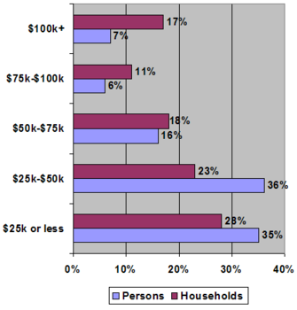
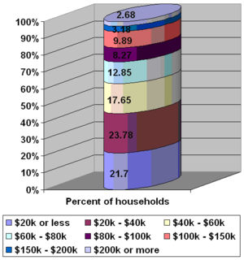
Percent of households according to income group.^{[11]}
Main article: Income quintiles
Households in the United States are often divided into quintiles according to their gross income. The 2005 Current Population Survey conducted by the US Census Bureau determined the following lower limits, and average numbers of income earners per household for each of the American income quintiles. All quintiles had roughly the same number of households, ca. 22,629,000. In addition the top 5%, those with incomes exceeding $157,000 annually, are often shown as a separate group. ^{[12]} In 2005 the lower threshold for the top fifth was $88,030, the lower threshhold for the fourth quintile was $55,331, while the bottom quintile consisted of those households with an annual income of less than $18,500.^{[10]}
Data | All households | Lowest fifth | Second fifth | Middle fifth | Fourth fifth | Highest fifth | Top 5%
Households (in 1000s) | 113,146 | 22,629 | 22,629 | 22,629 | 22,629 | 22,629 | 5,695
Lower limit | (X) | (X) | $18,500 | $34,738 | $55,331 | $88,030 | $157,176
Mean number of income earners | 1 | 0 | 1 | 1 | 2 | 2 | 2
Data | All households | Lowest fifth | Second fifth | Middle fifth | Fourth fifth | Highest fifth | Top 5%
Households (in 1000s) | 113,146 | 22,629 | 22,629 | 22,629 | 22,629 | 22,629 | 5,695
Lower limit | (X) | (X) | $18,500 | $34,738 | $55,331 | $88,030 | $157,176
Mean number of income earners | 1 | 0 | 1 | 1 | 2 | 2 | 2
Tenure
Owner occupied | 62.4% | 49.0% | 58.8% | 68.9% | 80.5% | 90.0% | 92.8%
Renter occupied | 29.2% | 48.3% | 39.7% | 29.9% | 18.7% | 9.6% | 6.9%
Type of household (of any race)
Family households | 68.06% | 41.06% | 59.97% | 70.04% | 80.87% | 88.35% | 90.61%
Married couple families | 51.35% | 19.03% | 38.89% | 51.00% | 67.05% | 80.08% | 85.59%
Single-male family | 4.32% | 3.08% | 4.64% | 5.69% | 4.89% | 3.30% | 2.47%
Single-female family | 12.38% | 18.94% | 16.43% | 13.35% | 8.93% | 4.24% | 2.54%
Non-family households | 31.93% | 58.92% | 40.02% | 29.96% | 19.12% | 11.64% | 9.36%
SOURCE: US Census Bureau, 2004^{[10]}

[edit] Race
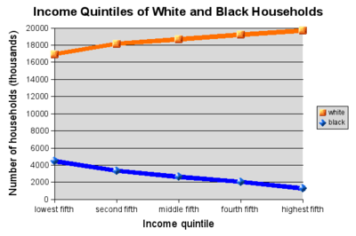
This chart shows the median household income for the four largest racial groups in the United States.^{[16]}
Race |  | All households | Lowest fifth | Second fifth | Middle fifth | Fourth fifth | Highest fifth | Top 5%
White alone | Number in 1000s | 92,702 | 16,940 | 18,424 | 18,978 | 19,215 | 19,721 | 5,695
White alone | Percentage | 81.93% | 74.87% | 81.42% | 83.87% | 84.92% | 87.16% | 87.93%
Asian alone | Number in 1000s | 4,140 | 624 | 593 | 786 | 871 | 1,265 | 366
Asian alone | Percentage | 3.65% | 2.76% | 2.26% | 3.47% | 3.84% | 5.59% | 6.46%
African American or Black | Number in 1000s | 13,792 | 4,474 | 3,339 | 2,637 | 2,053 | 1,287 | 236
African American or Black | Percentage | 12.19% | 19.77% | 14.75% | 11.65% | 9.07% | 5.69% | 1.04%
Hispanic or Latino (of any race) | Number in 1000s | 12,838 | 3,023 | 3,130 | 2,863 | 1,931 | 1,204 | 269
Hispanic or Latino (of any race) | Percentage | 11.33% | 13.56% | 13.83% | 12.20% | 8.53% | 5.89% | 1.19%
SOURCE: US Census Bureau, 2004^{[15]}

[edit] Education and gender
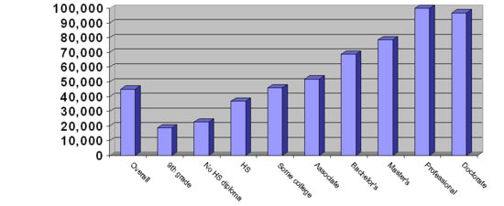
This graph shows the median household income in accordance with the householder's educational attainment. The data only applies to household with a householder over the age of twenty-five.^{[17]}
Household income as well as per capita income in the United States rise significantly as the educational attainment increases.^{[18]} In 2005 graduates with a Master's in Business Administration (MBA) who accepted job offers are expected to earn a base salary of $88,626. They are also expected to receive "…[a]n average signing bonus of $17,428."^{[19]} According to the US Census Bureau persons with doctorates in the United States had an average income of roughly $81,400. The average for an advanced degree was $72,824 with men averaging $90,761 and women averaging $50,756 annually. Year-round full-time workers with a Professional degree had an average income of $109,600 while those with a Master's degree had an average income of $62,300. Overall "…[a]verage earnings ranged from $18,900 for high school dropouts to $25,900 for high school graduates, $45,400 for college graduates and $99,300 for workers with professional degrees (M.D., J.D., D.D.S., or D.V.M.). ^{[20]}
Considering how education significantly enhances the earnings potential of individuals, it should come as no surprise that individuals with graduate degrees have an average per capita income exceeding the median household income of married couple families among the general population ($63,813).^{[20][21]} Higher educational attainment did not, however, help close the income gap between the genders as the life-time earnings for a male with a professionals degree were roughly forty percent (39.59%) higher than those of a female with a professionals degree. The life-time earnings gap between males and females was the smallest for those individuals holding an Associate degrees with male life-time earnings being 27.77% higher than those of females. While educational attainment did not help reduce the income inequality between men and women, it did increase the earnings potential of individuals of both sexes, greatly enabling many households with (a) graduate degree householder(s) to enter the top household income quintile.^{[20]}
Household income also increased significantly with the educational attainment of the householder. The US Census Bureau publishes educational attainment and income data for all households with a householder who was aged twenty-five or older. The biggest income difference was between those with some college education and those who had a Bachelor's degree, with the latter making $23,874. more. Income also increased substantially with increased post-secondary education. While the median household income for a household with a household holding an Associates degree was $51,970, the median household income for those with a Bachelor's degree or higher was $73,446. Those with doctorates had the second highest median household with a median of $96,830; $18,289 more higher than that for those at the Master's degree level, but $3,170 lower than the median for households with a professionals degree holding householder.^{[17]}
Criteria |  | Overall | Less than 9th grade | High school drop-out | High school graduate | Some college | Associates degree | Bachelor's degree | Bachelor's degree or more | Master's degree | Professional degree | Doctorate degree
Median individual income | Male, age 25+ | $33,517 | $15,461 | $18,990 | $28,763 | $35,073 | $39,015 | $50,916 | $55,751 | $61,698 | $88,530 | $73,853
Median individual income | Female, age 25+ | $19,679 | $9,296 | $10,786 | $15,962 | $21,007 | $24,808 | $31,309 | $35,125 | $41,334 | $48,536 | $53,003
Median individual income | Both sexes, age 25+ | $32,140 | $17,422 | $20,321 | $26,505 | $31,054 | $35,009 | $43,143 | $49,303 | $52,390 | 82,473 | $70,853
Median household income |  | $45,016 | $18,787 | $22,718 | $36,835 | $45,854 | $51,970 | $68,728 | $73,446 | $78,541 | $100,000 | $96,830
SOURCE: US Census Bureau, 2003^{[17][22]}
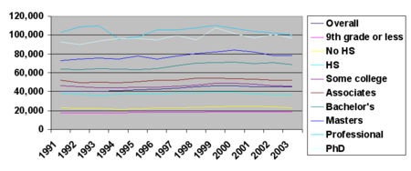
This graph shows the median household income in 2003 dollars according to educational attainment.^{[17]}
The change in median personal and household since 1991 also varied greatly with educational attainment. While, both the overall median personal and household icome increased since 1991, this increase did not take place on all levels of educational attainment. The overall income increased over the course of the 1990s, reaching its high in 1999, but decreasing has been ever since. In 1991 the median household income in the US was $40,873 in 2003 dollars, while the median household income in 2003 was $45,016. In 1999, however, the median household income was $46,236, 2.7% higher than today. While this trend held true for all levels of educational attainment the extend of chorinical falcutations in income were greatly influenced by educational attainment. Overall the median household and personal income decreased for those with more than a 9th grade education but less than a four-year college degree since 1991. In other words, the median household income decreased for households and individuals at the high school drop-outs and graduate, some-college, and an Associates degree level. Income did, however, increase for those with a Bachelor's degree or more. The following table shows the median household income according to the educational attainment of the householder. All data is in 2003 dollars and only applies to householders whose householder is aged twenty-five or older. The highest and lowest points of the median household income are presented in bold face.^{[17][22]}
Year | Overall Median | Less than 9th grade | High school drop-out | High school graduate | Some college | Associates degree | Bachelor's degree | Bachelor's degree or more | Master's degree | Professional degree | Doctorate degree
1991 | $40,873 | $17,414 | $23,096 | $37,520 | $46,296 | $52,289 | $64,150 | $68,845 | $72,669 | $102,667 | $92,614
1993 | $40,324 | $17,450 | $22,523 | $35,979 | $44,153 | $49,622 | $64,537 | $70,349 | $75,645 | $109,900 | $93,712
1995 | $42,235 | $18,031 | $21,933 | $37,609 | $44,537 | $50,485 | $63,357 | $69,584 | $77,865 | $98,302 | $95,899
1997 | $43,648 | $17,762 | $22,688 | $38,607 | $45,734 | $51,726 | $67,487 | $72,338 | $77,850 | $105,409 | $99,699
1999 | $46,236 | $19,008 | $23,977 | $39,322 | $48,588 | $54,282 | $70,925 | $76,958 | $82,097 | $110,383 | $107,217
2001 | $45,300 | $18,830 | $24,162 | $37,468 | $47,605 | $53,166 | $69,796 | $75,116 | $81,993 | $103,918 | $96,442
2003 | $45,016 | $18,787 | $22,718 | $36,835 | $45,854 | $51,970 | $68,728 | $73,446 | $78,541 | $100,000 | $96,830
Average | $43,376 | $18,183 | $23,013 | $37,620 | $46,109 | $51,934 | $66,997 | $72,376 | $78,094 | $104,368 | $94,487
SOURCE: US Census Bureau, 2003^{[17]}

[edit] Age of householder
Household income in the United States varies substantially with the age of the person who heads the household. Overall the median household income increased with the age of householder until retirement age when household income started to decline.^{[23]} The highest median household income was found among households headed by working baby-boomers.^{[23]} Households headed by persons between the ages of 45 and 54 had a median household income of $61,111 and a mean household income of $77,634. The median income per member of household for this particular group was $27,924. The highest median income per member of household was among those between the ages of 54 and 64 with $30,544. The group with the second highest median household income, were households headed by persons between the ages 35 and 44 with a median income of $56,785, followed by those in the age group between 55 and 64 with $50,400. Not surprisingly the lowest income group was compromised of those household headed by individuals younger than 24, followed by those headed by persons over the age of 75. Overall households headed by persons above the age of seventy-five had a median household income of $20,467 with the median household income per member of household being $18,645. These figures support the general assumption that median household income as well as the median income per member of household peaked among those households headed by middle aged persons, increasing with the age of the householder and the size of the household until the householder reaches the age of 64. With retirement income replacing salaries and the size of the household declining, the median household income decreases as well.^{[23]}

[edit] Aggregate income distribution
The aggregate income measures the combined income earned by all persons in a particular income group. Overall all households in the United States earned roughly $4,286,391 million in 2005 (4.3 trillion). Roughly one third, 32.5%, of all income in the US was earned by those households with an income over $150,000, approximately the top five percent. Approximately one fifth, 20.58%, of all income was earned by the top 2.67%, those households earning more than $200,000 a year. Overall the aggregate income distributing tilts toward the top, despite the fact that households with middle-range annual incomes ranging from $50,000 to $75,000 earned roughly one fourth, 25.11% of all income. As the percentage of middle-range income households is roughly one-fourth of the population, this particular income group's share of income is roughly equal to their representation in the general population. The bottom 6.37%, however only earned 0.27% of all income.^{[5]}
Aggregate income distribution, 2005^{[44]} [edit]
Percentage of the total income earned by each income group
10% |  |  |  |  |  |  |  |  |  | 20% |  |  |  |  |  |  |  |  |  | 30% |  |  |  |  |  |  |  |  |  | 40%
less than $25,000 |  |  |  |  |  |  | 6.76%
$25,000 to $50,000 |  |  |  |  |  |  |  |  |  |  |  |  |  |  |  |  |  | 18.12%
$50,000 to $75,000 |  |  |  |  |  |  |  |  |  |  |  |  |  |  |  |  |  |  |  |  |  | 22.54%
$75,000 to $100,000 |  |  |  |  |  |  |  |  |  |  |  |  |  |  |  |  |  |  |  | 20.00%
$150,000 or more |  |  |  |  |  |  |  |  |  |  |  |  |  |  |  |  |  |  |  |  |  |  |  |  |  |  |  |  |  |  |  |  | 32.58%
SOURCE: US Census Bureau, 2005^{[5]}

[edit] Household income over time
Please note that all figures are presented in 2003 dollars.
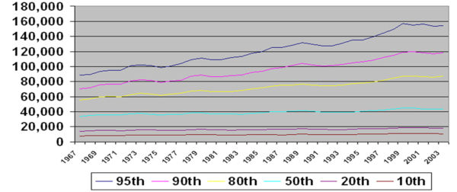
This graph shows the income of the given percentiles from 1967 to 2003, in 2003 dollars.^{[24]}
Since 1967, the median household income in the United States has risen modestly, fluctuating several times. Even though personal income has risen substantially and 42% of all household now have two income earners, the median household income has increased only slightly. According to the US Census Bureau, this paradoxial set of trends is due to the changing structure of American households. For example, while the proportion of wives working year-round in married couple households with children has increased fron 17% in 1967 to 39% in 1996, the proportion of such households among the general population has decreased. Thus, while married couple households with children are the most economically prosperous type of household in the United, their share of the population has been dwindeling in the United States. In 1969, more than 40% of all households consisted of a married couple with children. By 1996 only a rough quater of US households consisted of married couples with children. As a result of these changing household demographics, median household income rose only slighly despite an ever increasing female labor force and a considerable increase in the percentage of college graduates.^{[25]}
“ | "From 1969 to 1996, median household income rose a very modest 6.3 percent in constant dollars... The 1969 to 1996 stagnation in median household income may, in fact, be largely a reflection of changes in the size and composition of households rather than a reflection of a stagnating economy."- John McNeil, US Census Bureau | ”
Overall, the median household income rose from $33,338 in 1967 to an all-time high of $44,922 in 1999, and has since decreased slightly to $43,318. Decreases in household income are visible during each recession, while increases are visible during economic upturns. These flactuations were felt across the income strata as the incomes of both, the 95th and 20th percentile were affected by flactuations in the economy. Yet, it is important to note that income in the period between 1967 and 1999 grew faster among wealthier households than it did among poorer households. For example the household income for the 80th precentile, the lower threshold for the top quintile, rose from $55,265 in 1967 to $86,867 in 2003, a 57.2% increase. The median household income rose by 30% while the income for the 20th percentile (the lower threshold for the second lowest quitile) rose by only 28% from $14,002 to $17,984. One should note that ht majority of households in the top quintile had two income earners, versus zero for the lowest quintile and that the widening gap between the top and lowest quintile may largely be the reflection of changing household demographics including the addition of women to the workforce.^{[24][25]}
While per-capita, disposable income has increased 469% since 1972 it has only increased moderately when considering inflation. In 1972, disposable personal income was determined to be $4,129; $19,385 in 2005 dollars. In 2005, disposable personal income was, however, $27,640, showing a moderate 43% increase.^{[26][27]} Since 1990, household income has fallen slightly, but this does not take into account the decrease in average household size. ^{[28]}
Data | 2003 | 2000 | 1997 | 1994 | 1991 | 1988 | 1985 | 1982 | 1979 | 1976 | 1973 | 1970 | 1967
20th percentile | $17,984 | $19,142 | $17,601 | $16,484 | $16,580 | $17,006 | $16,306 | $15,548 | $16,457 | $15,615 | $15,844 | $15,126 | $14,002
Median (50th) | $43,318 | $44,853 | $42,294 | $39,613 | $39,679 | $40,678 | $38,510 | $36,811 | $38,649 | $36,155 | $37,700 | $35,832 | $33,338
80th percentile | $86,867 | $87,341 | $81,719 | $77,154 | $74,759 | $75,593 | $71,433 | $66,920 | $68,318 | $63,247 | $64,500 | $60,148 | $55,265
95th percentile | $154,120 | $155,121 | $144,636 | $134,835 | $126,969 | $127,958 | $119,459 | $111,516 | $111,445 | $100,839 | $102,243 | $95,090 | $88,678
SOURCE: US Census Bureau, 2004^{[24]} (Page 44/45)

[edit] International comparison
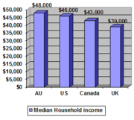
Median household income in Australia, the US, Canada and the UK.
In many industrialized countries median household income is not a commonly reported statistic . Data for other English speaking countries is shown in the table below. The data for each country has been converted to US dollars using Purchasing Power Parity (obtained from the OECD). Interestingly the variation between different English speaking countries is much smaller than the variation within the United States.
Country | Year | Median houshold income (PPP)
Australia.^{[29]} | 2003 | $48,000
United States | 2005 | $46,000
Canada. ^{[30]} | 2006 | estimated $43,000
New Zealand. ^{[31]} | June 2005-June 2006 | $40,000
United Kingdom. ^{[32]} | 2004 | $39,000
Scotland^{[33]} | 2004 | $38,000

[edit] Income by state

An average California home in Salinas, CA. In 2004, California was the most expensive state in the nation^{[34]} and had a median household income of $49,894 (rank 13).^{[35]}
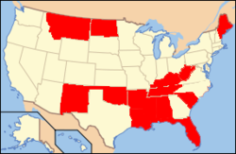
This map shows the bottom fifteen states according to median household income.
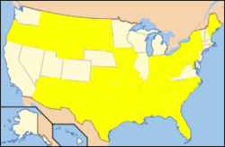
This map shows those states whose median household income is below the national median.
The median household income by state ranged from $32,589 or 26.7% below national median, in West Virginia to $57,352 or 29% above national median, in New Hampshire. Connecticut, which is often referred to as the nation's wealthiest state,^{[36]} came in at number four with a median household income of $55,970. California which had the highest median home price in the nation.^{[34]} where home prices have far outpaced incomes^{[37]} only ranked number thirteen with a median household income of $49,894.^{[35]} While California's median income was not near enough to afford the average California home or even a starter home, West Virginia, which had the nation's lowest median household income also had the nation's lowest median home price.^{[34][35]} The northeastern states, more specifically those located in New England, as well as the western states had the highest median household income. Of the top fifteen states, all were located in the Northeast and West, with the sole exception of Minnesota which ranked fifth. The southern states had the by far lowest median household income with nine out of the country's fifteen poorest states being located in the South. It should be noted, however, that New York, Pennsylvania and the District of Columbia also fell below the national median. Overall, median household income tended to be the highest in nation's most urbanized northeastern, north mid-western and western States, while rural and mostly southern states had the lowest median household income.^{[35]}
State | Rank | Median household income | +/- national average | Change 1999-2005 (inflation adjusted)
New Hampshire | 1 | 57,352 | +12,879 | -2%
New Jersey | 2 | 56,772 | +12,299 | -4.5%
Maryland | 3 | 56,763 | +12,290 | -0.5%
Connecticut | 4 | 55,970 | +11,497 | -3.5%
Minnesota | 5 | 55,914 | +11,441 | -5.7%
Alaska | 6 | 54,627 | +10,154 | -6.9%
Virginia | 7 | 53,275 | +8,802 | -0.8%
Hawaii | 8 | 53,123 | +8,650 | -0.4%
Massachusetts | 9 | 52,354 | +7,881 | -3.3%
Colorado | 10 | 51,022 | +6,549 | -8.4%
Utah | 11 | 50,614 | +5,691 | -10.5%
Delaware | 12 | 50,152 | +5,679 | -5.4%
California | 13 | 49,894 | +5,421 | -3.6%
Washington | 14 | 48,688 | +4,215 | -8.1%
Wisconsin | 15 | 47,220 | +2,747 | -8.2%
Nevada | 16 | 46,984 | +2,511 | -5.8%
Rhode Island | 17 | 46,199 | +1,726 | +4.4%
Illinois | 18 | 45,787 | +1,314 | -7.9%
Vermont | 19 | 45,692 | +1,219 | -4.5%
Nebraska | 20 | 44,623 | +150 | -4.6%
Michigan | 21 | 44,476 | +3 | -12%
United States national average ($44,473) -6%
Pennsylvania | 22 | 44,286 | -187 | -5.2%
New York | 23 | 44,228 | -245 | -2.7%
Ohio | 24 | 44,160 | -313 | -9.3%
Missouri | 25 | 43,988 | -485 | -5.5%
Kansas | 26 | 43,725 | -748 | -9.8%
Wyoming | 27 | 43,641 | -832 | +4.1%
Georgia | 28 | 43,217 | -1,256 | -8.3%
Iowa | 29 | 43,042 | -1,431 | -5.7%
District of Columbia | 30 | 43,003 | -1,470 | +0.5%
Indiana | 30 | 43,003 | -1,470 | -9.7%
Oregon | 31 | 42,617 | -1,856 | -10.4%
Arizona | 32 | 42,590 | -1,883 | -6.8%
Idaho | 33 | 42,519 | -1,954 | -5.8%
Texas | 34 | 41,275 | -3,198 | -9.9%
South Dakota | 35 | 40,518 | -3,955 | -2.5%
Florida | 36 | 40,171 | -4,302 | -6.7%
North Dakota | 37 | 39,594 | -4,879 | +1.2%
Maine | 38 | 39,395 | -5,078 | -1.9%
South Carolina | 39 | 39,326 | -5,147 | -9.5%
North Carolina | 40 | 39,000 | -5,473 | -11.3%
Tennessee | 41 | 38,550 | -5,923 | -8.7%
Oklahoma | 42 | 38,281 | -6,192 | -5.3%
Alabama | 43 | 38,111 | -6,362 | -7.8%
New Mexico | 44 | 37,587 | -6,886 | -6.2%
Kentucky | 45 | 37,396 | -7,077 | -5.3%
Louisiana | 46 | 35,523 | -8,950 | -3.7%
Montana | 47 | 35,201 | -9,272 | +1.6%
Arkansas | 48 | 33,948 | -10,525 | -7.2%
Mississippi | 49 | 33,659 | -10,814 | -10.3%
West Virginia | 50 | 32,589 | -11,884 | -3.8%
SOURCE: US Census Bureau, 2004/05^{[35]}

[edit] Median income

