Oligopolies
Characteristics
How do you know it is an oligopoly?
Industry Concentration Ratio (60-70 percent)
Why do they exist?
- Economies of Scale

- Mergers
Horizontal Merger
A combination of two firms that produce the same type of good or service.

Vertical Merger
A merger between a firm and one of its suppliers or customers.

Congeneric Merger
A merger of firms in the same general industry, but for which no customer or supplier relationship exists.

Conglomerate Merger
A merger of companies in totally different industries.

- Ownership of Scarce Resources, or Production Techniques

Oligopoly Models
Quasi-Competitive Model
Pricing Behavior
Production Behavior
Resembles a perfectly competitive market
Efficient
Cartels
Pricing Behavior
Production Agreements
Resembles a monopoly
Illegal
Side Payments
Cheating

Oligopoly Models

Quasi Competitive
When companies in an industry act competitively against each other. Prices are determines for the industry at the point where D=MC. The industry demand curve and the marginal revenue curve are the same line. This model is very similar to the perfect competition model. The only difference is the number of firms.

Cournot
When firms determine the quantities and let the market determine the price.

Bertrand
When firms determine the price and let the market determine the quantities.

Price Leader _ also known as Stackelberg Model
The leader firm sets the price to maximize their own profits. All other firms in the industry (known as fringe firms) are price takers.

Cartel
Firms join together (or collude) to set quantities produced by the industry. Their objective is to maximize industry profits, not necessarily their own profits. By working together they can keep prices high. Industry quantity is determined producing where MR= MC. This is similar to the monopoly model. Even though there are multiple firms, they act as one.

These figures below are for all beer (light/regular)

Anheuser Busch 45
Molson, Miller Coors 26
Constellation 7.4
Heineken 3.9
Pabst 2.5
Other 17.5

Soft Beverage market

- Coca-Cola Co. 42.5
- Pepsi-Cola Co. 27.2
- Cadbury Schweppes 17.3
- Cott Corp. 4
- National Beverage 3
- Other 6.2

Cereal Industry
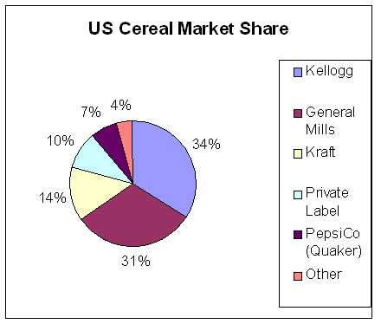

Footwear Manufacturers

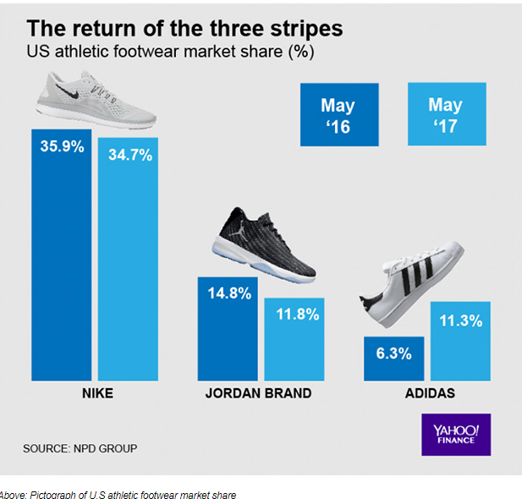

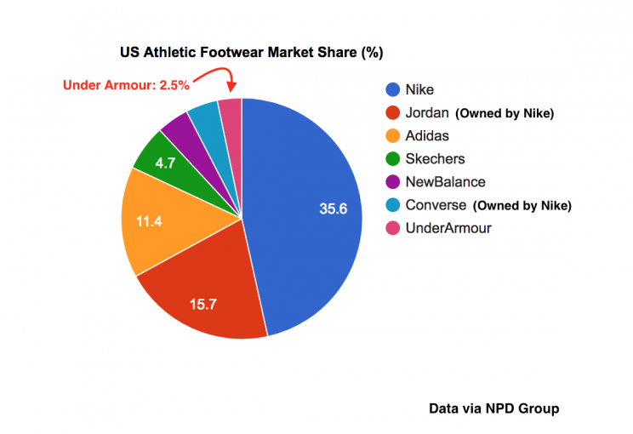

Automakers
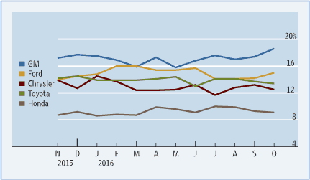

Cigarettes


