Econ 215 Notes: PEFECT COMPETITION
Perfect Competition: the situation prevailing in a market in which buyers and sellers are so numerous and well informed that all elements of monopoly are absent and the market price of a commodity is beyond the control of individual buyers and sellers.
In the perfect competitive market, there are a large number of firms, each producing the same product (as called a standardized or homogeneous product). Since the number of firms is very large, no one firm can influence the market price, thus each firm has no market power and each is a price taker. We also assume that there is perfect information, meaning everyone knows what price is being charged in all markets. The barriers to entry are low, so it is easy for other firms to get into or out of the market. There are a very large numbers of firms in the market. Government doesn’t get involved unless it involves more competitive markets.

Short Run vs Long Run
- Economic Purpose: In the Short Run there is no time for adjustments or quick fixes. In the Long Run companies can make adjustments.
- Profit maximization - Firms are assumed to sell where marginal costs meet marginal revenue. This is where the profit maximized. In a perfect competition model the demand curve and MR curve are the same. Therefore profit is maximized at the quantity where D=MC.
- Homogeneous products - The products are perfect substitutes for each other. The qualities and characteristics of a market good or service do not vary between different suppliers.
- Non-increasing returns to scale - The lack of increasing returns to scale (or economies of scale) ensures that there will always be a sufficient number of firms in the industry. In other words, the larger companies do not have a cost advantage over the smaller companies.

In the short run firms may earn economic profits or losses, but in the long run economic profits can be expected to be zero and firms will earn only normal
ECONOMIC FORMULAS
- TR(Total Revenue)= P(Price)*Q(Quantity)
- Q= Output for the industry
- q= output for the company
- MR=Marginal Revenue=Change of TR/Change of q
- Profit= TR(Total Revenue)-TC(Total Cost), or (Price-AC)*q
- Additional Profit= MR(Marginal Revenue) - MC(Marginal Cost) at each unit sold
ASSUMPTIONS
- Since price comes from the industry their only decision is how much quantity to produce.
- Companies that base their price for the industry. They are known as “Price Takers”, taking or copying the same price as the industry.
- Companies can sell as much output (q) as they want to at the market price.

Price Price

MC S
AC

D =MR

D

(FIRM) q (INDUSTRY) Q

The graphs above are in illustration of perfect competition market where the price is set by the industry and is carried into the firms.

The graph on the right represents the Industry demand and supply. The equilibrium (or market) price can be found at the intersection of the Industry demand and supply lines.

The graph on the left represents the cost curves and demand line for an individual company that operates in the perfectly competitive industry. All of the individual companies in the industry (called firms) take the price that is set in the market by the industry. In other words, the graph on the right determines the price that will be taken by the company on the left.

- MC curve shows the relationship between MC and q. This concept and curve was covered in the cost section of the class.
- The intersection of the MR=MC lines on the graph on the left, is the way a company can find out how much they should produce to maximize their profit. Remember, the D line and the MR line are the same in a perfectly competitive market. Therefore, to find the profit max quantity go to MR=MC. Then from that point draw a line down to the q axis. That q is known as the profit maximizing quantity “q*”.

- AC curve shows the relationship between AC and q. The AC line is necessary to help the firm determine how much profit they are going to make. Once the company determines the profit maximizing quantity, they can find the AC at that quantity. They find the AC at q* by drawing a line from q* up to the AC curve then draw a line to the left toward the price axis. The profit is the area between the price and the AC at q*.

In the long run the industry adjusts.
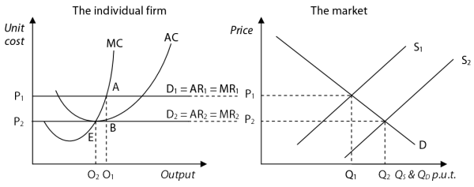

Using the graphs above… the starting industry demand (D) and supply curve (S₁) intersect to yield a market price of P₁. P₁ is the price that every firm in the industry has to charge. For that reason, the individual firm’s Demand line is set at D₁. This is also the marginal revenue line, MR₁.
To find the profit maximizing quantity
Go to the point where MR₁ intersects MC (point A). Then to find the profit maximizing quantity draw a line down to the output axis O₁. On the graph above this is the dashed line going down to O₁. We usually use a q instead of an o but for this illustration we will use output rather than quantity. O₁ is the q* - otherwise known as the profit maximizing quantity.

Finding the profit area
In the short run while the price is constant, firms can show economic profit. If the original price is P₁ then the individual firm earns a profit. The area of profit is the rectangular area from P₁ to A to B to P₂.
This profit attracts more companies into the industry. When the new companies enter the industry the industry supply curve shifts to the right from S₁ to S₂.
When the new companies enter, the price charged by ALL of the companies will fall from P₁ to P₂. As a result, the profit for the individual companies will fall. This process will continue until there is no more profit. That will occur when the Price is equal to the average costs. In the graph above this occurs at P₂. At that point, MC =AC = D₂ =MR₂

To reiterate… new companies entering will cause the price to fall to P₂. To find the profit maximizing quantity at that price… go to the point where MR₂ intersects MC. Then to find the profit maximizing quantity draw a line down to the output axis. On the graph above this is the dashed line going down to O₂. O2 becomes the q* - otherwise known as the profit maximizing quantity.

Finding long run equilibrium
Since the price is now equal to the AC, the economic profit is $0. That means there is no reason for a company to enter the industry. There is also no reason for a company to leave the industry since they are earning a normal profit. At this price, the industry is in long run equilibrium.

Below is the diagram for a loss

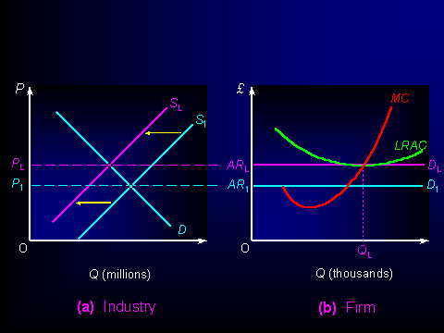

In the above graph, we see in the long run that firms lose profits. At P1 the profit maximizing quantity is found where D1 intersects with MC. In the graph above this would be to the left of the Q_{L} line. Notice that the AC line (LRAC) is actually above the Price. That means it costs more to produce the good than they can sell it for. The losing companies drop out of the industry shifting the industry supply curve to the left (on the graph on the left). When companies leave prices rise to P_{L}. At P_{L}, AC = P so profit is $0. At this point the industry is in long run equilibrium.

