The Supply side of the market deals with the costs to companies. The highest cost to companies is the labor cost.

Today’s class focuses on current labor market conditions and issues.

The Unemployment Rate

| **HOUSEHOLD DATA Table A-15. Alternative measures of labor underutilization**  [Percent] | | | | | | | | | |
| --- | --- | --- | --- | --- | --- | --- | --- | --- | --- |
| **Measure** | **Not seasonally adjusted** | | | **Seasonally adjusted** | | | | | |
| **Aug. 2014** | **July 2015** | **Aug. 2015** | **Aug. 2014** | **Apr. 2015** | **May 2015** | **June 2015** | **July 2015** | **Aug. 2015** |
| **U-1 Persons unemployed 15 weeks or longer, as a percent of the civilian labor force** | 2.8 | 2.0 | 2.1 | 2.9 | 2.3 | 2.4 | 2.2 | 2.1 | 2.2 |
| **U-2 Job losers and persons who completed temporary jobs, as a percent of the civilian labor force** | 3.0 | 2.7 | 2.5 | 3.1 | 2.6 | 2.7 | 2.6 | 2.6 | 2.6 |
| **U-3 Total unemployed, as a percent of the civilian labor force (official unemployment rate)** | 6.3 | 5.6 | 5.2 | 6.1 | 5.4 | 5.5 | 5.3 | 5.3 | 5.1 |
| **U-4 Total unemployed plus discouraged workers, as a percent of the civilian labor force plus discouraged workers** | 6.7 | 6.0 | 5.6 | 6.6 | 5.9 | 5.8 | 5.7 | 5.7 | 5.5 |
| **U-5 Total unemployed, plus discouraged workers, plus all other persons marginally attached to the labor force, as a percent of the civilian labor force plus all persons marginally attached to the labor force** | 7.5 | 6.7 | 6.3 | 7.4 | 6.7 | 6.6 | 6.4 | 6.4 | 6.2 |
| **U-6 Total unemployed, plus all persons marginally attached to the labor force, plus total employed part time for economic reasons, as a percent of the civilian labor force plus all persons marginally attached to the labor force** | 12.0 | 10.7 | 10.3 | 12.0 | 10.8 | 10.8 | 10.5 | 10.4 | 10.3 |
| NOTE: Persons marginally attached to the labor force are those who currently are neither working nor looking for work but indicate that they want and are available for a job and have looked for work sometime in the past 12 months. Discouraged workers, a subset of the marginally attached, have given a job-market related reason for not currently looking for work. Persons employed part time for economic reasons are those who want and are available for full-time work but have had to settle for a part-time schedule. Updated population controls are introduced annually with the release of January data. | | | | | | | | | |

Over 7 million part time workers for economic reasons

<http://www.bls.gov/news.release/empsit.t08.htm>

Labor Issues in the US

The LF Participation Rate

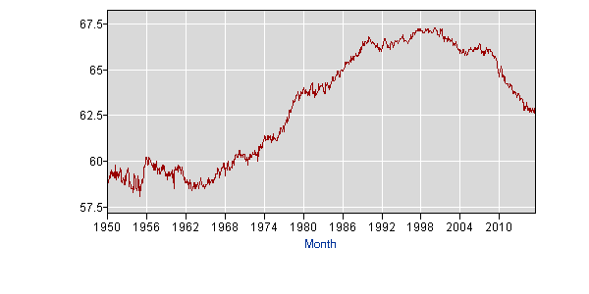

Male Labor Force Participation Rate

**find five interesting facts/trends in this table**

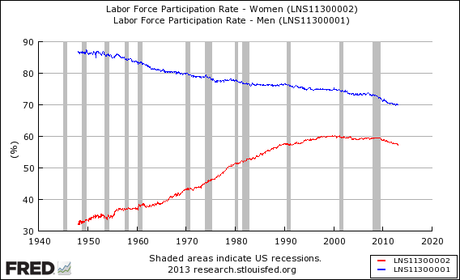

No changes in real wages

<http://www.pewresearch.org/fact-tank/2014/10/09/for-most-workers-real-wages-have-barely-budged-for-decades/>

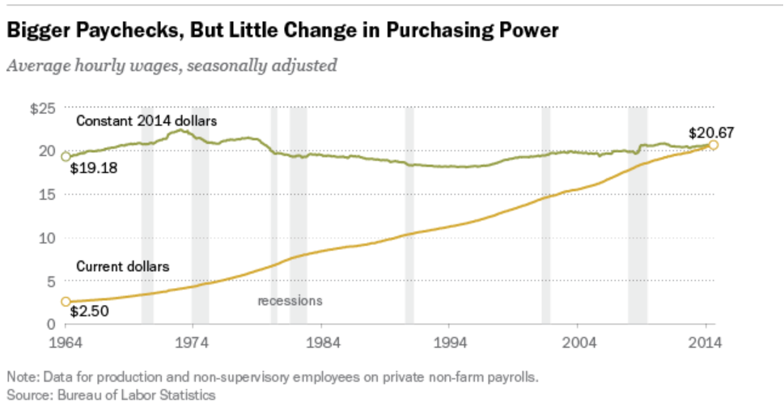

Changes in the minimum wage

<http://www.nbcnewyork.com/news/local/New-York-State-New-Minimum-Wage-15-Dollars-Hour-First-State-326456581.html>

<http://fortune.com/2015/07/30/1223726-15-hour-minimum-wage-workers-fast-food/>

<http://seattle.eater.com/2015/8/13/9143329/is-the-seattle-minimum-wage-law-as-bad-for-restaurants-as-the>

Extension of unemployment insurance

The housing market recovery

US corporate taxes

<http://taxfoundation.org/blog/us-has-highest-corporate-income-tax-rate-oecd>

The Overworked American

<http://20somethingfinance.com/american-hours-worked-productivity-vacation/>

Productivity changes – how do we compare

<http://www.tradingeconomics.com/united-states/productivity>

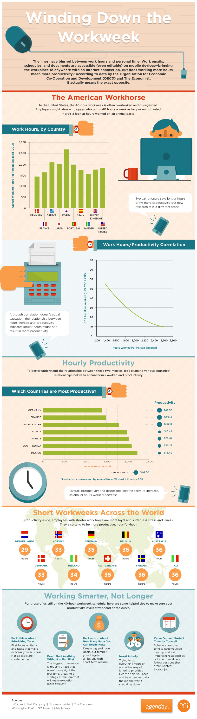

Benefit costs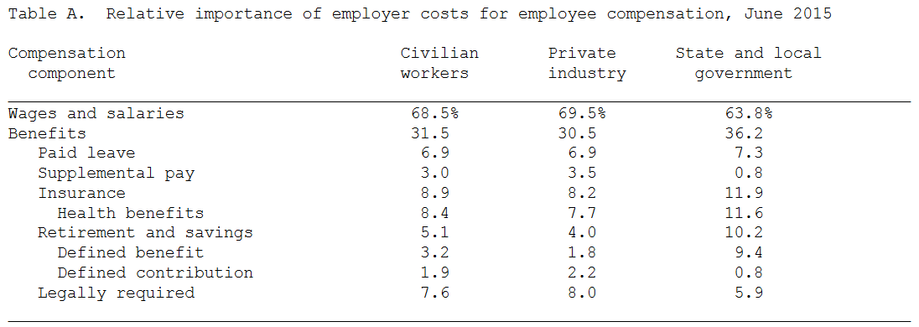

<http://www.bls.gov/news.release/ecec.nr0.htm>