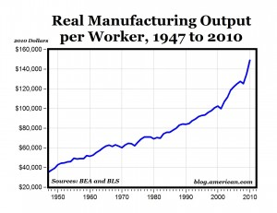
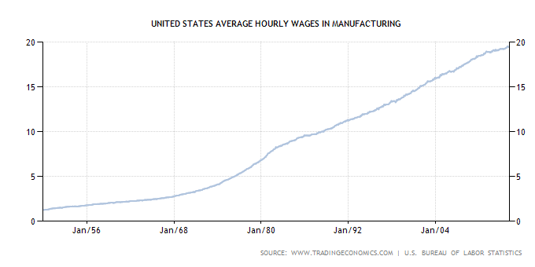
http://www.tradingeconomics.com/united-states/wages-in-manufacturing

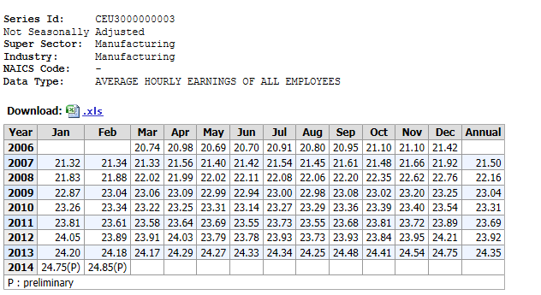
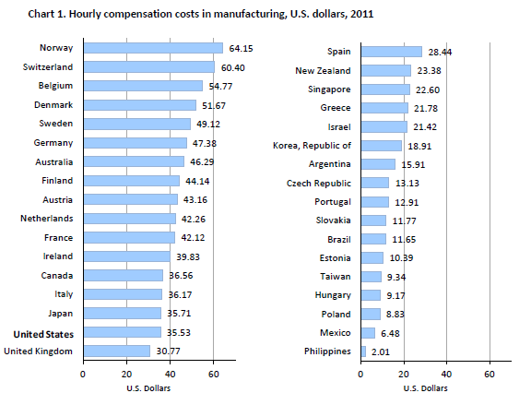
http://www.bls.gov/news.release/pdf/ichcc.pdf
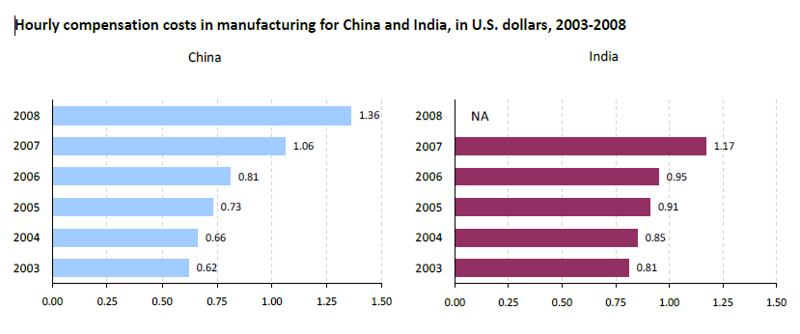

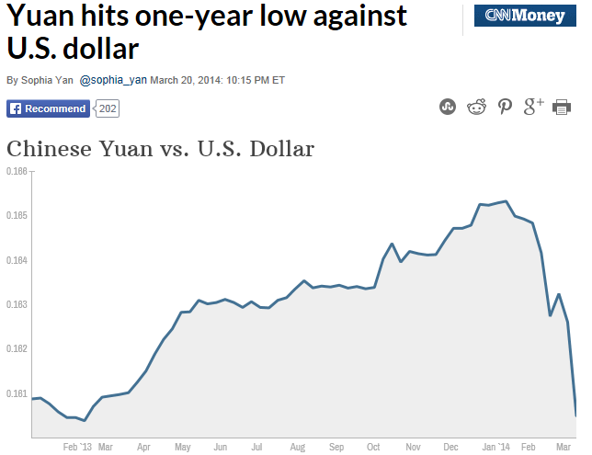

http://www.xe.com/currencycharts/?from=USD&to=CNY&view=2Y

Demand Notes

is a derived demand. It stems from the demand for the goods produces.

Production function

Q = f(K,L)
Q is the total product, or output
Output depends on capital and
If one input is held constant, then what happens if the other input is changed? Form an employers perspective, this allows the company an opportunity to calculate the value of the changing input to the production process.

MPL = change in Q/ change in L – holding constant

Assuming a price of $2 per unit in a perfectly competitive product market

Output MP_{L} AP_{L} MRP VAP
0 0 - - - -
1 11 11 11 22 22
2 27 16 13.5 32 27
3 47 20 15.7 40 31.4
4 66 19 16.5 38 33
5 83 17 16.6 34 33.2
6 98 15 16.3 30 32.6

MRP is the price times the MP_{L}, it is the dollar value of what a worker produces.
AP_{L} is the per worker contribution to the firm

Assume a farmer owns an apple orchard. He picks 3 bushels of apples an hour; he can sell each bushel for $4. In this example, his MP_{L} per hour is 3 and P = $4, therefore his MRP is $12. Since he owns the farm his wage rage is $12 per hour. What if he picked more apples per hour?

How is the typical employee paid?
Athletes, celebrities, doctors, lawyers, salesman, CEOs.
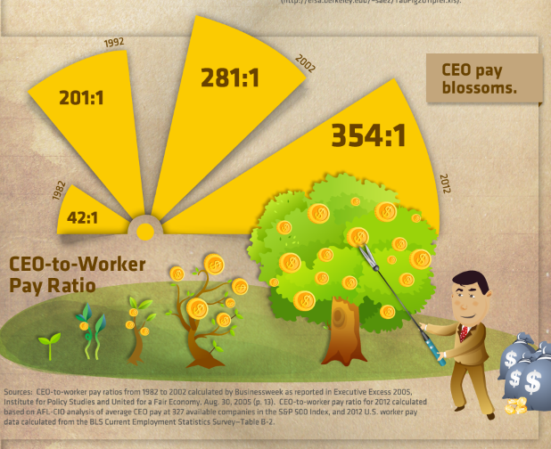

23 of the Fortune 500 CEOs are women
http://www.mercurynews.com/business/ci_24696574/23-female-ceos-running-fortune-500-companies

Floyd Mayweather made $85 million
http://www.forbes.com/sites/kurtbadenhausen/2012/06/18/mayweather-tops-list-of-the-worlds-100-highest-paid-athletes/

Customer service representatives, retail clerks, construction workers, school teachers.
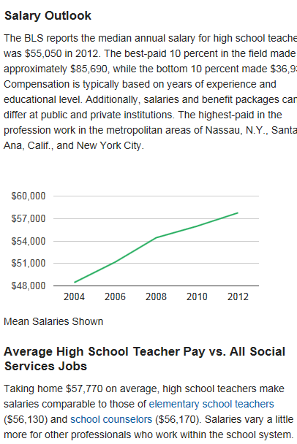

Why?

How is marginal productivity measured in the service sector versus the manufacturing sector?

The demand curve is the relationship between L and MRP.

Total Product and the derivation of the demand curve
Total Product of

Average Product of
Marginal Product of
A B C
wage
rate

MRP_{L} = D_{L}

A B C

Explaining the graphs and the Zone of Production
From the origin to point A the total product is increasing at an increasing rate, as a result the marginal product is rising. At point A, the point of inflection, marginal product reaches its peak, and begins to decline. Total product is still increasing but not as fast as before.

Beyond point C MPL is negative.

Production range is between points B and C. Since MPL is the wage, and APL is the average contribution per worker, the company would like the average contribution to be above the wage rate.

Law of Diminishing Marginal returns, holding capital constant, increasing the number of units does not have as positive an effect as units increase. The reason is not because worker A differs from worker B, all workers are assumed to be identical. The reason is that after the specialization process, the existing workers are exhausting the fixed capital resources.

Competitive Market

In this competitive market w = MRP_{L}. Think about a perfectly competitive product market. The demand curve is downward sloping but all firms charge the same price. In this market, the demand curve is downward sloping, and all firms pay the same wage rate which is equal to the MRP.

wage

S_{L} = MWC_{L}

Ld = MRP_{L}

Assume the supply curve is flat, in other words there are numerous workers willing to work at a particular wage. The demand assumption is that each of these workers is equally skilled.

Application Questions:
Worker A adds 3 toasters to the production process per hour (his MP_{L} is 3). The company sells each toaster for $20. Assume the additional costs per toaster: such as materials and other capital is $10. The company pays the workers $25 per hour. Should this worker be hired?

What if the next workers MPL was 2 toasters per hour. Should the second worker be hired?

At what wage rate should the worker be hired?

What if the company had to lower their price because a competitor lowered their price to $14 per toaster? Should the company still hire these workers?

The demand curve can be more or less flat (elastic).
The factors that affect the demand curve’s elasticity (shape) are
- the ease of substitution between and capital
- the elasticity of the product
- the competitive nature of the industry
- s share of total cost
- public sector issues versus private sector issues
- International competition - in a intensive industry

Wage taker

wage

S_{L}

S_{L} = MWC_{L}

Ld = MRP_{L}
D_{L}

industry firm

Imperfectly Competitive Labor Market
Workers have unique skills. You can assume the worker as a supplier has some power in wage setting. This is comparable to an imperfect product market where the MR curve and the demand differ because prices change with output. The demand curve will be steeper as well.

wage

W

S_{L} = MWC_{L}

MRP_{L} Ld

The Demand Curve in the long run

wage

Ld LR

Ld SR

Output (scale) effect
As wages decrease, supply shifts right in the product market – mc curve shifts right. This decrease in cost inspires an increase in the demand for the product the company is producing. Therefore, the quantity of demanded increases.

Substitution effect
In the short capital is fixed, so a reduction in wages does not lead to a reduction in capital. In the long run, a reduction in wages inspires firms to substitute for capital.

Therefore, the long run demand cure is flatter (more elastic) because
- substitution of capital for is more easily accomplished in the long run
- as wages fall the output effect means more will be produced so needs increase
- technology
- international options

What happens to the demand for capital in the long run when the wage rate fall?
Output effect – as more is produced more capital is needed since output (Q) is a function of capital and (K,L).
Substitution effect – as labor becomes cheaper, labor is substituted for capital, less capital is needed.
The answer depends on which effect outweighs the other.

Sample Questions

1. Draw a total product of curve holding capital constant. Underneath draw an average product of curve and a marginal product of curve. Explain the peak points for MPL and APL, as well as the point where MPL is zero.

2. Explain the firms hiring decision. What quantity of should the firm employ?

3. Derive a demand curve from your AP_{L} and MP_{L} graph.

4. Explain the firm’s decision to hire when AP_{L} is greater than MP_{L}.

5. What is the difference between demand curves when the product market is perfectly competitive as opposed to imperfectly competitive?

6. Using the scale and substitution effect explain how the long run demand curve differs from the short run demand curve.

7. What is the impact of an increase in wages on the quantity of demanded? Explain the output and substitution effects.

8. What is the impact of a decrease in wages on capital?

9. The hiring decisions of firms operating in a competitive market are considered to have no impact on market wages. Show graphically how the firm takes it wage from the market.

10. Explain the logic behind the MRP = MCW hiring rule.

11. What factors impact the shape of the demand curve?

Additional Notes:
The Short-run Demand for Labor
- assume that the production function Q = f(L,K) describes the technological possibilities facing the firm
  - the maximum amount of output (Q) which can be produced from various quantities of labor (L) and capital (K), given the existing state of technology
- in the short-run the stock of capital is assumed to be fixed (at K_{o})
- the upper diagram in Figure 5-1 plots the production function Q = f(L,K_{o}) for a fixed capital stock
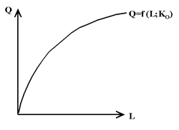<a onClick="window.open('/olcweb/cgi/pluginpop.cgi?it=gif:: ::/sites/dl/free/0070891540/43154/benjamin_05_01a_250_182.gif','popWin', 'width=266,height=198,resizable,scrollbars');" href="#"><img valign="absmiddle" height="16" width="16" border="0" src="/olcweb/styles/shared/linkicons/image.gif"> (3.0K)</a> | Figure 5-1a
- output (Q) increases as the amount of labor (L) increases but the Marginal Product of Labor (MPL, the increase in Q when an additional unit of labor is added to the production process) decreases as more labor is added to the production process
  - hiring more labor is subject to diminishing marginal returns as each additional worker is not provided with additional capital equipment and thus has a lower productivity level
  - the marginal product of labor is the slope (first derivative) of the production function
    - diminishing marginal returns implies that the first derivative of the production function is positive and the second derivative is negative; as the firm moves up the production function the positive slope decreases in value
- the lower diagram in Figure 5-1 plots the value of the marginal physical product of labor (VMPL)
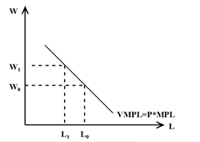<a onClick="window.open('/olcweb/cgi/pluginpop.cgi?it=gif:: ::/sites/dl/free/0070891540/43154/benjamin_05_01b_250_178.gif','popWin', 'width=266,height=194,resizable,scrollbars');" href="#"><img valign="absmiddle" height="16" width="16" border="0" src="/olcweb/styles/shared/linkicons/image.gif"> (3.0K)</a> | Figure 5-1b
- if the output market is characterized by perfect competition, then the firm is a price taker and can sell additional units of output at the given market price (P)
  - if perfect competition exists in the product market, VMPL = P*MPL
- the VMPL will decline as more labor is hired because of diminishing returns to hiring labor (the MPL declines as more L is added to the production process)
- the profit-maximizing firm will continue to operate as long as it can cover the variable costs of production (such as the wage rate paid to labor)
  - as we shall see in the next chapter, the demand for labor will also be affected by labor costs which are independent of the number of hours worked by labor (quasi-fixed labor costs)
- thus, the profit-maximizing firm will keep adding additional units of labor to the production process as long as the value of the marginal product of labor (VMPL) is greater than the marginal cost of hiring labor (which is the wage rate W)
- in the short run a profit-maximizing firm will keep hiring additional units of labor up to the point where VMPL = W
  - for the given wage rate W_{o} in Figure 5-1, the profit-maximizing firm will hire L_{o} units of labor
- the VMPL is the short-run demand for labor and identifies the quantity of labor demanded at various wage rates
  - if the market wage rate increases from W_{o} to W₁, then the profit-maximizing firm will reduce the quantity of labor demanded from L_{o} to L₁
  - the short-run demand for labor slopes down because of diminishing returns (a declining MPL) to hiring more labor
- in the short-run, the quantity of labor demanded depends on the wage rate (W), the price of output (P) and the marginal productivity of labor (MPL); thus, in the short run labor demand depends on the real wage rate (W/P) and the (the first derivative of the) production function
- an increase in the price of output or an increase in the marginal productivity of labor (say from technological progress) will shift the short-run demand for labor curve to the right
- in a non-competitive product market (for example, a monopoly), the demand for labor curve also depends on the price elasticity of the demand for output
  - given a downward-sloping product demand (average revenue) curve, the demand for labor depends on the Marginal Revenue (MR) from selling an additional unit of output and the Marginal Product of Labor (MPL)
  - for a non-competitive product market, the demand for labor curve is given by the Marginal Revenue Product of Labor (MRPL) curve, where MRPL = MR*MPL
  - compared to a perfectly competitive firm, the demand for labor curve for a non-competitive firm, such as a monopolist, will be steeper
    - since the MR declines as output increases, an increase in the quantity of labor causes both the MPL and the MR to decline (making the labor demand curve steeper)
The Long-run Demand for Labor
- in the long run, the profit-maximizing firm can vary the inputs of both labor (L) and capital (K)
  - we assume that there are diminishing marginal returns to adding more units of K (holding L constant) and to adding more units of L (holding K constant)
    - we assume that the first derivatives of Q = f(L, K) are positive and the second derivatives are negative
- an isoquant-isocost diagram can be used [i] to determine the optimal combination of L and K and [ii] to derive the demand for labor when K is a variable input into the production process
http://highered.mcgraw-hill.com/sites/0070891540/student_view0/chapter7/chapter_notes.html

Chapter Notes
The Competitive Labor Market
- assuming that firms can buy all the labor they wish at the going wage rate (firms are wage takers in the labor market), the market labor demand curve for perfectly competitive firms (firms that are price takers in the product market) is the horizontal summation of the labor demand curves of the individual firms
  - as discussed in the previous two chapters, a perfectly competitive firm's labor demand curve is the Value of the Marginal Product of Labor (VMPL = P*MPL) schedule minus any (amortized) fixed costs
  - if the firm is a monopolist, the market demand curve corresponds to the monopolist's Marginal Revenue Product of Labor (MRPL = MR*MPL) curve minus any (amortized) fixed costs
- the market labor supply curve is the horizontal summation of the individual labor supply curves (as derived in Chapter 2)
- the intersection of the market labor demand curve and the market labor supply curve determines the equilibrium wage rate and the equilibrium employment level
  - given the LD_{o} and LS curves in Figure 7-1, the competitive market equilibrium occurs at point E_{o}; the equilibrium wage rate W_{o} 'clears' the labor market
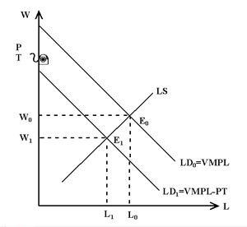<a onClick="window.open('/olcweb/cgi/pluginpop.cgi?it=gif:: ::/sites/dl/free/0070891540/43154/benjamin_07_01_300_276.gif','popWin', 'width=316,height=292,resizable,scrollbars');" href="#"><img valign="absmiddle" height="16" width="16" border="0" src="/olcweb/styles/shared/linkicons/image.gif"> (7.0K)</a> | Figure 7-1
- assuming 'linear' curves, the labor demand and supply curves can be written as:
  - LD = a + bW + gX , where b is a negative parameter and X represents exogenous (shift) variables such as product price, fixed costs and payroll taxes
  - LS = c + fW + hZ, where Z represents exogenous (shift) variables such as consumer prices and income taxes
  - since economists have traditionally plotted the wage rate on the vertical axis of a labor demand and supply diagram, these two equations have to be re-arranged with W on the left hand side of the equation to represent the traditional labor demand and supply curves drawn in Figure 7-1
    - in Figure 7-1 the vertical intercept of the labor demand curve would be – a/b (recall that b is a negative parameter) and the vertical intercept of the labor supply curve would be – c/f
- reduced form equations for the equilibrium wage W and employment level L can be obtained by solving the structural equations for labor demand LD and labor supply LS
  - equating labor demand LD and labor supply LS produces the following equation
a + bW + gX = c + fW + hZ,
which can be re-arranged to obtain the reduced form equation for W
W = [ a + gX – c – hZ ]/ [f – b ]
  - substituting the W reduced form equation into L = LD = a + bW + gX,
L = a + gX + b [ a + gX – c – hZ ]/ [f – b ]
and re-arranging produces the following reduced form equation for L
L = [ af – bc +gfX – bhZ ] / [ f – b ]
- the W and L reduced form equations allow us to determine the effects on the equilibrium wage and employment level from a change in an exogenous factor (X or Z)
  - for example, if X increases by one unit, the equilibrium wage W will increase by g/[f – b] and the equilibrium employment level L will increase by gf/[f – b]; again recall that b is a negative parameter and thus the divisor [f – b] is a positive number
- we now examine how equilibrium wages and employment levels in a competitive labor market are affected by the imposition of a payroll tax
The Labor Market Effects of Payroll Taxes
- a payroll tax is a tax levied on employers with the amount of tax payable based on the size of the payroll (the wage rate multiplied by the quantity of labor employed)
- the federal government levies two payroll taxes: employer-paid premiums for Unemployment Insurance (UI) and for the Canada Pension Plan (CPP), both of which are 'capped' (there is no premium paid for earnings above the cap)
  - UI premiums: in 2002 employers paid 3.08% of payroll costs for annual labor earnings up to $39,000 (the cap); in 2002 the maximum annual UI premium paid by the employer for one employee is $1,201
  - CPP premiums: in 2002 employers paid 4.7% of payroll costs for annual labor earnings from $3,500 to $39,100 (the cap); in 2002 the maximum annual CPP premium paid by the employer for one employee is $1,673.20.
  - for employees earning less than the cap ($39,000), in 2002 employers pay a combined UI and CPP premium of 7.78% of the employee's earnings; the maximum annual premium paid to the federal government by the employer for one employee is $2,874.20
  - in addition to federal UI and CPP premiums (a euphemism for payroll taxes), employers also pay workers' compensation (WC) premiums to provincial governments
  - in 1997 payroll taxes were 12% of labor income (see textbook page 199)
- the firm must pay part of the value of the marginal product of labor (VMPL) to governments in the form of UI, CPP, and WC premiums
- the demand for labor curve will be represented by the VMPL schedule minus the payroll tax (PT)
  - a profit-maximizing firm will hire labor up to the point where W = VMPL – PT
    - for example, if the VMPL for the nth worker is $110 and payroll taxes are 10%, a profit-maximizing firm will hire the nth worker as long as the wage is not greater than $100 (W = VMPL – PT)
  - the imposition of a payroll tax shifts the labor demand curve downwards by the amount of the payroll tax
- Figure 7-1 illustrates the labor market effects of the imposition of a payroll tax
- with no payroll tax, the labor demand curve is represented by the LDo = VMPL line and the equilibrium position in the labor market is E_{o}; the equilibrium wage rate is W_{o} and the equilibrium quantity of labor is L_{o}
- imposing a payroll tax shifts the labor demand curve down to LD₁ = VMPL – PT
  - the vertical intercept of the labor demand curve shifts down by PT, the portion of the VMPL which must be paid to the government (payroll taxes)
  - the new equilibrium position in the labor market is E₁; the equilibrium wage rate decreases to W₁ and the equilibrium quantity of labor decreases to L₁
- the imposition of a payroll tax (paid by the employer) reduces the demand for labor, the equilibrium wage paid to labor and the equilibrium quantity of labor
  - in the long run (when all factors are variable in the production process), the imposition of a payroll tax on labor will cause profit-maximizing firms to substitute other non-taxed factors of production (such as capital) for labor, further reducing the demand for labor
- the incidence of the payroll tax (who actually pays it) depends on the elasticities (slopes) of the labor demand and supply curves
  - given a downward-sloping labor demand curve, employees will pay part of the payroll tax levied on firms in the form of lower wage rates (and less employment)
  - if the labor supply curve were perfectly inelastic (vertical in Figure 7-1), then the equilibrium wage rate will fall by the full amount of the employer-paid payroll tax and there will be no effect on employment levels
    - while the employer remits the payroll tax to the government, the tax is shifted back on to the employee who implicitly pays the payroll tax (wages decline by the full amount of the payroll tax if the labor supply curve is perfectly inelastic)
    - from the reduced form equations above, a 1 unit increase in X from an increase in payroll taxes results in a g/[f – b] decrease in wages and a gf/[f – b] decrease in employment; the size of these wage and employment effects depends on b, the slope of the LD curve, and f, the slope of the LS curve
- as the textbook points out (page 201), "the growing body of empirical evidence seems to support the conclusion that in the long run ... the incidence of payroll taxes falls largely on workers, and that the disemployment effect is small."
  - for a survey of the literature on the effects of payroll taxes on employment, click-on:
http://strategis.ic.gc.ca/SSG/ra01275e.html
- workers are the big losers when the government imposes payroll taxes on employers; while the employer remits the payroll tax to the government, the payroll tax comes out of the pockets of the employees
  - besides any loss in employment, a payroll tax paid by employers reduces the wage rate received by employees and thus reduces employees' utility level (the employee's income budget-line in the income-leisure choice model rotates inwards given a fall in the wage rate)
  - since UI and CPP premiums are also paid by employees (both employees and employers pay UI and CPP premiums), workers suffer a double hit in utility
    - UI and CPP premiums lower 'net' take-home pay in two ways: there is a lower 'gross' wage (because the firm shifts employer-paid UI and CPP premiums back onto the employee in the form of lower wages) and the employee also pays UI and CPP premiums which further reduce 'net' pay (after tax deductions)
The Effects of a Minimum Wage in the Labor Market
- minimum wages are set by provincial governments
  - for particulars on the current Ontario minimum wage, see the following web site:
http://www.gov.on.ca/LAB/es/minwagee.htm
- as illustrated in the textbook (page 209), the ratio of minimum wages to average wages in the Canadian manufacturing sector declined from .50 in 1975 to .35 in 1985 and then rose back to approximately .40 in the late 1990s
- we analyze and discuss the effects of minimum wages under two different labor market assumptions: (i) a competitive labor market and (ii) monopsony in the labor market
A Competitive Labor Market
- the traditional economic argument against minimum wages assumes a competitive labor market
- each profit-maximizing firm is assumed to be able to hire all the labor it wishes at the competitive market wage rate
- in Figure 7-2 the market-clearing wage rate is W_{o} with L_{o} workers employed
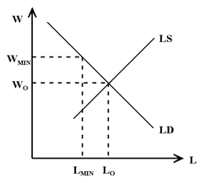<a onClick="window.open('/olcweb/cgi/pluginpop.cgi?it=gif:: ::/sites/dl/free/0070891540/43154/benjamin_07_02_250_217.gif','popWin', 'width=266,height=233,resizable,scrollbars');" href="#"><img valign="absmiddle" height="16" width="16" border="0" src="/olcweb/styles/shared/linkicons/image.gif"> (4.0K)</a> | Figure 7-2
- suppose that the government imposes a minimum wage of W_{min} > W_{o}
- at the wage W_{min}, profit-maximizing firms will only employ L_{min} workers and (L_{o} – L_{min}) workers will lose their jobs
  - the number of workers who lose their jobs following the imposition of a minimum wage depends on the elasticity of the labor demand curve for minimum wage workers and the size of the (W_{min} – W_{o}) differential (factors affecting the elasticity of the demand for labor curve were discussed in Chapter 5)
  - for example, if the elasticity of labor demand curve is – 1/3 and there are 1,000,000 Canadian workers paid the minimum wage, an increase in the minimum wage of 3% (about $.20) will result in 10,000 Canadian workers losing their 'minimum wage' jobs; the vast majority of 'minimum wage' workers (990,000 out of 1,000,000) keep their jobs and receive a 3% wage increase
- a modest increase in the minimum wage creates a few big losers (minimum wage workers who lose their jobs and their entire annual labor income) and many small winners (workers who keep their jobs and receive a modest increase in wages and annual income)
  - most of the 'losers' tend to be young people with few skills and little work experience
- it should also be noted that raising the minimum wage does little to alleviate poverty because relatively few low-income households have minimum wage workers (most poor individuals do not work) and relatively few minimum wage workers live in low-income households
  - many 'minimum wage' workers (particularly young singles) are part of a family and have access to family income well above poverty levels
Monopsony in the Labor Market
- a perfectly competitive firm is a price taker in the product market (it can sell all it wants to at the market price) and is a wage taker in the labor market (it can buy any quantity of labor at the market wage rate — the labor supply curve is horizontal)
  - the perfectly competitive firm is typically a very small player in a very large product market and a very large labor market
- a monopolist faces a downward-sloping product demand curve and sets the price (by restricting output) to maximize profits
  - a monopolist equates marginal revenues (MR) to marginal costs
- a monopsonist faces an upward-sloping labor supply curve and sets the wage rate (by restricting the amount of labor hired) to maximize profits
  - a monopsonist equates the marginal cost of hiring another worker with the Value of the Marginal Product of Labor (VMPL = P*MPL); if the monopsonist is also a monopolist, the marginal cost of hiring is equated to the Marginal Revenue Product of Labor (MRPL = MR*MPL)
  - a monopsonist firm is typically a large player in a small labor market (for example, a 'one company' town in an isolated region); it can exercise market power as a buyer of labor
The Monopsonist's Demand for Labor
- Figure 7-3 depicts the monopsonist's upward-sloping labor supply (LS) curve
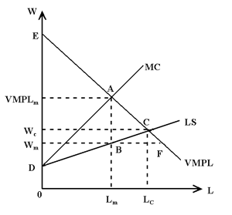<a onClick="window.open('/olcweb/cgi/pluginpop.cgi?it=gif:: ::/sites/dl/free/0070891540/43154/benjamin_07_03_300_279.gif','popWin', 'width=316,height=295,resizable,scrollbars');" href="#"><img valign="absmiddle" height="16" width="16" border="0" src="/olcweb/styles/shared/linkicons/image.gif"> (7.0K)</a> | Figure 7-3
- to attract and hire additional labor, the monopsonist must raise the wage (LS slopes up)
  - if a monopsonist reduces the wage, some (but not all) workers will withdraw their labor services
    - if a perfectly competitive firm reduces the wage below the market-clearing level, all workers will leave the firm
- given an upward-sloping labor supply (LS) curve, there is an upward-sloping marginal cost (MC) of labor curve
  - to hire additional workers the monopsonist has to raise the wage rate; since all existing employees will also receive the new higher wage, the marginal cost of hiring an additional worker is greater than the wage paid to the additional worker
    - for example, suppose that a firm has 10 employees being paid $100 each; to hire an additional worker, the firm must raise the wage rate, say to $105; the marginal cost of adding the 11th worker is $155, i.e., $105 for the new worker and an additional $5 for each of the 10 workers already employed
  - the slope of the MC curve is steeper than the slope of the LS curve
- a profit-maximizing monopsonist will keep hiring workers up to the point where the marginal cost (MC) of hiring an additional worker is equal to the value of the marginal product of labor (VMPL), or equal to the marginal revenue product of labor (MRPL) if the monopsonist is also a monopolist
- in Figure 7-3, profit maximization occurs at point A, the intersection of the marginal cost (MC) of labor curve and the VMPL curve
- the monopsonist will hire L_{m} workers, pay each worker W_{m}, and make a profit equal to the profit triangle AED (the sum of VMPL – MC for each worker)
  - the last worker hired by the monopsonist has a VMPL_{m} > the wage (W_{m})
  - at the profit-maximizing wage W_{m}, there are vacancies equal to the horizontal distance BF in Figure 7-3; the profit-maximizing monopsonist does not fill these vacancies because that would require an increase in wages for all existing employees
- compared to perfect competition in the labor market (point C in Figure 7-3), the monopsonist hires fewer workers (L_{m} < L_{c}) and pays each worker a lower wage (W_{m} < W_{c})
Minimum Wages in a Monpsonist Labor Market
- Figure 7-4 illustrates the effects of a minimum wage in a monopsony labor market
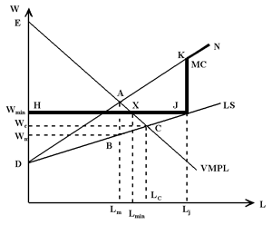<a onClick="window.open('/olcweb/cgi/pluginpop.cgi?it=gif:: ::/sites/dl/free/0070891540/43154/benjamin_07_04_300_248.gif','popWin', 'width=316,height=264,resizable,scrollbars');" href="#"><img valign="absmiddle" height="16" width="16" border="0" src="/olcweb/styles/shared/linkicons/image.gif"> (8.0K)</a> | Figure 7-4
- the profit-maximizing position for a monopsonist is again point A (where MC = VMPL)
  - the monopsonist hires L_{m} workers, pays each worker W_{m}, and makes a profit equal to the profit triangle AED
- now suppose that the government sets the minimum wage at W_{min}
- the minimum wage replaces that segment of the original labor supply curve to the left of point J in Figure 7-4; the minimum wage law prevents firms from hiring labor at a wage less than W_{min}
  - the new kinked LS curve is the horizontal line HJ (at the minimum wage) and the original LS curve for wage rates greater than the minimum wage
- given a new kinked LS curve, there will be a new kinked marginal cost (MC) of hiring labor curve
- along the new HJ horizontal section of the LS curve, the marginal cost of hiring an additional worker is the minimum wage
  - the HJ horizontal section of the LS curve is also the monopsonist's marginal cost (MC) of labor curve (for labor quantities up to L_{j})
- if the firm hires more than L_{j} workers, it will have to pay all it's existing workers a wage higher than the minimum wage; the marginal cost for hiring an additional worker past point J is considerably higher than the minimum wage
  - past point J the marginal cost curve corresponds to the original marginal cost curve
- the new 'minimum wage' marginal cost (MC) of labor curve is discontinuous at point J and is represented by the kinked line HJKN
- the monopsonist will maximize profits at point X, where the new kinked MC curve intersects the VMPL curve
  - given a minimum wage W_{min}, the monopsonist will hire L_{min} workers and make a profit equal to the new profit triangle HEX
- imposing a minimum wage on a monopsonist has the following labor market effects:
  - an increase in employees hired, from L_{m} to L_{min}
  - an increase in the wage rate paid to employees, from W_{m} to W_{min}
  - a decrease in monopsonist profits (in Figure 7-4, the new profit triangle HEX is smaller than the original profit triangle ADE
- in effect, the imposition of a minimum wage redistributes some of the monopsonist's profits to workers in the form of higher wages and/or increased employment levels
- if the government wanted to achieve the maximum positive wage effect, it should set the minimum wage at point A; the monopsonist would hire no new employees but would pay all of its existing workers a much higher wage (point A compared to point B)
- if the government wanted to achieve the maximum employment effect, it should set the minimum wage at point C (which corresponds to the competitive labor market outcome)
  - the monopsonist would hire (L_{c} – L_{m}) additional employees and pay all workers a higher wage (W_{c} versus W_{m})
- the AC segment of the VMPL curve represents a 'trade-off' curve for a government imposing a minimum wage on a monopsonist
  - moving from A towards C increases the positive employment effect of the minimum wage but decreases the wage gain for all existing workers
- in conclusion, the imposition of a minimum wage in a labor market where employers have monopsony power can result in an increase in employment
  - in a perfectly competitive labor market the imposition of a minimum wage will result in a decrease in employment
- the radically different employment effects of a minimum wage under different assumptions about the competitive structure of the labor market raises an obvious question: are there monopsonists in the real world, or only in labor economics textbooks?
- most firms have some monopsony power in the short run; most firms can lower the wage rate without immediately losing all of their workers and a firm may have to raise the wage rate to attract more workers in a local labor market
- however, most firms do not have monopsony power in the long run; if the firm cuts its wage rate, eventually its employees will move to other employers (in the long run workers are mobile)
- the obvious exception to the 'no monopsony in the long run' argument is a 'one company' town in an isolated labor market (for example, a mining company or pulp/paper mill in Northern Ontario)
  - there are few other employers in the immediate area, existing workers are reluctant to leave their hometown, and new workers are reluctant to move to an isolated area (there is limited labor mobility)
  - however, in most cases workers in the 'one company' have unionized and bargained for wage rates higher than the government would set as the minimum wage (see Chapter 15); the imposition of a minimum wage less than the union wage would have no effect on labor demand
- are there any examples of labor markets where employers have monopsony power and employ low wage workers?
- perhaps the McJob market, low-wage jobs in fast-food outlets
  - unskilled, low-wage workers tend to be immobile: there are costs to moving and little expected gain from a move (what difference does it make if you flip hamburgers here or there?)
  - a fast-food outlet may have a well defined local labor market (within walking distance or a short bus ride)
  - it may also be the case that high welfare benefits reduce the net gain from working and the firm may have to offer a higher wage to attract welfare recipients
- given a local labor market with limited labor mobility of low skilled workers, the labor supply curve for McJobs may slope up; the firm may have to increase the wage rate (or offer recruitment bonuses) to attract additional workers
  - under such circumstances, a minimum wage could increase employment levels
- for a discussion of the U.S. literature on the employment effects of minimum wages, including the Card and Krueger study of minimum wages and 'fast-food' jobs (see textbook page 215), click-on:
http://www.uvm.edu/~vlrs/doc/min_wage.htm

