The Changing American Household
Society’s view of marriage is changing.
http://www.pewsocialtrends.org/2011/12/14/barely-half-of-u-s-adults-are-married-a-record-low/?src=prc-headline
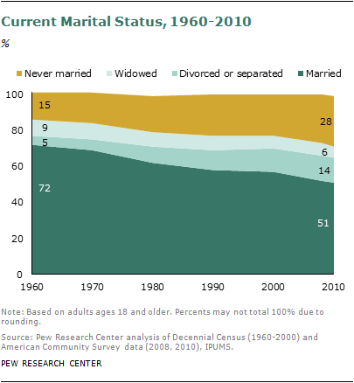
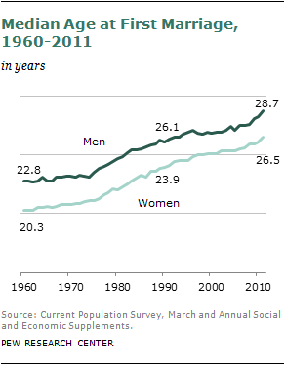
http://www.pewsocialtrends.org/2011/12/14/marriage-rate-declines-and-marriage-age-rises/
General
There are 99.6 million unmarried people over age 18 in the U.S., representing nearly 44% of the adult population. U.S. Census Bureau. "America's Families and Living Arrangements: 2010"
In 2010, unmarried households were 45% of all U.S. households. - U.S. Census Bureau. "America's Families and Living Arrangements: 2010"
44.9% of the unmarried population aged 18 and older are female. For every 100 unmarried women there are 88 unmarried men. -U.S. Census Bureau. "America's Families and Living Arrangements: 2010"
23.0% of the unmarried population aged 18 and older are people of color and 77.0% are white. While a clear majority of the unmarried population is white, it is considerably more racially diverse than the married population. - U.S. Census Bureau's Current Population Survey (CPS), 2007.
39.2% of the unmarried population aged 18 and older were formerly married and 60.8% have always been single - U.S. Census Bureau's Current Population Survey (CPS), 2008.
8.9% of the married adult population is aged 18-29 years, compared to 33.7% of the unmarried adult population, while 3.2% of the married adult population is aged 80 years or over, compared to 6.5% of the unmarried adult population. - U.S. Census Bureau. American Community Survey: 2005.
49.9% of the married population are women, compared to 56.4% of unmarried population. - U.S. Census Bureau. American Community Survey: 2005.
http://www.unmarried.org/statistics.html

Cohabitating and income
http://www.usatoday.com/news/nation/census/2010-09-24-cohabitation24ONLINE_ST_N.htm

Cohabitating and divorce
http://www.ewtn.com/library/ISSUES/zcohabit.htm
Divorce rates by state
http://www.infoplease.com/ipa/A0923080.html
Marriages and divorces by state by year
http://www.infoplease.com/ipa/A0005044.html
Discussion Questions
What are the economic implications of these trends?
Did the trends cause the economic changes or did the economic changes cause the trends?
In your opinion is society going in the direction you think it should be going? Explain why.
Given the number of single family homes, how has the recent economic downturn in the labor market pressured the government’s involvement in society and the stabilization of the household?
Do you think it is a good idea for young people to live together after college – guys and ladies – for economic reasons? Pros and cons
How has the number of divorces impacted the concept of women in the labor force?

