SCPSA 2008

PROGRAM FOR THE

2008 Annual Meeting of the South Carolina Political Science Association

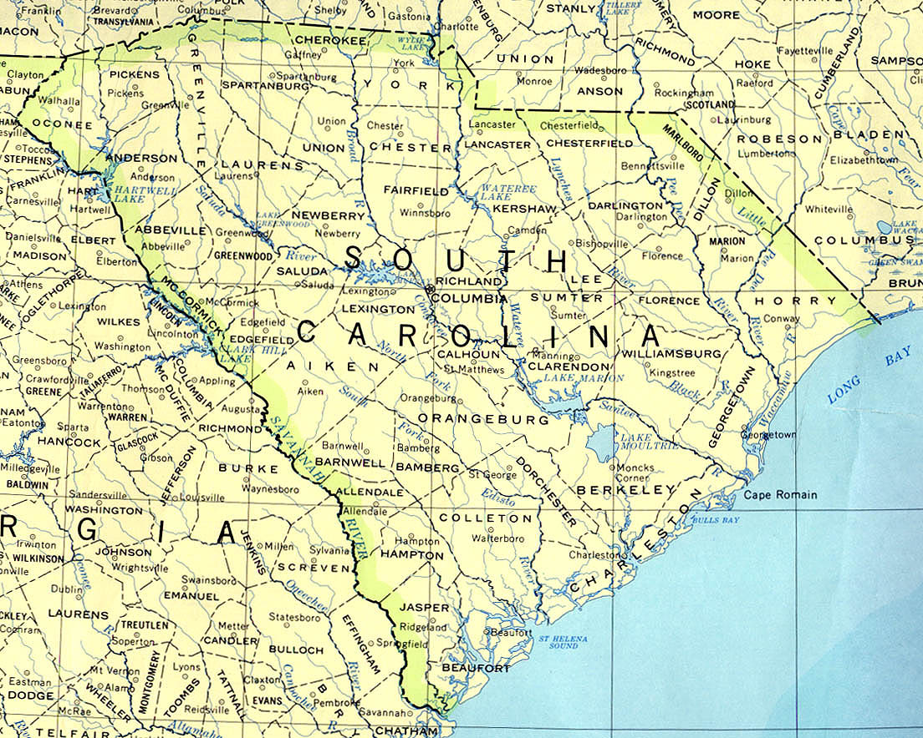

HOSTED BY:

DEPARTMENT OF SOCIAL SCIENCES
SOUTH CAROLINA STATE UNIVERSITY
FINE ARTS CENTER

300 COLLEGE STREET, N.E.
ORANGEBURG, SOUTH CAROLINA 29117-0001

SATURDAY, MARCH 1, 2008
~ SCHEDULE ~

Rooms within the Fine Arts Center are denoted by (FA #) or (Vaughn) for the Barbara A. Vaughn Recital Hall

9:00 – 9:30 a.m. Welcome
Continental Breakfast (Lobby)

9:30 – 10:45 a.m. Session I

Panel 1: American Politics I (Vaughn)
Roundtable: Women, Politics and Policy: Trends in the Nation and
South Carolina

Chair: Karen M. Kedrowski (Winthrop University)

Roundtable Participants: Adolphus G. Belk, Jr (Winthrop University)
Lynne Ford (College of Charleston)
Linda Salane (Alliance for Women and Columbia College)
Laura Woliver (University of South Carolina)

Panel 2: Political Theory (FA 305)

Chair: Willie M. Legette (South Carolina State University)

Papers:

William Joseph Maye (Winthrop University), The Republic of Plato or Socrates? A
Defense of the Ironic Interpretation and its Socratic Genesis

Colin D. Pearce (University of South Carolina – Beaufort), Napoleonic Ambition and
Jeffersonian Virtue: The Case of Lewis Rand

Erin M. McCullough (University of South Carolina – Aiken), Limitation and
Reform: Leo Strauss’ Interpretation and Analysis of Plato’s Republic

Discussant: Jacob Butler (Morris College)

Panel 3: Public Policy (FA 203)

Chair: Teresa Nesbitt Cosby (Furman University)

Lucas McMillan (University of South Carolina), Costly or Cost-Free? An Analysis of
Governors’ Participation in U.S. Foreign Policy

Amber Freeman (South Carolina State University), Political Analysis of the 1906 Atlanta
Race Riot

Heather Getha-Taylor (University of South Carolina), Reflections on the Civil Service
Reform Act: Thirty Years Later

Kristen Capogrossi (Furman University), Traditionalistic and Title III: The Ability of a
Federalist System to Address National and State Concerns

Discussant: Don Raber (Presbyterian College)

10:45 – 11:00 a.m. Break

11:00 a.m. – 12:15 p.m. Session II

Panel 4: American Politics II (Vaughn)
Roundtable: Election 2008 – National and Southern Politics

Chair: C. Blease Graham, Jr. (University of South Carolina)

Roundtable Participants: Robert Botsch (University of South Carolina – Aiken)
Scott Huffmon (Winthrop University)
Bruce Ransom (Clemson University)

Panel 5: Roundtable on Teaching and Learning in Political and Social
Sciences (FA 203)

Chair/Discussant: Kimberly Richburg (Lander University)

Paper:

Teresa Nesbitt Cosby (Furman University), Does Participation in an Undergraduate
Mock Trial Program Improve the Performance of Students in Law Schools?

Presenter:

Larry D. Watson (South Carolina State University), Fully Integrating
Technology in the Teaching of Social Studies – National Humanities Center Tool Box

Panel 6: Undergraduate Symposium on International Negotiation:
The Impact of Culture (FA 305)

Chair: Ken Rogers (Coastal Carolina University)

Papers:

Jonathan White (Coastal Carolina University), Understanding the French Negotiation
Style: Historical, Cultural, and Philosophical Influences

Shane Watson (Coastal Carolina University), Adapting to the High-Context Style of
Negotiation

Mary de Metz (Coastal Carolina University), Negotiating with a Potential Nuclear
Capable Iran

Discussant: Joseph Stewart, Jr. (Clemson University)

12:15 – 12:30 p.m. Break

12:30 – 1:45 p.m. Lunch (Student Center – Bulldog Lounge)

Welcome: E. Gail Joyner-Fleming, Interim Dean of Education,
Humanities and Social Sciences,
South Carolina State University

Keynote Speaker: Attorney Carl B. Epps, III of Nelson Mullins Riley &
Scarborough LLP in Columbia, South Carolina

Presentation of Mary Jean Byrd Award for Best Undergraduate Paper

Business Meeting

1:45 – 2:00 p.m. Break

2:00 – 3:15 p.m. Session III

Panel 7: The Impact of Culture on Global Politics (FA 203)

Chair: Laura Woliver (University of South Carolina)

Papers:

Karen Kedrowski (Winthrop University), Breastfeeding Policies and Practices in an
International Human Rights Context

Alissa Warters (Francis Marion University), All in the Family: The Use of Surrogates in
the 2008 Presidential Primaries

Kema Irogbe (Claflin University), The Cultural Impact of Globalization on
Non-Western Societies
Roger L. Lovegrove (Winthrop University), End Credits: An Analysis of Contemporary
Contagion Films and the Eschatology of the Apocalypse Myth

Discussant: Colin D. Pearce (University of South Carolina – Beaufort)

Panel 8: Politics and Policy in the Carolinas (FA 305)

Chair: Lucas McMillan (University of South Carolina)

Papers:

Dan Ruff (Midlands & Orangeburg-Calhoun Technical Colleges), Black Republican
Candidates in South Carolina during the Modern Era

Stephen Samuel Smith (Winthrop University), The Politics of School Resegregation in
Charlotte-Mecklenburg

Christopher Skeen (University of South Carolina – Aiken), Immigration Attitudes and
The Confederate Flag

Robert and Carol Botsch (University of South Carolina – Aiken), A Case Study of
Dog/Cat Neuter Policy in Aiken County

Discussant: David White (Francis Marion University)

Panel 9: American Politics III (Vaughn)
Roundtable: Election 2008 – The Obama Phenomenon and its Larger
Political Implications

Moderator: Sherral Brown-Guinyard (South Carolina State University)

Roundtable Participants: Jacob Butler (Morris College)
James Henderson (Coastal Carolina University)
Willie M. Legette (South Carolina State University)

***********************************

Judges for Mary Jean Byrd Award for Best Undergraduate Paper

Heather Getha-Taylor, University of South Carolina
Don Raber, Presbyterian College
Joseph Stewart, Jr., Clemson University

***********************************
Keynote Speaker

Attorney Carl B. Epps, III
Partner of Nelson Mullins Riley & Scarborough LLP
in Columbia, South Carolina

Mr. Epps has served as coordinating trial counsel for clients on a national and regional level. He has extensive experience in both federal and state courts, and has been an active trial lawyer throughout his career. He has represented clients in, among other areas of litigation, banking disputes, directors and officers' liability, professional negligence claims, chemical exposures, real estate development, product liability, and a variety of other forms of litigation. He has represented litigation clients in numerous jurisdictions and has been lead counsel in approximately 100 cases that have gone to verdict. In 1996, Mr. Epps received the Robert M. Hemphill Award, given by the South Carolina Defense Trial Attorneys' Association for distinguished and meritorious service to the legal profession and the public. In 2000, he received the Compleat Lawyer Award, given by the University Of South Carolina School Of Law for significant contributions to the legal professional by a graduate who embraces the highest standard of professional competence, ethics and integrity. Mr. Epps frequently speaks on subjects related to his areas of practice and has served as a faculty member for an International Association of Defense Counsel Trial Academy. Mr. Epps is listed in Who's Who in American Law and in The Best Lawyers in America. In 2005, the South Carolina Chapter of the American Board of Trial Advocates named Mr. Epps Trial Lawyer of the Year.

Mr. Epps is a Fellow of the American College of Trial Lawyers and a member of the American Bar Association, the American Board of Trial Advocates (president, Columbia-Greenville Chapter, 1991), and The Supreme Court Historical Society. As a member of the Defense Research Institute, he has held numerous positions of leadership, including the following: chair, Corporate Roundtable, 2002; chair, Toxic Tort and Environmental Law Committee, 1997-99; board member, 1995-98; chair, Law Economics Committee, 1994-95; regional vice president, 1994-95; and South Carolina state chair, 1987-94. Mr. Epps is a member of the International Association of Defense Counsel, the Richland County Bar Association, the South Carolina Defense Trial Attorneys' Association (president, 1987-88); and Trial Attorneys of America.

A member of the South Carolina Bar for more than 30 years, Mr. Epps is admitted to practice before the 4th U.S. Circuit Court of Appeals and the U.S. District Court for the District of South Carolina.

In 1970, Mr. Epps earned a Juris Doctor, magna cum laude, from the University Of South Carolina School Of Law where he was co-recipient of the Claude M. Sapp Award for outstanding achievement. During law school, he was secretary-treasurer, and later president of the law school student body, a member of the Order of Wig and Robe, Phi Delta Phi, and a member of the board of editors of the South Carolina Law Review. Before entering law school, Mr. Epps worked for Ciba Pharmaceutical Company. In 1966, Mr. Epps earned a Bachelor of Science degree from the University of South Carolina.

(Excerpted from http://www.nelsonmullins.com/lawyers/print-bio.cfm?ID=28)
Lodging in Orangeburg

OFFICIAL HOTEL FOR THE SCPSA CONFERENCE

SLEEP INN
3689 St. Matthews Road
Orangeburg, South Carolina
803-531-7200
FAX: 803-531-4100
EMAIL: gm.SC071@choicehotels.com

Group Number: 1483

**************************************************
Restaurants in Orangeburg

Ruby Tuesday
Fatz Cafe
Mediterranean Grill and Spirits
Cracker Barrel Old Country Store
Kentucky Fried Chicken
Subway
Wendy’s
Hardees
Burger King
McDonald’s

(Located in the vicinity of St. Matthews Road / Hwy 601 near I – 26)

**************************************************

(Information concerning other Orangeburg area hotels and restaurants is available upon request.)

Directions to South Carolina State University

South Carolina State University (SCSU) is located in Orangeburg, South Carolina, at Interstate 26 and U.S. Highway 601 [Exit 145].

If traveling to Orangeburg via I-95
Traveling south, take I-95 to exit 97 [US 301 south] Orangeburg. Continue south on US 301, for approximately 22 miles, to US 601 [Magnolia] (McDonalds across the street). Turn right at the light. Then, turn right at the 2nd light. [Geathers Street.]. Proceed to SCSU guard booth; keep left at fork in road. At end of street make left then an immediate right into Smith Hammond Middleton (GYM) parking lot. The Fine Arts Center is located across the street.

*************

Traveling north, take I-95 to exit 86B [I-26 west]. Take I-26 west to exit 145A (Orangeburg) [US 601 south], and continue on US 601 south approximately 5 miles. SCSU will be on the left. Proceed to SCSU guard booth; keep left at fork in road. At end of street make left then an immediate right into Smith Hammond Middleton (GYM) parking lot. The Fine Arts Center is located across the street.

If traveling to Orangeburg via I-20
Traveling east from Georgia or west within South Carolina, take I-20 to exit 64
[I-26 east]. Continue on I-26 east to exit 145A (Orangeburg) [US 601 south].
Continue on US 601 south approximately 5 miles. SCSU will be on the left. Proceed to SCSU guard booth; keep left at fork in road. At end of street make left then an immediate right into Smith Hammond Middleton (GYM) parking lot. The Fine Arts Center is located across the street.

If traveling to Orangeburg via I-26
Traveling east (from Columbia), or west (from Charleston) within South Carolina, take I-26 to exit 145A (Orangeburg) [US 601]. Continue on US 601 south approximately 5 miles. SCSU will be on the left. Proceed to SCSU guard booth; keep left at fork in road. At end of street make left then an immediate right into Smith Hammond Middleton (GYM) parking lot. The Fine Arts Center is located across the street.

MAP OF

SOUTH CAROLINA STATE UNIVERSITY
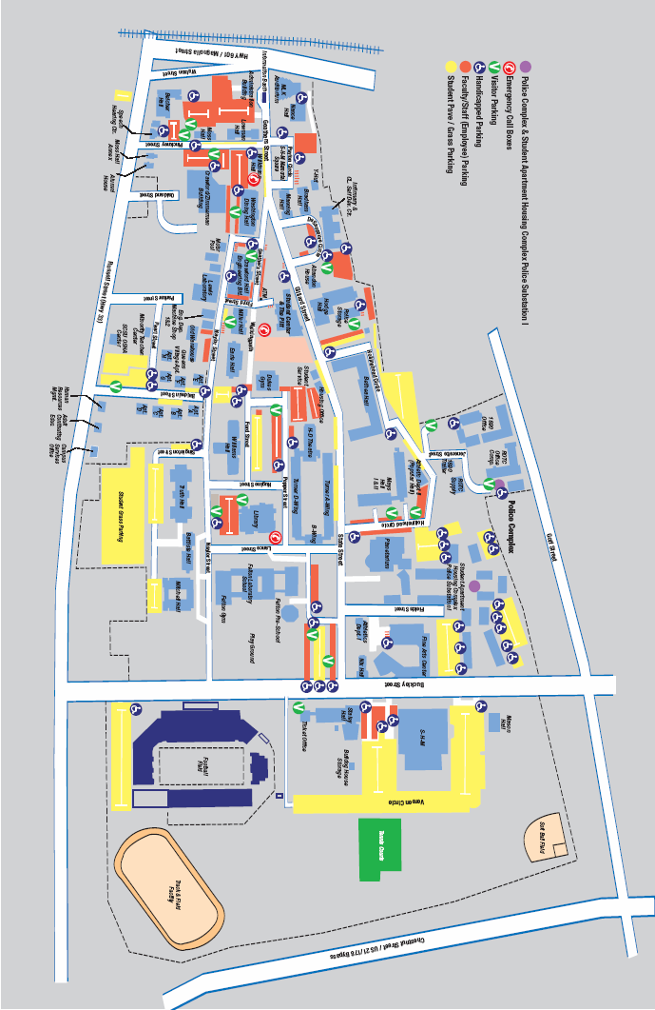

Main Entrance

Student
Center

Fine Arts

SHM
Parking

INDEX OF CONFEREES

Name Institution Panel #
Adolphus G. Belk, Jr. Winthrop University belka@winthrop.edu 1
Carol Botsch USC – Aiken carolb@usca.edu 8
Robert Botsch USC – Aiken bobb@usca.edu 8
Byron Brock SCSU Byron2209@yahoo.com Facilitator
Sherral Brown-Guinyard SCSU sbguinyard@scsu.edu 9
Jacob Butler Morris College jbutler@morris.edu 2, 9
Kristen Capogrossi Furman University kristen.capogrossi@furman.edu 3
Carl B. Epps, III Nelson Mullins Riley &
Scarborough LLP Keynote Speaker Luncheon
Cindaia Ervin SCSU Cervin4@scsu.edu Facilitator
Mary de Metz Coastal Carolina University 6
Lynne Ford College of Charleston fordl@cofc.edu 1
Amber Freeman SCSU amberf86@hotmail.com 3
Heather Getha-Taylor USC – Columbia GethaTay@gwm.sc.edu 3
C. Blease Graham, Jr. USC – Columbia cgraham@gwm.sc.edu 4
James Henderson Coastal Carolina University henderj@coastal.edu 9
John T. Holder Winthrop University holderj@winthrop.edu
Scott Huffmon Winthrop University huffmons@winthrop.edu 4
Kema Irogbe Claflin University irogbe@claflin.edu 7
E. Gail Joyner-Fleming SCSU zf_gfleming@scsu.edu Luncheon
Daniel Jones SCSU djjones@yahoo.com Facilitator
Karen M. Kedrowski Winthrop University kedrowskik@winthrop.edu 1
Eileen Kirley-Tallon Francis Marion University ekirleytallon@fmarion.edu
Willie M. Legette SCSU wmlegette@scsu.edu 2
Roger L. Lovegrove Winthrop University lovegrove@winthrop.edu 7
Megan Martino SCSU mmarti19@scsu.edu Facilitator
William Joseph Maye Winthrop University maye2@winthrop.edu 2
Whitney McCrea SCSU whsemc@yahoo.com Facilitator
Erin M. McCullough USC – Aiken emmccullough@usca.edu 2
Lucas McMillan USC – Columbia mcmillan@sc.edu 3, 8
Teresa Nesbitt Cosby Furman University teresa.cosby@furman.edu 3, 5
Colin D. Pearce USC – Beaufort pearce@sc.edu 2, 7
Don Raber Presbyterian College draber@presby.edu 3
Bruce Ranson Clemson University bruce@strom.clemson.edu 4
Kimberly Richburg Lander University krichburg@lander.edu 5
Ken Rogers Coastal Carolina University krogers@coastal.edu 6
Dan Ruff Midlands & O-C Technical Colleges druff1@sc.rr.com 8
Linda Salane Alliance for Women
& Columbia College lsalane@colacoll.edu 1
Christopher Skeen USC – Aiken skeen.c@gmail.com 8
Stephen Samuel Smith Winthrop University smiths@winthrop.edu 8
Joseph Stewart, Jr. Clemson University jstewa4@clemson.edu 6
Alissa Warters Francis Marion University twarters@fmarion.edu 7
Konisha Watson SCSU kwatso8@scsu.edu Facilitator
Larry D. Watson SCSU dwatso17@scsu.edu 5
Shane Watson Coastal Carolina University 6
David White Francis Marion University dwhite@fmarion.edu 8
Jonathan White Coastal Carolina University 6
Laura Woliver USC – Columbia woliver@gwm.sc.edu 1, 7
Min Ye Coastal Carolina University mye@coastal.edu

