Non Profit Client and Donor Directory
Software
Design
Document

February 13, 2010
Document: NPCDD-SDD

____________________________________
Jessica Alford, Project Leader
Katie McMullen
Tom Lawrence
Anthony Kent
Clay Hambright

____________________________________
Dr. Garrison, Professor
CSCI 680
Winthrop University

(Original Signed)

Contents
Contents 2
Revision Sheet
Review History
1. Introduction
1.1 Purpose
1.2 System Overview
1.3 Design Goals
1.4 References
2. Current software architecture
3. Design Decisions
3.1 Access control and security
4. Architectural/Detailed design
4.1 Overview
4.2 Boundary Conditions
4.3 Subsystem Design
4.4 Hardware/Software Mapping
4.5 Persistent Data management
5. Interface Design
Appendix A Acronyms, Definitions and References
A.1 Acronyms
A.2 Definitions

Introduction

Purpose of the system
This document provides a high level description of the planned design and implementation of the Non-profit Client and Donor Directory. The directory shall be designed to be a software solution for two non-profit organizations in York Country, South Carolina. The first customer, Tender Hearts Ministries is managing a thrift store and is in need of a database to store client’s information. The second customer, Children’s Attention Home (CAH) is a non-profit 24 hour emergency shelter and in need of a database to store volunteer and donor information. The Non-Profit Client and Donor Database is a collaboration of the requirements from Tender Hearts Ministries and Children’s Attention Home. The Non Profit Client and Donor Directory Software Development Plan will outline the functional and non-functional requirements in which the design of the system shall follow.

Design Goals
The goals of the system are to make it easier for client, donor, and volunteer information to be input into the system as well as search by related fields of interest for each data type specified.

Cost containment
Robustness
Access control
User Friendly Interface
Good documentation
Limited modifiability by qualified Access technicians

References
Non-Profit Client and Donor Directory-SDP

Current software architecture
Two current systems will be replaced and integrated to form the Non-Profit Client and Donor Directory. The first system is a Microsoft Access database used by Tender Hearts. This system is a simple access database that stores client information. The software team will be building upon Tender Heart's Access Database system but with develop a new front-end. The new system will keep all of the current functionality and add some additional features.
The second system is a Microsoft Excel spreadsheet used by the Children's Attention Home. This spreadsheet stores donor and volunteer information. The two systems are to be combined to form the Non-profit Client and Donor Directory.
Figure 1 depicts the high-level system architecture. The system will be constructed from multiple distinct components:
- User Interface — the windowed interface for editing inputting personal information, and viewing or printing reports.
- Data Model — the classes needed to organize Therapies, Tasks, Profiles, Sessions, etc.
- Data Storage — the interface for storing, importing and exporting the data model and raw collected data.

Figure 1

USER INTERFACE(S)
Data Input

Database

Report Generation

Search and Sort

Figure Design Decisions

3.1…User Interface Design Decisions
The user interface design that shall be implemented is a tab centered design. There will be 4 tabs – client, donor, volunteer and reports. The client, donor and volunteer tabs shall allow the user to enter client, donor or volunteer information and save it to the database. They will also have the ability to search within that person type. Each tab will contain text inputs needed for those types. The individual tabs (client, donor, volunteer) will provide the user with drop down fields with which they can select search criteria. The program will start on a default tab that will be selected by the customer.
The reason for the tab-centered design is to allow the option of turning off certain tabs if either Tender Hearts Ministries or Children’s Attention Home is not using one of the person types (Client, Donor and Volunteer). There is a search field at the top of the Client, Donor and Volunteer tabs. These search criteria for the Search Drop-downs will be Last Name, First Name, Date of Birth for all with the additional referred by , affiliation and event (volunteer only) for search criteria for donor and volunteer.

Figure 3.1 Client Tab Wireframe
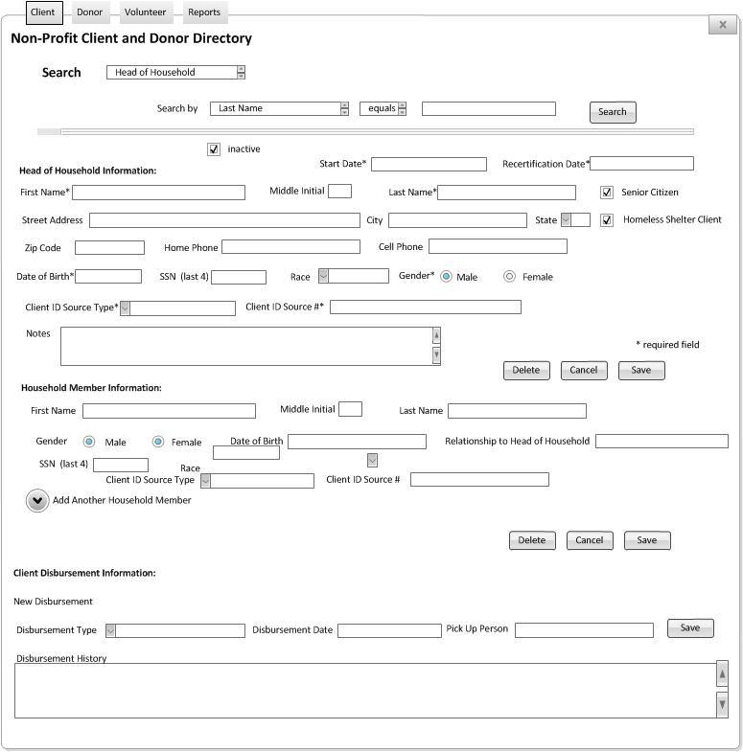

Notes on Client Tab: A Pop-up will appear when the recertification date is 2 months away

Figure 3.2 Donor Tab Wireframe
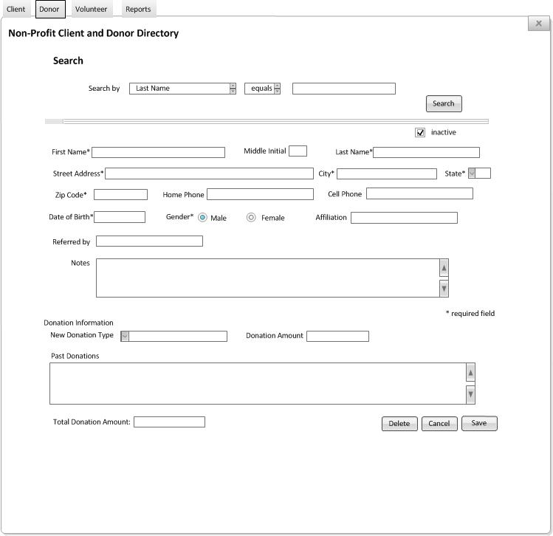
Figure 3.3 Volunteer Tab Wireframe
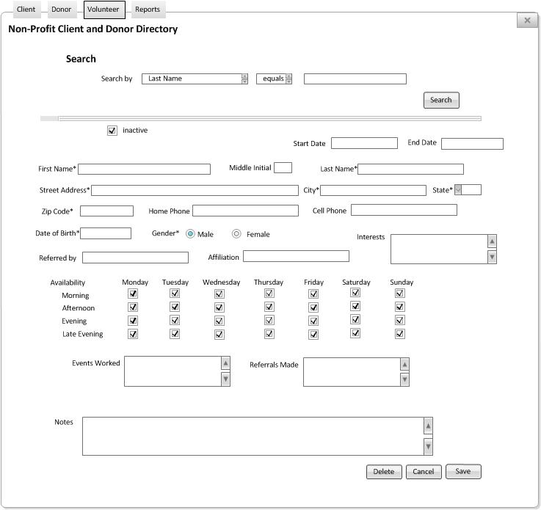

Figure 3.4 Reports Tab Wireframe
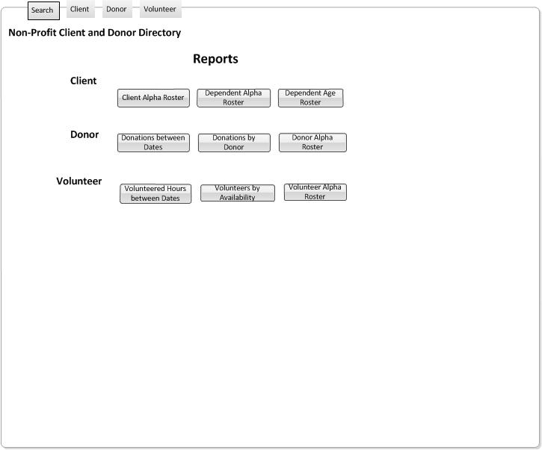

The following details the layouts of each report mentioned in the wireframe for the Reports tab. When you click on one of the buttons on the reports tab it will pop up asking whether to display the report with Active, Inactive or both types of clients, donors or volunteers depending on the report.

Figure 3.5 Layout of Client Alpha Roster

Figure 3.6 Layout of Dependent Alpha Roster
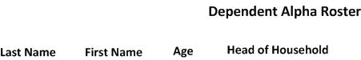

Figure 3.7 Layout of Dependent Age/Race Roster
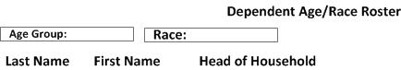

Figure 3.8 Layout of Donor Alpha Roster

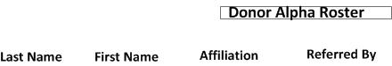

Figure 3.8 Layout of Donations for Donor Roster
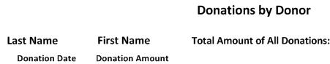

Figure 3.9 Layout of Donations between dates roster
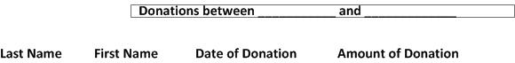

Figure 3.9 Layout of Volunteer Alpha Roster
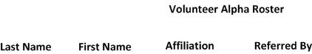

Figure 3.10 Layout of Volunteer Availability Roster (User will select time/date in popup to display those available during that time frame)

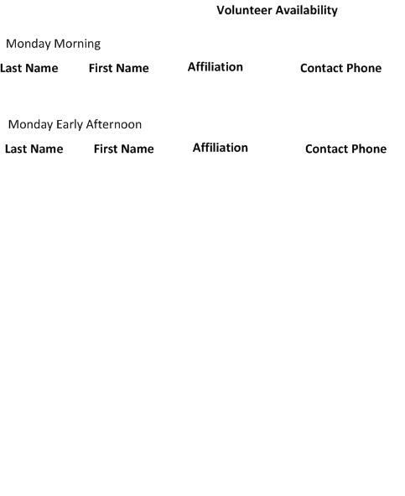
Figure 3.11 Layout of Volunteers Hours worked between dates roster
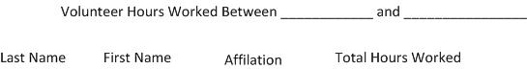

Figure 3.12 Admin Tab Wirefram

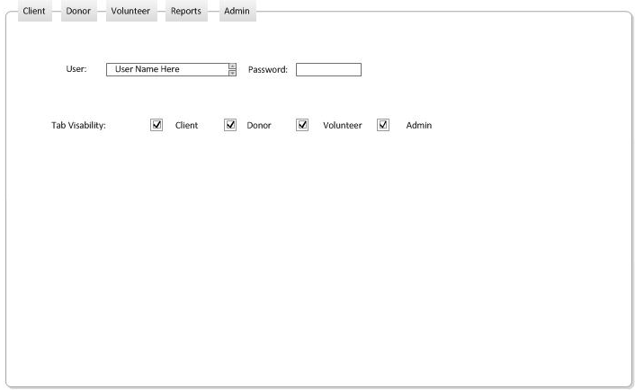
3.2 Error Handling & Data Validation
- If the user enters data into one of the fields that does not match the field type or length a pop-up error message will display when the save button is selected. The user will not be able to save until the error has been corrected.
- If the user does not enter information in all of the required fields that system will display a pop-up error when the user tries to save the information. The user must information into all required fields before the data will be saved.
- If database does not update, the system shall display an error pop up message.
- The system shall check for duplicate data when submitted.

3.3 Access control and security

- The system will have three user types, an administer, user and a superad administer

- Super administrator will have the ability to grant system usage to administrators and create extended capabilities. They will have the ability to hide tab items from view of users if a tab is not being used by either Tender Hearts or Children’s Attention Home.

- The administrator will have only the access grated by the super administrator, then will then have the ability to grant assess rights to users.

- Users will only be able to access those parts of the system the administrator granted for them access to.

- Due to the low risk associated with the system, the system will user the current security controls set up on the customer computer running Windows XP. The system will offer user protection by requiring users and administrators log-in using passwords and special identification names.

Architectural/Detailed Design

Overview
The system will have four subsystems, which include client, donor, volunteer and dependent.

Boundary Conditions
- The system shall close by the user clicking an “x” in the top right corner or by choosing the “exit” option from the drop down menu. Before the program completely exits, a pop-up window will appear asking the user to confirm they want to quit and reminding them to save their changes.
- When an error occurs the system shall provide information regarding the error type and a short explanation on how to handle the error though the user of a pop-up window.

4.3 Subsystem Decomposition
During the subsystem decomposition of the NPCDD we divide the system into smaller subsystems with a strong coherence. The different subsystems should have a loose coupling.
The system will be decomposed based on the use cases and the actors we have defined.
The decomposition shows the existence of the following subsystems:
- Volunteer Subsystem
- Donor Subsystem
- Client Subsystem

Hardware/software mapping

Requirements for Microsoft Access 2003
Component | Requirement
Computer and processor | Personal computer with an Intel Pentium 233-megahertz (MHz) or faster processor (Pentium III recommended)
Memory | 128 MB of RAM or greater
Hard disk | 180 MB of available hard-disk space; optional installation files cache (recommended) requires an additional 200 MB of available hard-disk space
Drive | CD-ROM or DVD drive
Display | Super VGA (800 × 600) or higher-resolution monitor
Operating system | Microsoft Windows 2000 with Service Pack 3 (SP3), Windows XP, or later
Other | Microsoft Exchange Server is required for certain advanced functionality in Microsoft Office Outlook; Microsoft Windows Server 2003 running Microsoft Windows SharePoint Services is required for certain advanced collaboration functionality; certain inking features require running Microsoft Office on the Microsoft Windows XP Tablet PC Edition; speech recognition functionality requires a Pentium II 400-MHz or faster processor and a close-talk microphone and audio output device; Information Rights Management features require access to a Windows 2003 Server running Windows Rights Management Services
Internet connection | Internet functionality requires dial-up or broadband Internet access (provided separately); local or long-distance charges may apply

Persistent data management
The NPCDD shall use Microsoft Access 2003 for its relational database. The tables below shows the requirement to satisfy, the table name, the table field names, and the data type associated with each. Primary keys and constraints are set according to the data type being entered into the system. The user shall identify whether the new input is a Client or Dependent, Donor, or Volunteer.

Client Information Table- Primary Key Information CLIENT ID

Table Name | Requirement Short Name | Database Field Description | Data Type | Comments | Required Field
ClientInformationTbl | Client ID | ClientID | Number | Auto-Generated | Y
 | Inactive | Inactive | True/False |  | N
 | Name | Lastname | String | 20 characters | Y
 |  | FirstName | String | 20 characters | Y
 |  | MiddleInitial | String | 1 character
 | Mobile Phone Number | CLCell | Number | 12 characters (###-###-####) | N
 | Home Phone Number | CLHome | Number | 12 characters (###-###-####) | N
 | Address | CLAddress | String | 30 characters | Y
 |  | CLCity | String | 15 characters | Y
 |  | CLState | String | 2 characters | Y
 |  | CLZip | Number | 5 integers | Y
 | Date of Birth | CLDOB | Date | 10 characters  (DD/MM/YYYY format) | Y
 | Notes | Notes | Text | 200 characters | N
 | Race | Race | String | Combo Box : Caucasian, African American, Native American, Asian, Hispanic, Pacific Islander, other | N
 | Gender | Gender | String | Limited to M,F | Y
 | Client ID Number | CLIDSourceNum | String | Combo Box: Medicaid, Medicare, SSI, SCEBT, Housing Authority, Driver’s License, Other ID | Y
 | Client ID Source | CLIDSource | String | (Drivers License, Medicaid Number) 20 characters | Y
 | Sr Citizen | CLSenior | Yes/no | Checkbox | N
 | Homeless Person | CLHomeless | Yes/No | Checkbox | N
Special Note: Recertification Date calculated from Start Date (1 year) | State Date | CLStartDate | Date | 10 characters  (DD/MM/YYYY format) | Y
 | Total in Household | CLTotalinHH | number | 2 Integers | Y

CLIENT HOUSEHOLD INFORMATION TABLE – Primary Key Information HHMember ID
Table Name | Requirement Short Name | Database Field Description | Data Type | Comments | Required Field?
ClientHouseholdInformaionTBL | Dependent Number | HHMemberID# | Number | autogenerated | Y
 | Client ID # | ClientID_CI | Number | Linked to Client Table by this field (one to many) | Y
 | Last Name | LastName | String | 20 characters | Y
 | First Name | FirstName | String | 20 characters | Y
 | Middle Initial | MiddleInitial | String | 1 character | N
 | Sex | HHSex | String | Checkbox | Y
*special note: Age needs to display on GUI and is calculated from DOB | Birthdate | HHDOB | Date | 10 characters  (DD/MM/YYYY format) | Y
 | Proof | HHIDProof | String | Combo Box: Medicaid, Medicare, SSI, SCEBT, Housing Authority, Driver’s License, Other ID | Y
 | ID | HHID | String | 20 characters | Y
 | Relationship | Relationship to Client | String | 20 characters | Y
Client Disbursement Table- Primary Key OrderID
Table Name | Requirement Short Name | Database Field Description | Data Type | Comments | Required Field?
ClientDisbursementTBL | Order ID | OrderID | Number | autogenerated | Y
 | Member ID | HHMemberID | Number |  | Y
 | Client Disbursement ID | ClientID_DISB | Number | autogenerated | Y
 | Disbursement Date | Disbursement Date | Date | 10 characters  (DD/MM/YYYY format) | Y
 | Disbursement Type | Disbursement Type | String | Combo Box (Food, Clothing, Thanksgiving, Christmas, Other) | Y
 | Pick Up Date | PickUp | Date | 10 characters  (DD/MM/YYYY format) | Y
 | Picked Up By | PickBy | String | 20 characters | Y

VOLUNTEER Table - Primary Key VolID
Table Name | Requirement Short Name | Database Field Description | Data Type | Comments | Required Field?
VolunteerInformationTBL | Volunteer ID | VolID | Number | Auto-Generated
 | Inactive | Inactive | True/False |  | N
 | Name | Lastname | String | 20 characters | Y
 |  | FirstName | String | 20 characters | Y
 |  | MiddleInitial | String | 1 character | Y
 | Mobile Phone Number | VOCell | Number | 12 characters (###-###-####) | N
 | Home Phone Number | VOHome | Number | 12 characters (###-###-####) | N
 | Address | VOAddress | String | 30 characters | Y
 |  | VOCity | String | 15 characters | Y
 |  | VOState | String | 2 characters | Y
 |  | VOZip | number | 5 integers | Y
 | Date of Birth | VODOB | Date | 10 characters  (DD/MM/YYYY format) | N
 | Notes | Notes | Text | 200 characters | N
 | Gender | Gender | String | Limited to M,F | Y
 | Availability | Available | String | Hours/Week/Mo | N
 | Referral | Reference | String | Who They referred, may be more than 1 | N
**Need to get list of interested from Children’s Attention Home?? | Interests | Interest | String | Combo Box with multiple selections | N
 | Affiliation | Affiliation | String | I.E. employer | N
Volunteer Table Continued… | Monday Availability Morning | AVL_Mon_AM | True/False | checkbox | N
 | Mon Availability Afternoon | AVL_Mon_AF | T/F | checkbox | N
 | Mon Availability Evening | AVL_Mon_EV | T/F | checkbox | N
 | Mon Availability Late Evening | AVL_Mon_LT | T/F | checkbox | N
 | Tues Availability Morning | AVL_Tues_AM | T/F | checkbox | N
 | Tues Availability Afternoon | AVL_Tues_AF | T/F | checkbox | N
 | Tues Availability Evening | AVL_Tues_EV | T/F | checkbox | N
 | Tues Availability Late Evening | AVL_Tues_LT | T/F | checkbox | N
 | Wed Availability Morning | AVL_Wed_AM | True/False | checkbox | N
 | Wed Availability Afternoon | AVL_Wed_AF | T/F | checkbox | N
 | Wed Availability Evening | AVL_Wed_EV | T/F | checkbox | N
 | Wed Availability Late Evening | AVL_Wed_LT | T/F | checkbox | N
 | Thurs Availability Morning | AVL_Thurs_AM | T/F | checkbox | N
 | Thurs Availability Afternoon | AVL_Thurs_AF | T/F | checkbox | N
 | Fri Availability Morning | AVL_Fri_AM | True/False | checkbox | N
 | Fri Availability Afternoon | AVL_Fri_AF | T/F | checkbox | N
 | Fri Availability Evening | AVL_Fri_EV | T/F | checkbox | N
 | Fri Availability Late Evening | AVL_Fri_LT | T/F |  | N
 | Sat Availability Morning | AVL_Sat_AM | True/False |  | N
 | Sat Availability Afternoon | AVL_Sat_AF | T/F |  | N
 | Sat Availability Evening | AVL_Sat_EV | T/F |  | N
 | Sat Availability Late Evening | AVL_Sat_LT | T/F |  | N
 | Sun Availability Morning | AVL_Sun_AM | True/False |  | N
 | Sun Availability Afternoon | AVL_Sun_AF | T/F |  | N
 | Sun Availability Evening | AVL_Sun_EV | T/F |  | N
 | Sun Availability Late Evening | AVL_Sun_LT | T/F |  | N

DONOR Table - Primary Key DOID

Table Name | Requirement Short Name | Database Field Description | Data Type | Comments | Required Field
DonorInformationTBL | Donor ID | DOID | Number | Auto-Generated | Y
 | Active/Inactive | Active | True/False | Checkbox | N
*Name not required because could be anonymous donor | Name | Lastname | String | 20 characters | N
 |  | FirstName | String | 20 characters | N
 |  | MiddleInitial | String | 1 character | N
 | Mobile Phone Number | DOCell | Number | 12 characters (###-###-####) | N
 | Home Phone Number | DOHome | Number | 12 characters (###-###-####) | N
 | Address | DOAddress | String | 20 characters | N
 |  | DOCity | String | 15 characters | N
 |  | DOState | String | 2 characters | N
 |  | DOZip | Number | 5 integers | N
 | Date of Birth | DODOB | Date | 10 characters  (DD/MM/YYYY format) | N
 | Notes | Notes | Text | 200 characters | N
*Need to check with Attention Home for drop down fields | Donation Type | Type | String Or Checkbox | Drop Down: In kind, Money, Time | Y
 | Referral | Reference | String | Referred By | N
 | Affiliation | Affiliation | String | I.E. employer | N

DATES of Service – Primary Key of Volunteer

Table Name | Requirement Short Name | Database Field Description | Data Type | Comments
Service | Dates Of Service | Dates | Date
 | Events Worked | EventName | String
 |  | Notes | String | Enter any notes

Interface Design
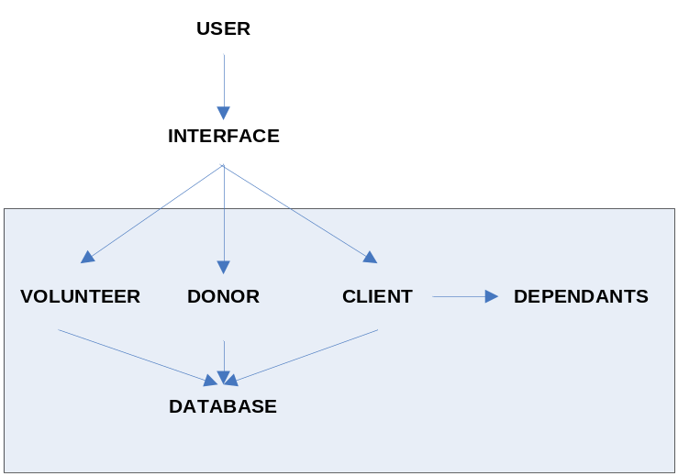

The user interface in NPCDD is an important component of NPCDD that will allow the interactive, flexible, use of the NPCDD software to users. To see further table information please see section 4.4.

Appendix A Acronyms, Definitions and References
This section shall provide the acronyms, definitions and references required to properly interpret the Software Design Document (SDD).

A.1 Acronyms
DBMS  NPCDD | Database Management System  Non-Profit Client and Donor Directory
GUI | Graphical User Interface
RTM | Requirements Traceability Matrix
SCI | Software Configuration Item
SDD | Software Design Document
SRS | Software Requirements Specification

A.2 Definitions
Configuration item | “An aggregation of hardware, software, or both, that is designated for configuration management and treated as a single entity in the configuration management process.” [IEEE90]

