**More Computer Basics**

**Things to Consider When Buying a Computer**

**File Management –** decide where to store your files. Decide what to name your files

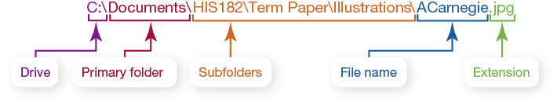

File names include the extension. What files types have an .exe extension?______________________________

**Software Categories** (A Programmer writes programs, a user runs programs.)

Two basic types of software and their purpose: Operating and Application. Give examples of each.

Other Software Categories:

1. ______________________ designed to allow the user to perform tasks. Examples:

2. ______________________ interacts directly with the hardware: operating system(OS), drivers, utilities

**Match** the following software types to the definitions: Beta version, Freeware, Open Source, Shareware

___________________ – copyrighted software you can get free. Examples:

___________________ – Programs still under development

___________________ – SW that allows users to run it for a limited time free of charge. Ex:

___________________ – free to use and change the source code if changes are distributed at no cost. Ex:

Everything in a computer uses **Binary numbers**

Storage Capacity

|  |  |  |
| --- | --- | --- |
| Bit | b | 0 or 1 |
| Byte | B | ? bits |
| Kilobyte | KB |  |
| Megabyte | MB |  |
| Gigabyte | GB |  |
| Terabyte | TB | 240 bytes =~ trillion |
| Petabyte | PB | 250 bytes =1,024 TB=Quadrillion |

A **network** is two or more computers that are connected so that data and resources can be shared

Example networks:

LAN

WAN

The **Internet** != WWW != Cloud

The major components of the Internet are: **(Internet service providers, servers, browsers**)

* + companies that make the connections
  + computers that provide services & information
  + software used to access the Internet

**URL –**

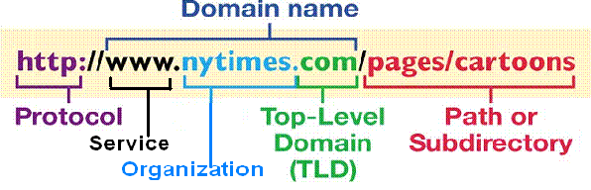

Example TLDs:

Identify suspect URL’s

Reasons to have Home Networks?

Issues with the Internet

Netiquette examples:

10 Core Rules: http://www.mccc.edu/~virtcoll/Netiquette