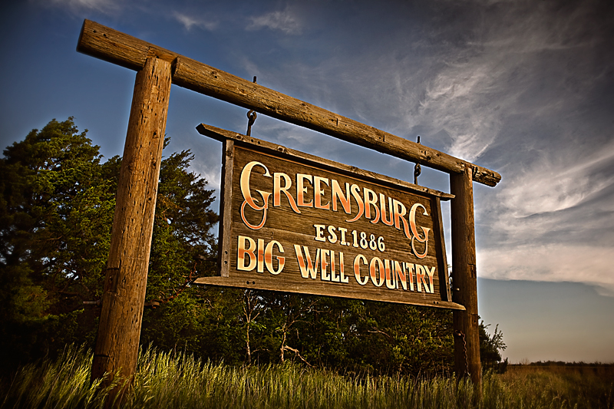
Greensburg Eco Tour
December 9th 2009

Contents
Overview 2
Proposed Walking Eco-Tour 3
Eco Silo Home 5
Greensburg City Hall 6
Greensburg GreenTown Solar Eco-Home 7
Kiowa County Courthouse 8
Greensburg State Bank 9
Business Incubator 10
Dillons Kwik Shop 11
547 Arts Center 12
Justification 13
Logistical and Operational Issues 15
Future Plans 17
Conclusion 17
Appendix A 18
Works Cited 19

Overview
At 9:45 p.m central time on May 4, 2007 Greensburg Kansas was hit by the largest tornado possible, an EF5 (Wikipedia: Enhanced Fujita Scale). The tornado was estimated to be 1.7 miles in width and traveled for nearly 22 miles. Nearly the entire city was destroyed by the tornado (95% in all) with the remaining severely damaged.
After the tornado, the city council passed a decree that all city buildings would be built to LEED standards. Greensburg became the first city to ever do this. Greensburg GreenTown, a non-profit organization was created to help the people of Greensburg not only rebuild green, but also learn what it really means to “go green”. GreenTown was designed to educate and inspire the community and world to take part in green efforts.
GreenTown currently gives a walking and driving tour to locals and visitors each day throughout the year. After taking the tour we found it very informative, but lacking in structure. It was nice to have the freedom to pick our next stop, however we believe most people like a more structured tour. By making slight changes the tour will become marketable to a larger set of individuals. Potential tourists need to know that they will see a specific group of places before they go on the tour. For example on this tour you will see 6 of the worlds only 17 LEED certified buildings. I would be much more excited to know this then to come to a tour where I was not sure at all what I would be seeing until on it.
In an effort to establish long-term stability of the Greensburg GreenTown tour, we have created a comprehensive new eco-tour packed with justifications. This new tour will give marketability to the GreenTown tour effort giving them a means to stimulate their local economy and maintain these tough financial times. We are additionally including a market development plan and further ideas to pursue as Greensburg Kansas grows over the years.

Proposed Walking Eco-Tour
Since the GreenTown organization plans to move its offices to the top of the Silo Home we have moved the beginning of the tour to that location. The walking tour should last about an hour and a half in total on average. It will be good practice to block out two hours total for the tour in the event there are any delays. Money for the tour should be collected prior to the tour. We believe the tour is valued at ten dollars per person. The following pages show how the tour will be run and what information will be most interesting to visitors:
- Begin the tour at the Silo Home. Visitors will have a chance to walk around the Silo Home prior to the tour. The tour guide will give a brief introduction (background of Greensburg/Origins of GreenTown project- 5 minutes) and then show the visitors the Silo Home for another 5 minutes.
- At this point the tour guide will walk the visitors past the City Hall in route to the Solar Eco Home that will be built. During this 10-minute walk the tour guide will discuss LEED standards and explain the factors that make the City Hall LEED certified.
- Next the visitors will arrive at the new Solar Eco Home. This will be a 15-minute stop where various green technologies will be shown. The tour guide will stress the education incentive that GreenTown is built on.
- The next stop will be a 5-minute walk to the Courthouse. At this stage stress the significance of this building to the community. It was the only building to withstand the tornado. Also stress that it was an old building that has become LEED certified. Spend 5-minutes at this location.
- After visiting the Courthouse, make the 10-minute walk to the Business Incubator. On the way to the Business Incubator, make sure to walk by the State Bank and discuss its origin.
- Once the group arrives at the Business Incubator discuss its history (why Sun Chips is printed on the side), visit the various shops and encourage questions. Also encourage visitors to come back to support local businesses. Spend 10 minutes at the business incubator.
- Now that you have visited the Business incubator, make your way past the Kwik Stop and to the 547 Arts Center. This walk will take about 5 minutes. Spend 10 minutes in the Arts center talking about its significance to Greensburg. It was the first meeting place for the town after the tornado. Was built and brought in piece by piece. Also discuss its LEED platinum certification, one of only a handful of buildings in the country to have this certification.
- After spending time at the 547 Arts Center, make your way back to the GreenTown Office in the Silo Home. This is a time to answer final questions and encourage visitors to visit the gift shop as well as check out the Big Well tour across the street.

Eco Silo Home
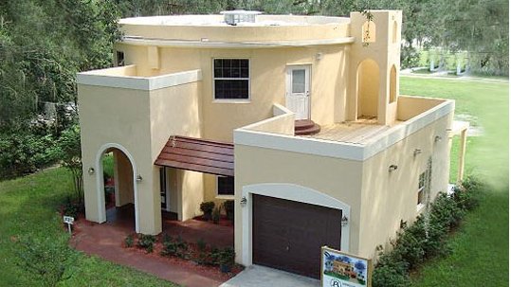
Background
This is a picture of what the Eco-Silo Home should look like when complete in Greensburg, Kansas. This building will house both a bed & breakfast on the bottom floor and offices for Greensburg GreenTown on the top floor. On the roof there is a working garden. This house is designed to withstand another tornado. To test this building, Greensburg dropped a car twice on the roof of this building. The car was destroyed while the roof experienced no damage.
Important Green Facts
- The Silo Eco Home is equipped with a Tank less Water Heater. A Tank less water heater provides hot water only when needed. A normal water heater keeps 40-80 gallons of water heated at all times. A Tank less water heater keeps no water heated unless it is needed. Appendix A shows how a Tank less Water Heater works.
- The Silo Eco Home also contains a toilet and sink combo unit. This unit reduces the amount of water used per bathroom visit. The picture below is an example of what one looks like. The water from the sink is reused when flushing the toilet.
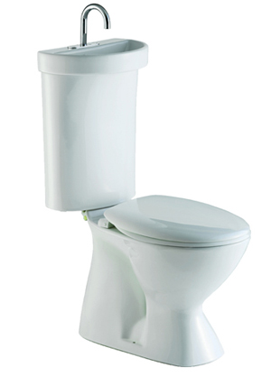
- The Silo Eco Home contains Energy Efficient LED lighting.
- The Silo Eco Home also has a vegetable garden on its rooftop.

Greensburg City Hall
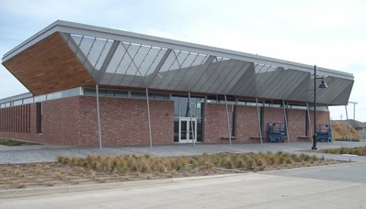
Background
This building has just opened with a dedication service on December 6th. This location will serve as a meeting place for city functions and court sessions. It is the first new construction LEED Platinum city hall building in America, and includes solar panels and geothermal technology. LEED platinum is the highest level of certification that can be obtained for a building.
Important Green Facts
- The roof is angled to maximize the natural lighting the building receives. This will reduce energy costs by reducing monthly bills. The sun will reflect off of the angled roof and thus light the building during the daytime hours.
- Drought resistant plants are on site requiring little water for upkeep. To water these plants, the building has a rainwater collection system that then is filtered to the plants on site.
- City has has been built out of reclaimed brick from the Greensburg power plant (destroyed by the tornado), and recycled wood and materials.
- The City Hall also contains energy efficient office equipment. This includes but is not limited to computers, monitors, printers, fax machines, copiers and scanner.

Greensburg GreenTown Solar Eco-Home
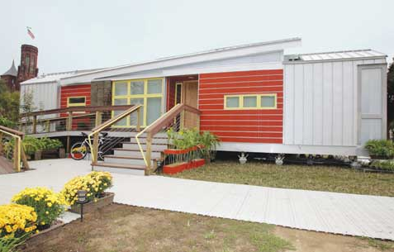
Background
This will be the Second Eco-Home that is being donated by the University of Colorado and was the winner of the 2005 Solar Decathlon competition. This is been named the Solar Eco-Home. It will serve as an additional center for green learning and living in Greensburg and the US as a whole.
Important Green Facts
- Straw Bale Construction. Straw bale construction uses baled straw from wheat, oats, barley, rye, rice and others in walls covered by stucco.
- Agriboard is made from compressed wheat or rice straw with exterior skins and structural support of Laminated Strand Lumber. Agriboard is able to withstand winds in excess of 250 mph when modified to Fire + Storm shelter specifications.
- Structural Concrete Insulated Panels (SCIP) are panel wall systems constructed with EPS foam and concrete to build energy efficient concrete walls.
- The Solar Eco Home uses warmboard, which is a home floor heating solution that lowers the cost of heating a home.

Kiowa County Courthouse
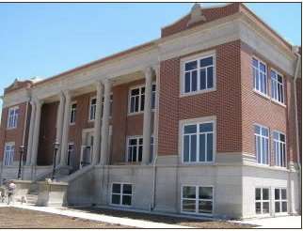
Background
The Kiowa County Courthouse is one of the only buildings that survived the tornado in 2007. The original building was constructed 95 years ago in just over 9 months. The courthouse is hoping to attain LEED gold status. The building will maintain the same design, but will be updated with energy savings and sustainable features.
Important Green Facts
- Spay foam insulation will be used to keep heat inside of the Courthouse during the winter. It is more expensive then alternative insulations, but lasts longer, and is energy star rated.
- Geothermal HVAC system is a specialized multistage heat pump system that extracts both heat and air from the ground through a series of 32 300-ft vertical wells.
- Daylighting is provided to all the exterior zones with the existing window openings to reduce energy consumption.
- The Courthouse will capture storm water runoff for lawn irrigation. Runoff will be collected and stored in a 15,000 gallon underground cistern. The cistern will reclaim rainwater, which will also be used as gray water for toilets.

Greensburg State Bank
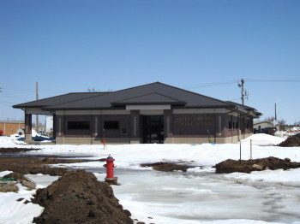
Background
The Greensburg State Bank has been a very important part of the Greensburg community. The family of bank president Thomas V. Corns has been a part of the bank since it first opened in 1924. The bank was able to resume business the Monday after the tornado because the bank’s vault sustained little damage (Greensburg State Bank History).
Important Green Facts
- Built on the site of the original bank, this makes use of previously developed land and does not disturb the landscape.
- Lighting control system detects when building is occupied and only keeps the light on at those times, this reduces energy usage.
- Plastic benches onsite constructed with recycled material.
- All plants onsite are drought tolerant and do not require frequent watering.

Business Incubator
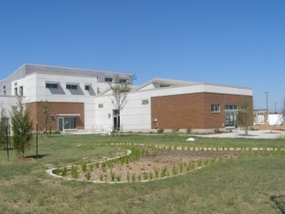
Background
One of the LEED Certified Platinum buildings in town Sun Chips helped build this to aid small business development. This facility is a low rent facility to house local businesses including a coffee shop, glass art studio, paint store, and several offices (GreenTown green tour).

Important Green Facts
- Maximizes use of natural lighting to conserve energy using windows facing south, skylights, and clerestories (windows above eye level).
- Geothermal heating and cooling uses a ground source heat pump. The consistent temperature of the soil can be used to aid heating and cooling.
- 25% of building material was recycled material including bricks salvaged from the tornado.
- Water conserved by reusing sink water to flush toilets.

Dillons Kwik Shop
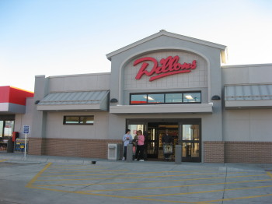
Background
This multi-purpose facility (convenience store/grocery store) was built by the parent company of the Dillons and Kwik Shop chains, The Kroger Company, to better serve rural areas while reducing overhead. Kroger Company is the country’s largest supermarket chain (Wikipedia: The Kroger Company).
Important Green Facts
- Waste heat from mechanical systems reused to heat water.
- Energy efficient LED lighting is used in coolers and freezers.
- Indoor air ventilation improves air quality.
- High-albedo roof reflects heat to reduce buildings cooling costs.

547 Arts Center
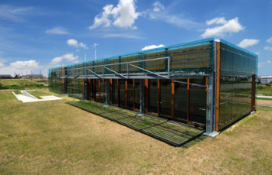
Background
The 547 Arts Center was built to cultivate an interest in visual and performing arts in Greensburg. This facility was constructed by University of Kansas Architecture students and was the first LEED Certified Platinum structure in Kansas (Studio 804 Projects).
Important Green Facts
- Lumber recovered from the tornado used in construction to reduce the amount of natural resources harvested for construction.
- Windows use tempered glass to help cool the building during summer.
- Concrete floor absorbs heat during the winter months to reduce energy used to heat the building.
- Uses both wind turbines and solar panels to generate electricity.

Justification
In a city that is changing at such a rapid pace there are always new and interesting things to see in Greensburg. This makes choosing the sites to visit in a ninety minute tour a challenge. One of the major factors to consider when designing the tour is why people interested in green living will want to see this landmark. Another factor to consider is the proximity to the GreenTown offices. Finally certain facilities are government offices and commercial businesses and may not want to have business interrupted due to tour traffic. Based on these criteria one can weigh the importance of the various facilities and decide which ones are should be visited, which ones should be mentioned while passing by, and which sites cannot be visited.
To fit within a walking tour, the tour should be confined to the downtown Greensburg area, specifically the areas near the GreenTown office. This will eliminate several major structures such as the BTI Greensburg Facility, the new school, and the new hospital. While these sites are some of the more interesting facilities to those who want to learn more about green construction and living, these sites are simply not close enough to the GreenTown offices to be part of a walking tour that accommodates a high volume of visitors. Instead information should be provided if a visitor has a particular interest in one of these structures.
While Greensburg’s big well is a major tourist attraction, unless the site adopts a lot of the new green efforts it does not fit in with the mission of the green tour as a means of educating people about sustainable living. Instead the big well would be better suited as a separate attraction. Many tourists will come to the big well but many will also come to see the city itself and visitors to one attraction will likely make an effort to see the other attraction.
The temporary GreenTown offices will be the beginning of the tour while a more permanent solution is being constructed. With GreenTown relocating to the one of the chain of eco homes, the Silo Home, this will eventually become the beginning of the tour. This building and the Solar Eco Home will be important parts of educating people in green construction techniques and technology as well as educating visitors in sustainable living. These facilities fulfill GreenTown’s mission to educate people in green technology and make them very important points of interest.
Two government facilities, the city hall and courthouse will be an important part of the tour. When passing by the city hall structure this would be a good time to inform visitors about the process of obtaining LEED Platinum Certification. The courthouse is important because it is an older facility that survived the tornado and was updated to gain LEED Certification. For many people wanting to learn more about sustainable living, they do not just want to know about the process of constructing a green building, they will also want to learn about the process of updating an existing building to be more efficient. Due to this facility’s location on the tour between two longer walks between the Solar Eco Home and the incubator this would be a good place to actually stop and walk in for about five minutes.
Two commercial facilities, the Greensburg State Bank and the Dillons Kwik Shop would be ideal places to mention on the tour but may not be ideal locations spend a lot of time since tour visits could interrupt business. Instead, the tour will talk about these locations’ green features and facts when walking by them on the tour. It is important to mention these sites since learning about these sites might give visiting retailers and businesses ideas about how they might benefit from constructing a green building.
Finally, the Sun Chips Business Incubator and the 547 Arts Center will be important stops on the tour. Since these buildings are LEED Certified Platinum, these facilities utilize some of the most advanced and effective green technology and will be showcases for Greensburg’s green efforts. Also the Arts Center is a particular point of interest since it shows a side of Greensburg that many would not expect.

Logistical and Operational Issues
There are many logistical and operational issues facing the green tour if it is to take on a large volume of customers. If these issues are not at least considered they could significantly raise costs, drive away customers, or even be a liability issue for the eco tour.
The first of these issues which need to be addressed is who gives the tours. A good tour guide is essential to any effective tourism business, but these people need to be trained and compensated. Since GreenTown is a relatively small organization barely has enough staff to tackle all the ambitious projects that GreenTown directs, it will be hard to bring on additional staff members to guide a tour. During the time period when the eco tour runs, there will need to be careful scheduling of GreenTown staff members to give the green tour. In addition, new staff members should be quickly trained so they can begin giving tours as soon as possible. Tour guides unfamiliar with either the city or green technology will have to prepare so that they can effectively engage visitors taking the tour and be able to answer the many questions tourist will have. Not only should tour guides be familiar with the city of Greensburg and green technology, tour guides should know what to do in the event of an emergency as this could become a liability issue for the GreenTown organization if someone were injured while taking the tour. One way to address the shortage of staff at GreenTown might be to add an internship program. The addition of an intern could take some of the tour groups and also aid in some of GreenTown’s projects. This would be a win-win situation since GreenTown would get an extra staff member that would not have to be compensated as much as a fulltime employee and the intern would be able to learn about green technology by assisting in some of GreensTown’s projects.
Another issue facing the eco tour is how to deal with booking a tour. A formal booking process will have to be implemented to be sure that booking a tour is as easy as possible for any visitor to Greensburg. Booking could easily be done over the phone, but with GreenTown expanding its presence on the web it may wise to enable online booking as well. Tours could be scheduled for 10:00 AM, 1:00 PM, or 3:00 PM depending upon how many visitors are anticipated for a single day. Also while walk up visitors who have not booked in advance should not be turned away, it should noted in any marketing materials for the tour that booking in advance will help ensure a better experience and will help to make accommodations for visitors with special needs (large tour groups of 15 or more, guests with disabilities, etc.).
Finally, the eco tour will have to address special circumstances such as weather and guests with disabilities by offering a vehicle tour by request. Since Greensburg is in a remote location, many visitors are making a special effort to come out and see the city. While the walking tour should be encouraged in good weather conditions, the green tour should available as a vehicle tour when rain or cold weather are present, this will help maximize the enjoyment of all tourists which come to take the tour. Due to the cooler temperatures in the late autumn and winter months the green tour may only want to run as a vehicle tour.

Future Plans
In a city that is changing as rapidly as Greensburg, the eco tour will have to adapt as the city changes. As newer buildings are constructed with even more green technology, certain buildings may be pushed off the tour or given lesser priority. This will more effectively educate visitors in the latest green construction techniques and technology. The Chain of Eco Homes will certainly be a major priority for GreenTown because these homes will showcase the sustainable lifestyle that GreenTown is trying to promote and about which they are trying to educate people. If the eco tour is particularly successful, one major investment that could be made to improve the tour would be add a tour van to better accommodate bad weather and guests who would prefer not to walk. However, addressing the shortage of staff at GreenTown is a higher priority; the ambitious nature of Greensburg’s rebuilding effort is what keeps people interested in the community.

Conclusion
These suggestions are a building block that we hope will help sustain the future of Greensburg GreenTown. We hope this will provide a way to spread the green effort across the country and the world and continue the work that has begun in Greensburg over two years ago. GreenTown should revisit this tour every year and make necessary adjustments to assure it meets the needs of its visitors and displays the progress of Greensburg. We believe this is the beginning of a long future for the GreenTown Eco-Tour effort. We wish you the best and hope to have the opportunity to work with you again.

Appendix A
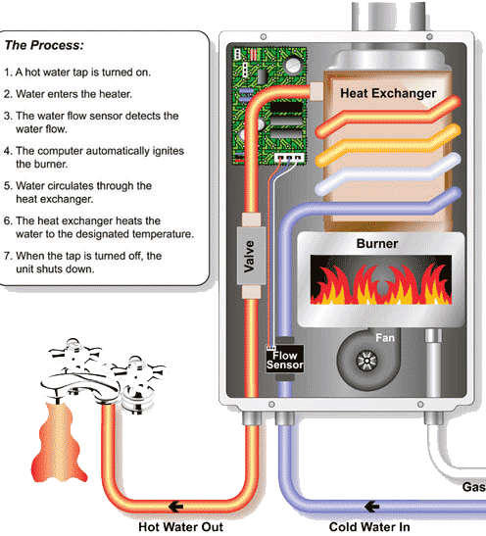

Works Cited
Greensburg State Bank History. (n.d.). Retrieved December 7, 2009, from Greensburg State Bank : www.bestbank.us/history.html
GreenTown green tour. (n.d.). Retrieved December 6, 2009, from Greensburg GreenTown: http://www.greensburggreentown.org/greentown-greentour/GreenTown%20GreenTour_PDF.pdf
Studio 804 Projects. (n.d.). Retrieved November 29, 2009, from Studio 804: http://www.studio804.com/projects/sustainable%20prototype/images/SustainablePrototype1.html
Wikipedia: Enhanced Fujita Scale. (n.d.). Retrieved December 2, 2009, from Wikipedia: http://en.wikipedia.org/wiki/Enhanced_Fujita_Scale
Wikipedia: The Kroger Company. (n.d.). Retrieved December 7, 2009, from Wikipedia: http://en.wikipedia.org/wiki/Kroger

