Teaching Doctor Faustus through the Ars Moriendi Tradition

The rough edges in Christopher Marlowe’s intellectual life serve as a foil to the mainstream Christianity in Doctor Faustus: the playwright had a reputation for atheism or at least for unorthodox opinions; papers allegedly found in a writing room that he shared with Thomas Kid denied the deity of Christ; and twelve days before he was fatally stabbed through the eye in a bar fight, the Privy Council had arrested him for heresy (Gill 214). Some readers of Marlowe believe that it is hard to tell if the smoke of bad reputation signifies the fire of actual heresy, but there is little doubt that he qualified as an “atheist,” one who disbelieves in God and is unfettered by “moral obligation” (“Atheist”).¹ Marlowe’s reputation for making controversial religious statements is partly due to Kid, who, under duress, attributed a heretical document to him; and the “ascription may well have been correct” (Kuriyama 125). And yet, “however scornfully Marlowe rejected the [Christian] system intellectually, it still had a powerful hold of some sort on his imagination and emotions” (Kocher 118-19). Although Marlowe may not have had a Christian spirit, Doctor Faustus clearly shows that he had a Christian intelligence; for the play is built around an element of mainstream Christianity, the ars moriendi tradition or the art of dying well. This fact has been part of the criticism for over a half century, most helpfully in Beach Langston’s hard-to-find but excellent article, “Marlowe’s Faustus and the Ars Moriendi Tradition” (1952). The present essay enhances a subset of Langston’s inquiry, the five deathbed temptations (unbelief, despair, impatience, pride, and avarice), not only to outline a very effective way of teaching Doctor Faustus but also to highlight possible connections to other texts frequently read in a British survey or an Elizabethan literature course.
Between the late fifteenth and the early eighteenth centuries, many treatises on the ars moriendi were published in England. The most important was The Ars Moriendi (1450), whose woodcuts, as we shall soon see, are fertile ground for class discussion.² Others were written by such familiar scholars as Thomas Becon, Erasmus, Thomas Lupset, and William Perkins; and many of these works are helpfully anthologized in David William Atkinson’s The English Ars Moriendi. In Marlowe’s time, the ars moriendi was as much “in the air” as one of its subcategories, the “near-death experience,” is today.
More specifically, the dying person, or moriens, is the central figure in a psychomachia on his or her deathbed. This “soul struggle” comes from morality plays in which good and evil compete for the attention of a character like Youth, much as the Good Angel and the Bad Angel compete for Faustus’s soul. In the case of the moriens, we find demons in opposition to angels, saints, and good counselors. On the one hand, the demons tempt him with unbelief, despair, impatience, pride, and avarice. Two of these need some clarification: the impatience is for death itself, and avarice means an inappropriate attitude not only toward worldly goods but also toward other people. On the other hand, the angels, saints, and good counselors insist that if Christ’s sacrifice has saved far greater sinners, then it will surely save the moriens as well. As in the conversation between the Redcrosse knight, Despaire, and Una in The Faerie Queene, an episode long acknowledged to participate in the ars moriendi tradition (Fike 110-11, n. 3), a deathbed psychomachia centers on human insufficiency versus divine mercy. The demons remind the moriens of his wicked deeds, while the positive figures cite scripture and the Fathers to provide assurance of forgiveness. He may even see the crucified Christ on the cross, as Caxton points out in Art and Craft to Know Well to Die: “‘every Christian person—be he good or evil—before that his soul issueth out of his body seeth our Lord Jesus Christ set in the cross’” (qtd. in Langston 163). A final piece of information completes the background: eventually the ars moriendi tradition merged with the ars vivendi, the art of living well. In order to die well, one must first live well; the best preparation for a holy death is a righteous life. Again, The Faerie Queene provides a helpful benchmark: instruction in right living is precisely what Redcrosse receives at the House of Holiness; and the personifications there—Faith, Hope, Zeal, Patience, Humility, Reverence, and Charisma—stand in direct opposition to the deathbed temptations in the ars moriendi tradition (Fike 22). Or as Kurtz states with his dying breath in Heart of Darkness (and I will complete the thought he is unable to finish), “Live rightly, die, die [well].”
With this background information on the board, I then have students look at two woodcuts from The Ars Moriendi. The first is called “The devil’s temptation to despair” (Figure 1). Six hideous demons hold scrolls that accuse the moriens of various sins. They read: “Behold your sins. You have perjured yourself, fornicated, lived avariciously, and killed.” In the upper left the demon holds a record of the man’s deeds in life. According to George Bullen, the human figures at the top are a man toward whom the moriens has been guilty of perjury and a woman with whom he has committed the sin of fornication (10-11). Indeed the demons point to them accusingly. The human figures at the bottom include a man whom the moriens has killed and another whom he has ruined. The demon
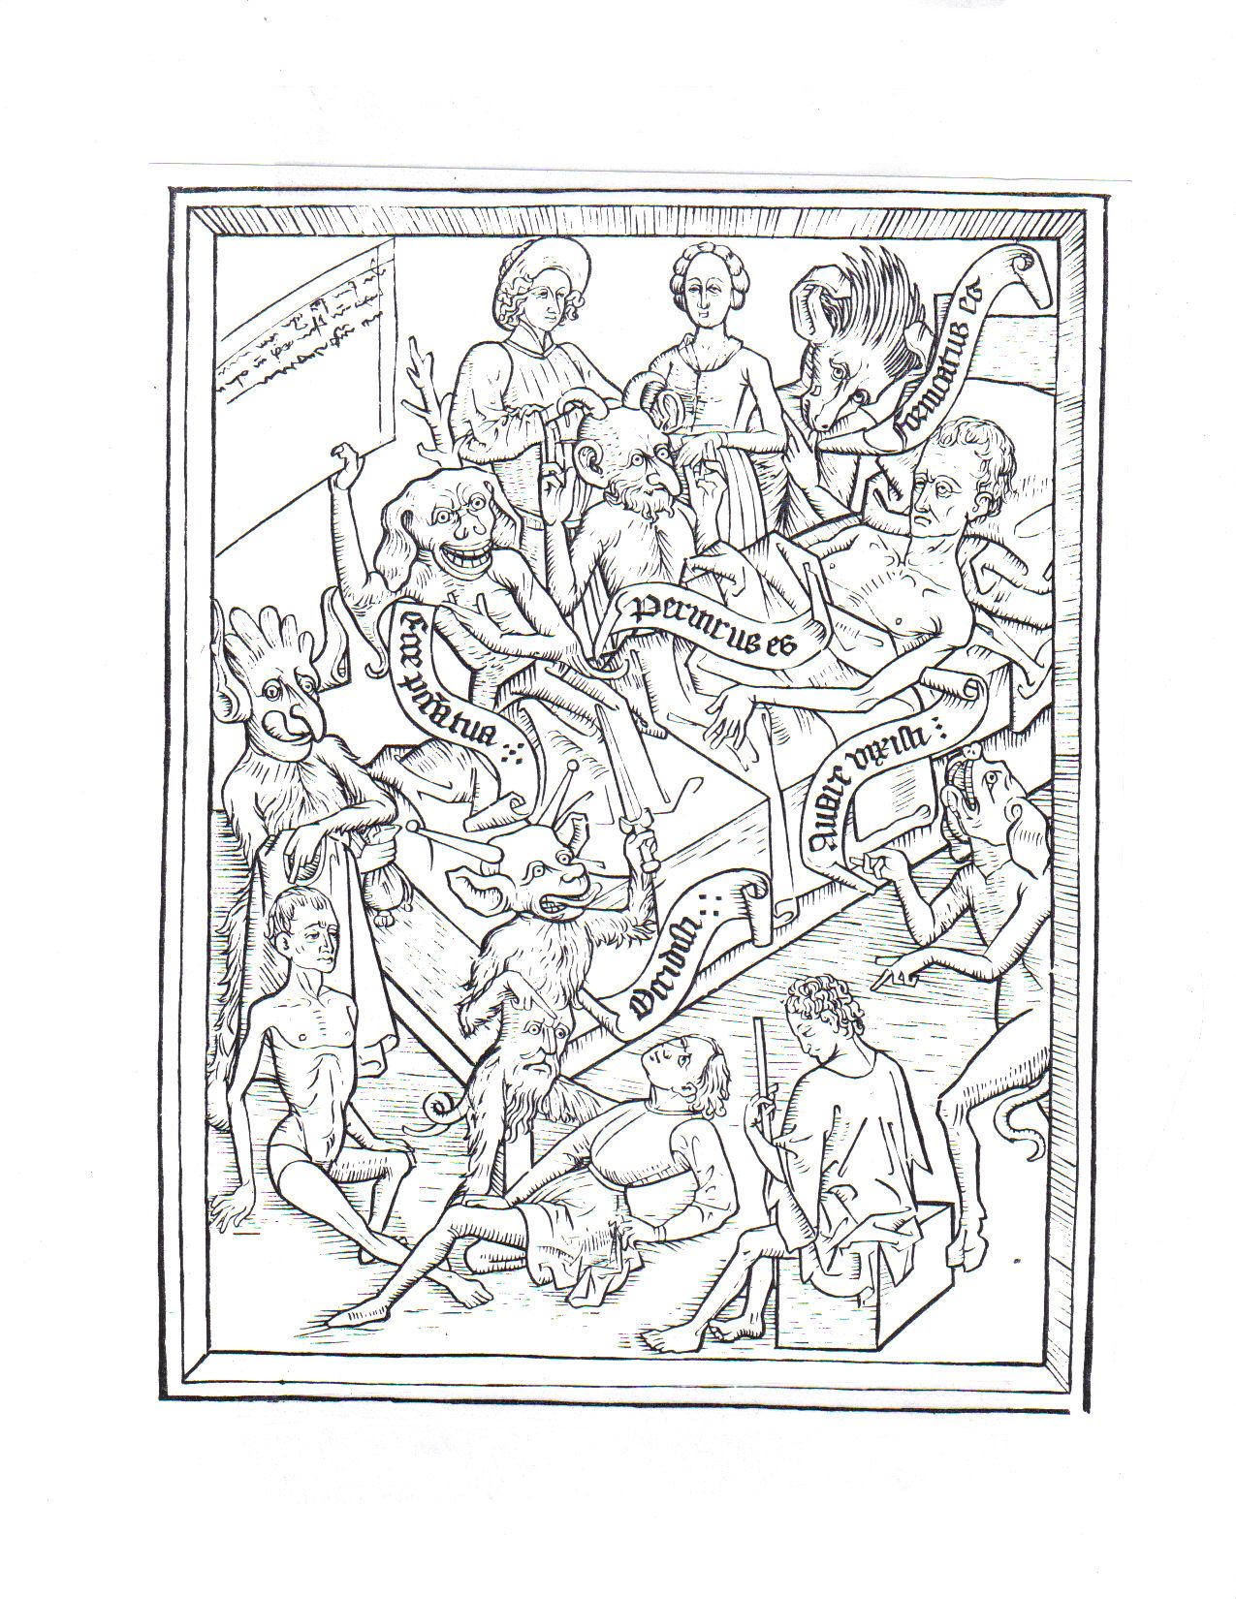
Figure 1: “The devil’s temptation to despair.” The two woodcuts are from W. Harry Rylands’s 1881 edition of The Ars Moriendi: A Reproduction of the Copy in the British
Museum. C. 1450.
accusing him of murder holds a dagger. To the left a demon holds a full purse and a shirt as he points to the naked man. These images accuse the moriens of avarice. He has profited, as we would say today, by stealing the shirt off another man’s back; and the woodcut may offer before and after images: perhaps the moriens has transformed the well-to-do man on the block into the shirtless man on the ground.
The second woodcut is called “The angel’s good inspiration against despair” (Figure 2). Here the scrolls have the angel saying, “By no means despair”; and the demon in the lower right saying, “There is no victory for me.” Students predictably misinterpret one part of the image, believing Christ to be the figure on the cross in the upper left. But where are the nails and the crown of thorns? Where is the sign saying, “God saue thee King of the Iewes” (Matthew 27:29)? The crucified man is rather the thief Dismas to whom Jesus promised that “to day shalt thou be with me in Paradise” (Luke 23:43), the only sinner in the Bible who died in faith but lived without it. At the top of the image stand a man and a woman. He is, of course, “St. Peter with the cock that was the symbol
of his fall and the key that showed how completely he was forgiven” (M. O’Connor 117). She is Mary Magdalene, who holds a pot of spikenard (the aromatic oil that she used to anoint the feet of Jesus). Like Peter, she has a nimbus over her head, indicating
that she is now part of the communion of the saints. She was one of the women who kept watch while Jesus died on the cross, and she was the first person to whom he spoke after he arose. As a pardoned sinner and as a witness to Jesus’s death and resurrection, she is the embodiment of received forgiveness and of faith in his divinity. A more enigmatic figure is the man at the foot of the bed: Saul of Tarsus and his horse are sprawled on the ground. One recalls Flannery O’Connor’s apt remark in The Habit of
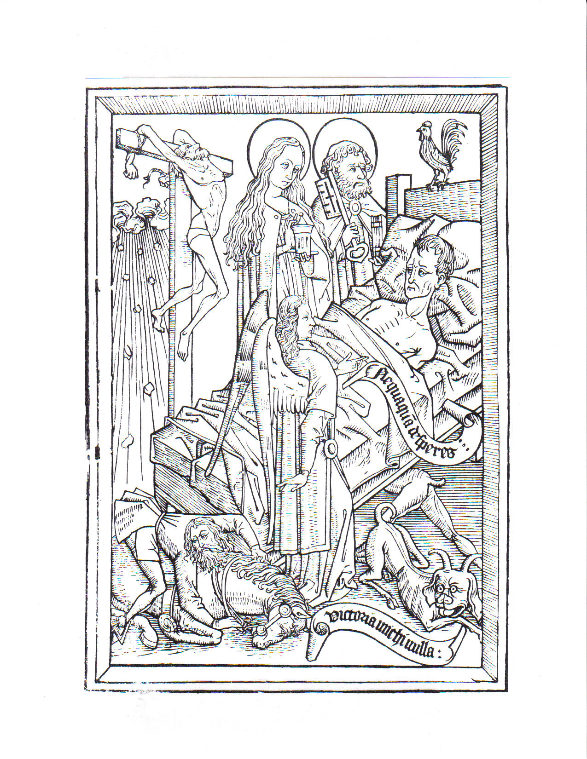
Figure 2: “The good angel’s inspiration against despair.”

Being: “I reckon the Lord knew that the only way to make a Christian out of that one was to knock him off his horse” (Fitzgerald 354-55).
These two images provide an example of deathbed psychomachia, or “soul struggle.” The demons say, “You’re damned.” The angel says, “You’re saved.” And the presence in the second woodcut of Saul, the thief, Peter, and Mary Magdalene—four of the great forgiven sinners in the New Testament—reminds the moriens that if they can be saved, his own salvation is nothing to worry about.³ As Susan Snyder writes, “The favorite exempla against despair are David, Mary Magdalene, the prodigal son, the good thief, and Paul—all notable sinners whose honor is now great in heaven” (26).⁴ Indeed the light of heaven breaking through the clouds in the woodcut’s upper left signifies the very salvation that these sinners enjoy.
The next question is how to apply the foregoing information to Doctor Faustus. The main task is to have students discuss the doctor in terms of the five deathbed temptations. As they move through this exercise, it is important for them to remember the convergence of the art of dying well and the art of living well: students need to talk not only about Faustus’s death but also about his life. If his death is terrible, how did his actions in life bring about that end? Here are some possibilities, along with supporting passages—in short, the sort of portrait that ought to emerge from a synergy of lecture, group work, and discussion as a whole class.
Unbelief. Lucifer quickly dissuades Faustus from statements that affirm the divinity of Christ: “Ah, Christ my Saviour, seek to save / Distressed Faustus’ soul” (5.257-58); and “See, see where Christ’s blood streams in the firmament! / One drop would save my soul, half a drop: ah, my Christ” (13.72-73).⁵ Here Faustus appears to affirm Christ as Lord and Savior, but the use of the conditional undercuts any sense of positive affirmation. One drop would save him if some other condition were in place, but it is not. Because he believes in God but does not believe God, his belief is a matter of theoretical construct rather than personal relationship. Although even Mephastophilis acknowledges God’s “saviour Christ” (3.49), Faustus ironically does not believe that God’s grace extends to him.
Pride. One of the reasons why Faustus is unable to believe more fully is that he is guilty of the second temptation, pride. Like his unbelief, his pride is not just a deathbed phenomenon but also a lifelong quality. Indeed, the Old Man says to him, “Yet, yet, thou hast an amiable soul, / If sin by custom grow not into nature” (“Appendix” 101). Snyder locates in the ars moriendi tradition “a cumulative process, beginning with secret evil, advancing to open sin, hardening into habit, and culminating into a state of complete despair that prevents any self-amendment” (47). Faustus’s pride is habitual and, as we shall see, does culminate in despair, a sin against the Holy Spirit. Images of pride abound. At the opening of the play the Chorus notes that, “swol’n with cunning, of a self-conceit, / His waxen wings did mount above his reach / And melting heavens conspired his overthrow” (20-22): the hubris of Faustus’s intellectual pride inevitably brings about dike. He fancies himself too great an intellect to be bogged down by conventional scholarship, all of which he has already mastered; therefore, he turns to the occult. He lays bare his own hubris in his opening soliloquy:
These metaphysics of magicians,
And necromantic books are heavenly!
Lines, circles, schemes, letters and characters!
Ay, these are those that Faustus most desires. (1.49-52)
The personification of pride in the pageant of the seven deadly sins puts a still sharper focus on Faustus’s intellectual pride: “I am Pride. I disdain to have any parents” (5.284). In much the same way, the doctor takes pride in his intellectual achievements because his education is not an inheritance from his “parents base of stock” (first Chorus 11).
Marlowe’s imagery of elevation—Faustus’s flight in a chariot drawn by dragons to study the cosmos (second Chorus), like Spenser’s dragon carrying Redcrosse high into the air (The Faerie Queene I.xi.18-19)—confirms pride as a present quality after the contract is signed. Along with the allusion to Icarus in the Chorus’s opening speech, the “aspiring pride and insolence / For which God threw him [Lucifer] from the face of heaven” (3.68-69), suggests that Faustus is headed for a fall. His intellectual successes are in vain (they do not benefit anyone but himself), and he later admits: “Ah gentlemen, I gave them my soul for my cunning” (13.34-35). As his death draws near he considers himself so great a sinner that he exists outside the possibility of salvation. With all this evidence stacked against him, there is no doubt that the doctor is guilty of pride, but in his case pride has been twofold. On the one hand, he has an overly inflated estimation of himself; therefore, he branches out from conventional study, attributing to himself the power to control Mephastophilis and the title “conjurer laureate” before the contract is made (3.33). On the other, Faustus’s pride diverges markedly from the pride in the ars moriendi books because it arises from an absolute certainty not of salvation but of unredeemable wretchedness.
Impatience. At the last, it may be that “Faustus, giving way to the temptation of impatience as the devil rends his flesh again, calls in agony to Lucifer and loses sight of Christ’s saving blood” (Langston 164). “O spare me, Lucifer!” he cries (13.75). But just prior to the fatal moment, impatience does not characterize the doctor’s attitude. In fact, he wants time to slow down because “a despairing sinner rather puts off as long as possible his inevitable damnation than races to meet it” (Snyder 58). Thus Faustus states, “Stand still, you every-moving spheres of heaven, / That time may cease, and midnight never come” (13.62). As his twenty-four years are running out, he does not want to surrender his soul but probably does not believe that there is any alternative. Until the very end, his impatience is not for death but with the things of the world and the restrictions of conventional academic knowledge—he would acquire the first and transcend the second. His pride and impatience are bound together with the next temptation.
Avarice. Faustus’s avarice characterizes both his life and his death. His lust for the things of this world is on display in his opening soliloquy, in which one can also locate unbelief and pride:
O what a world of profit and delight,
Of power, of honour, of omnipotence,
Is promised to the studious artisan!
All things that move between the quiet poles
Shall be at my command: emperors and kings
Are but obeyed in their several provinces.
Nor can they raise the wind or rend the clouds;
But this dominion that exceeds in this
Stretcheth as far as doth the mind of man:
A sound magician is a demi-god.
Here Faustus, try thy brains to gain a deity. (1.53-63)
A bit later he desires wealth and states that he will have demons “fly to India for gold, / Ransack the ocean for orient pearl” (1.82-83). The Bad Angel urges him to “think of honour and wealth” (5.22); “crowns and rich apparel” appear in a stage direction (5.83); and Covetousness speaks of “my sweet gold” (5.294). Whereas Faustus’s grand designs for wealth and power devolve into parlor tricks, much as his blank verse yields to prose, the second type of avarice that he displays—impatience for sexual gratification with women—endures until his final moments. Shortly after signing the contract, he asks Mephastophilis for a wife, yet the great scholar does not have the presence of mind to realize that marriage is a divinely sanctioned institution, not the “ceremonial toy” that the demon claims it to be (5.148). Indeed the doctor seems so intent on achieving delight in exchange for his soul that he abandons right reason altogether: “My four and twenty years of liberty / I’ll spend in pleasure and in dalliance,” he remarks (“Appendix” 72). At the end of the play, of course, he ignores the Old Man’s counsel in favor of a demon disguised as Helen of Troy. “Sweet Helen,” he says, “make me immortal with a kiss: / Her lips sucks forth my soul, see where it flies! / Come Helen, come, give me my soul again” (12.83-85). Marlowe probably had in mind the knight asleep in Acrasia’s lap in The Faerie Queene: “And through his humid eyes did sucke his spright, / Quite molten into lust and pleasure lewd” (II.xii.73). The seriousness of Faustus’s situation is clear in light of The Book of the Courtier’s statement that “the kiss may be called a spiritual rather than physical union because it exerts such a power over the soul that it draws it to itself and separates it from the body” (336). Moreover, W.W. Greg notes that the ars moriendi tradition includes “pictures of a devil dragging he naked soul out of the mouth of a dying man” and concludes that Faustus is committing “the sin of demoniality, that is, bodily intercourse with demons” (104, n. 8; 106). He is spiritually fornicating at the precise moment when he ought to be putting his spiritual house in order.⁶
Here is what we have so far: Faustus is guilty of some degree of unbelief; his pride is in full bloom; and in his lust and impatience for knowledge, power, wealth, and sensual gratification, he has embraced avarice. It is not surprising that such a character would find a pageant of the Seven Deadly Sins to be fitting entertainment. In fact, Pride, Covetousness, Envy, Wrath, Gluttony, Sloth, and Lechery fall nicely under the more general rubric of avarice in the ars moriendi tradition, for all constitute an inappropriate fixation on the world’s blind alleys. Such errors offer a pleasant but deceptively hollow diversion from Truth by promising wealth, power, supernatural knowledge, and sensual ecstasy.
Despair. The final temptation is present in Faustus even before the contract scene; he says, “Despair in God, and trust in Belzebub” (5.5). When he finally lapses into full-blown despair it is because the objects of his desire bring only earthly delight and because he cannot accept God’s grace, forgiveness, and mercy. As C.A. Patrides maintains throughout his fine article, hell in the Renaissance is thought to be both a place and a state of mind, the latter involving despair, the pain of damnation. Well before the death of his physical body, Faustus experiences despair: “My heart’s so hardened I cannot repent!” But he quickly talks himself out of it: “Why should I die then, or basely despair?” (5.194, 207). The doctor’s psychological hell calls to mind Mephastophilis’s statements: “Why this is hell, nor am I out of it” (3.77); “And where hell is, [there] must we ever be” (5.123)—or Satan’s “my self am Hell” (Paradise Lost 4.75). The Bad Angel reinforces Faustus’s despair with a description of “that vast perpetual torture-house” (“Appendix” 106), using imagery very similar to Despaire’s description of hell in The Faerie Queene:
To drive him to despaire, and quite to quaile,
He shewed him painted in a table plaine,
The damnèd ghosts, that doe in torments waile,
And thousand feends that doe them endlesse paine
With fire and brimstone, which for ever shall remaine. (I.ix.49)
Thus the five deathbed temptations in the ars moriendi tradition clearly apply to Faustus’s situation, with minor qualifications that only enhance students’ understanding of the play’s nuances. In fact, the ars moriendi is like a hub from which a variety of passages radiates. The next step is to put the tradition in a larger context. Clearly unbelief, despair, impatience, pride, and avarice—the five temptations—are incorrect choices. Clearly faith, hope, patience, humility, and charity—their opposites—are greatly to be desired. That is Faustus’s psychomachia, which he sums up by saying, “Hell strives with grace for conquest in my breast!” (12.55). The question is now the following: What other right and wrong choices—or positive and negative alternatives—can students identify in the play? I provide the following chart minus the items in the right column and have them work in groups to complete it and to find illustrations of the five temptations.

Wrong Choice Right Choice
Temptations | Proper Behavior
- Unbelief | - Faith
- Pride | - Humility
- Impatience | - Patience
- Avarice | - Charity
- Despair (the dagger)⁷ | - Hope
Lucifer | Christ
Bad friends (Valdes, Cornelius) | Good scholars
Mephastophilis | Old Man
Evil Angel | Good Angel
Justice (or its imitation) | Mercy, forgiveness, grace
Vice, parlor tricks | Good works
Terrible death | Peaceful, good death
Eternal torment in hell | Eternal life in heaven

A number of issues remain to be discussed. Students may already have read the “The Defence of Poesie,” in which Sir Philip Sidney argues that poetry’s purpose is “to delight & teach, and delight to move men to take that goodnesse in hand, which without delight they would flie as from a stranger; and teach to make them know that goodnesse wherunto they are moved” (10). Poetry delights in order to teach virtue. In contrast, the delights that Mephastophilis uses on Faustus detract from virtue: magic tricks, earthly delights, and especially sensuality. I engage my students in a discussion of how delight does not always make us incline to virtue; it can subvert us, much as for Faustus it prevents the proper preparation for a peaceful death. There is also a distinction to be made between character and reader: Faustus “reads” his situation and derives delight and instruction in vice from it, but we as readers of Marlowe’s text may delight in Faustus’s tragedy yet be instructed in the very right living that he eschews.⁸
My final question to students is whether or not Faustus is right to believe that he cannot be saved. The ars moriendi tradition says that he is wrong. Think of the thief on the cross in the woodcut: after living without faith, he converts at the very last minute; and he is with Jesus in heaven on the very same day. Faustus rationalizes by saying, “Tush, Christ did call the thief upon the cross; / Then, rest thee, Faustus, quiet in conceit [mind]” (10.28-29). As the Old Man puts it, “Never too late, if Faustus can repent” (5.254). Marlowe seems to realize the idea that I develop on day two with my students—that no one is damned by contract, especially one that is void because in various ways Mephastophilis does not hold up his end of the bargain. Indeed the reference to the thief suggests that Faustus could be saved even at the last moment. The trouble is that thinking of the thief is an excuse for Faustus to put off amending his behavior by embracing the good things on the right side of the chart and thus living well so that he might die well. Ultimately he is damned because, in his final moments, he cannot overcome his lifetime of bad habits and because he cannot reach out in faith to accept God’s grace, as the Old Man advises. Right after he mentions that “Christ’s blood streams in the firmament,” he even sounds like a classical man, espousing mere fate:
You stars that reigned at my nativity,
Whose influence hath allotted death and hell,
Now draw up Faustus like a foggy mist
Into the entrails of yon labouring cloud,
That when they vomit forth into the air,
My limbs may issue from their smoky mouths,
So that my soul may but ascend to heaven. (13.83-89)
One may hear an echo of Hamlet’s wish: “O, that this too too sullied flesh would melt, / Thaw, and resolve itself into a dew! (Hamlet 1.2.129-30). Similarly, Langston (164) links a passage from Perkins’s The Sicke Mans Salve to Faustus’s Pythagorean wish a few lines later that his soul could “be changed / Unto some brutish beast” so that, at death, his soul would be “dissolved in elements” (13.100-03). But “cloud” is the most interesting word here because two earlier uses of it reflect the power of necromancy. Faustus states:
All things that move between the quiet poles
Shall be at my command: emperors and kings
Are but obeyed in their several provinces,
Nor can they raise the wind, or rend the clouds. (1.56-59).
Unlike “emperors and kings,” Faustus apparently believes that he can “raise the wind, or rend the clouds.” A bit later the Chorus uses the word in the context of Faustus’s scientific exploration: “He views the clouds, the planets, and the stars.”⁹ That is, the natural world, which has been the object of his attention during the twenty-four years, is now his only hope of release from damnation. In a strange juxtaposition of thoughts, Faustus appeals for salvation to the very fate that he says damned him in the first place. In conclusion, although the reference to the thief suggests that grace may be embraced even at the last moment, a pattern of wrong living and particularly a state of despair render Faustus unable to make the right choice. “Hell strives with grace for conquest in [his] breast,” and hell wins.

Matthew A. Fike Winthrop University

Notes
- John Bakeless’s The Tragical History of Christopher Marlowe (1942) lists the documents that support the playwright’s heretical opinions (1:110), and a sampling of the more recent biographies bears out this point. Charles Nicholl’s The Reckoning: The Murder of Christopher Marlowe (1992) mentions that the playwright held “highly controversial…opinions about religion” (38). Constance Brown Kuriyama’s Christopher Marlowe: A Renaissance Life (2002) notes that “much evidence exists to suggest that Marlowe did voice unorthodox opinions and was acquiring a reputation for atheism” (134). David Riggs’s article, “Marlowe’s Life,” in The Cambridge Companion to Christopher Marlowe (2004) states, “Seven of Marlowe’s contemporaries allude in writing to his blasphemies; the number increases to eleven if we include writers who refer to him by pseudonyms” (25). And Park Honan’s Christopher Marlowe: Poet and Spy (2005) simply asserts that Marlowe had a reputation as “a well-known, flagrant ‘atheist’” (349).
- Sister Mary Catharine O’Connor’s The Art of Dying Well: The Development of the Ars Moriendi (1942)—still the authoritative reference—provides a detailed history of the book in Europe and a discussion of related ars moriendi literature. O’Connor comments on the two woodcuts discussed below on 116-17.
- Of course, Magdalene was not a prostitute; but having that reputation for centuries—thanks to Pope Gregory the Great’s erroneous statement in 591, which the Catholic Church overturned in 1969 (Galli)—cements her role in the ars moriendi tradition. In contrast to the Pope’s erroneous opinion, there is the etymology of her name: “[The name] Mary signifies bitterness; but since some may be led by immoderate bitterness into despair, the word Magdalene is added to her name, signifying a tower’s height—that is, hope of high mercy and the joys of heaven” (Snyder 36).
- Snyder’s article, “The Left Hand of God: Despair in Medieval and Renaissance Tradition,” is a definitive resource for the study of despair. Of special relevance to Faustus and Redcrosse is the following statement: “Pride is the root and beginning of all sin; despair is its end product” (46).
- Wherever possible, I cite editions that one might order for students in actual courses. All quotations from the play, for example, are from Roma Gill’s Norton edition of the A Text (2nd ed.). Quotations designated “Appendix” are among Gill’s excerpts from the B Text. The authoritative parallel version of both texts is W.W. Greg’s Marlowe’s Doctor Faustus: 1604-1616.
- Langston believes that Helen represents “the supreme temptation of the world and the flesh” (159, n. 26). Kirschbaum calls the Helen scene “the protagonist’s final defeat by the powers of darkness” (78). Brockbank believes that “‘Her lips suck forth my soul’ may make Faustus a witch and Helen a succubus, but ‘see where it flies!’ is a Simonian cry of triumph” (113).
- See the knife that Despaire hands to Redcrosse in The Faerie Queene I.ix.29.
- Clare Harraway’s Re-citing Marlowe: Approaches to Drama (2000) focuses on acts of reading in Marlowe’s plays; for Doctor Faustus see 25-50.
- The line appears in the B Text but not in Gill’s “Appendix.” See Greg’s parallel edition (213).
Works Cited
“Atheist.” Def. A.1 and 2. The Oxford English Dictionary. 2nd edition. 1989.
Atkinson, David William, ed. The English Ars Moriendi. New York: Peter Lang, 1992.
Bakeless, John. The Tragical History of Christopher Marlowe. Vol. 1. Cambridge:
Harvard UP, 1942. 2 vols.
Brockbank. “The Damnation of Faustus.” Leech 112-19.
Bullen, George. Introduction. Rylands 1-22.
Castiglione, Baldesar. The Book of the Courtier. Trans. George Bull. New York:
Penguin, 1967.
Conrad, Joseph. Heart of Darkness: A Case Study in Contemporary Criticism.
Ed. Ross C. Murfin. New York: St. Martin’s, 1989.
Fike, Matthew. Spenser’s Underworld in the 1590 Faerie Queene. Lewiston, NY: Edwin
Mellen, 2003.
Fitzgerald, Sally, ed. The Habit of Being. New York: Farrar, 1979.
Galli, Mike. “Mary Magdalene.” Women’s History. Nov. 2005. 28 Sept. 2007
<http://departments.kings.edu/womens_history/marymagda.html>.
The Geneva Bible: A facsimile of the 1560 edition. Madison: U of Wisconsin P, 1969.
Gill, Roma. “Christopher Marlowe.” Elizabethan Dramatists. Ed. Fredson Bowers.
Dictionary of Literary Biography. Vol. 62. Detroit: Gale Research, 1987.
212-31.
Greg, W.W. “The Damnation of Faustus.” Leech 92-107.
---, ed. Marlowe’s Doctor Faustus: 1604-1616. Oxford: Clarendon, 1968.
Harraway, Clare. Re-citing Marlowe: Approaches to the Drama. Brookfield, VT:
Ashgate, 2000.
Honan, Park. Christopher Marlowe: Poet & Spy. New York: Oxford UP, 2005.
Kirschbaum, Leo. “Religious Values in Doctor Faustus.” Twentieth Century
Interpretations of Doctor Faustus. Ed. Willard Farnham. Englewood Cliffs, NJ:
Prentice-Hall, 1969. 77-87.
Kocher, Paul H. Christopher Marlowe: A Study of His Thought, Learning, and
Character. Chapel Hill: U of North Carolina P, 1946.
Kuriyama, Constance Brown. Christopher Marlowe: A Renaissance Life. Ithaca:
Cornell UP, 2002.
Langston, Beach. “Marlowe’s Faustus and the Ars Moriendi Tradition.” A Tribute to
George Coffin Taylor: Studies and Essays, Chiefly Elizabethan by His Students
and Friends. Ed. Arnold Williams. Chapel Hill: U of North Carolina P, 1952.
148-67.
Leech, Clifford. Marlowe: A Collection of Critical Essays. Englewood Cliffs, NJ:
Prentice-Hall, 1964.
Marlowe, Christopher. Dr Faustus. Ed. Roma Gill. 2nd ed. New York: Norton, 1989.
Milton, John. Paradise Lost. The Riverside Milton. Ed Roy Flannagan. Boston:
Houghton, 1998. 297-710.
Nicholl, Charles. The Reckoning: The Murder of Christopher Marlowe. New York:
Harcourt, 1992.
O’Connor, Sister Mary Catharine. The Art of Dying Well: The Development of the Ars
Moriendi. New York: Columbia UP, 1942.
Patrides C.A. “Renaissance and Modern Views on Hell.” Harvard Theological Review
57 (1964): 217-36.
Riggs, David. “Marlowe’s Life.” The Cambridge Companion to Christopher Marlowe.
Ed. Patrick Cheney. New York: Cambridge UP, 2004. 24-40.
Rylands, W. Harry, ed. The Ars Moriendi: A Reproduction of the Copy in the British
Museum. C. 1450. London: Wyman & Sons, 1881.
Shakespeare, William. Hamlet. The Complete Works of Shakespeare. Ed. David
Bevington. 4th ed. New York: HarperCollins, 1992. 1060-1116.
Sidney, Sir Philip. “The Defence of Poesie.” The Prose Works of Sir Philip Sidney.
Ed. Albert Feuillerat. Vol. 3. Cambridge: Cambridge UP, 1962. 3-46. 4 vols.
Snyder, Susan. “The Left Hand of God: Despair in Medieval and Renaissance Tradition.”
Studies in the Renaissance 12 (1965): 18-59.
Spenser, Edmund. The Faerie Queene. Edmund Spenser’s Poetry: A Norton Critical
Edition. Ed. Hugh Maclean and Anne Lake Prescott. 3rd ed. New York: Norton,
1993. 1-499.

