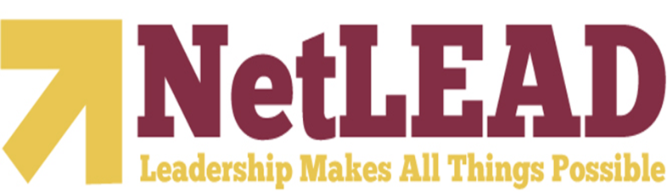
NetLEAD School Leadership Grant Program
November 17, 2010
9:00 AM to 12:00 PM
New Grant Orientation Agenda

Welcome: Dr. Jennie Rakestraw
- Relationship: Winthrop, NetSCOPE, and NetLEAD
- Introductions
- NetLEAD Narrative

Overview of NetLEAD Program: Dr. Mark Mitchell
- NetLEAD Overview
- NetLEAD Partners
Project Leader: Richard W. Riley College of Education
University Partner: Winthrop College of Business Administration
Upstate School District Partners: Dillon 1, 2, &3, Marlboro, and Marion 1, 2, & 7
Center for Educator Recruitment, Retention, & Advancement (CERRA)
South Carolina Association of School Administrators (SCASA)
Research Associates
The Evaluation Group
- Program Basis for Model, Primary Initiatives, and Benefits to Schools
- LEA Responsibilities and Benefits
- Project Management
Mid-Morning Break

Review of the Program Evaluation: Dr. Joel Philp, Dr. Felix Blumhardt
- Quality of the Project Evaluation
- TEG’s Approach to Evaluation

Conclusion: Dr. Jennie Rakestraw and Dr. Mark Mitchell
- Questions and Dialogue
- Outline Next Steps
- Determine Date and Location for Next Meeting
- Complete Evaluation for Today’s Session

