Math 201 Calculus I
Related Rates

Name: ____________________________________

Purpose: To discover how to use implicit differentiation to determine relationships between rates of change.
Procedure: Work on the following activity together in pairs.
- In calm waters, the oil spilling from a ruptured hull of a grounded tanker is spreading in all directions in a cylindrical shape. Determine the rate at which the volume of oil in the water is increasing when the radius of the oil is 60 feet and is increasing at a rate of 0.5 feet/second, and the height of oil in the water is 0.25 feet and is increasing at a rate of 0.01 feet/second.
  - What are the changing quantities in this problem? (Assign variables to each changing quantity.) How are they related? (Write equations to represent these relationships.) What rates are given in the problem? (Write in terms of the variables assigned above.) What are we interested in finding? (Write this in terms of the variables assigned above.)
  - Use implicit differentiation to complete the problem.

- A street light is mounted at the top of a 15ft pole. A man 6ft tall walks away from the pole at a rate of 5ft per second. How fast is the tip of his shadow moving when he is 40ft from the pole?
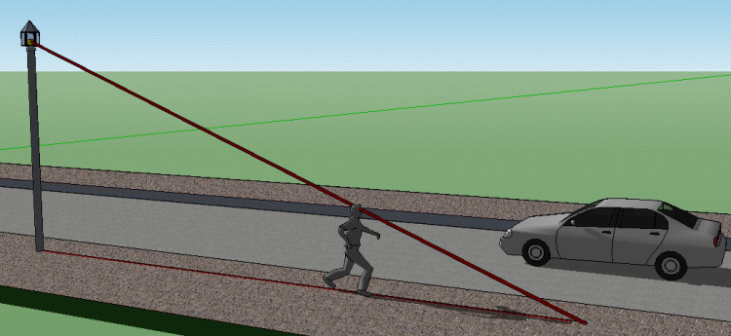

- Air is being pumped into a spherical balloon at a rate of 5 cm³/min. Determine the rate at which the radius of the balloon is increasing when the diameter of the balloon is 20 cm. (Look up any formulas that you want to use.)
- The combined electrical resistance $R$ of $R_{1}$ and $R_{2}$ connected in parallel is given by:
$$\frac{1}{R}=\frac{1}{R_{1}}+\frac{1}{R_{2}}$$
where $R, R_{1}$, and $R_{2}$ are measured in ohms. $R_{1}$ and $R_{2}$ are increasing at rates of 1 and 1.5 ohms per second respectively. At what rate is $R$ changing when $R_{1}=50$ ohms and $R_{2}=75$ ohms?

